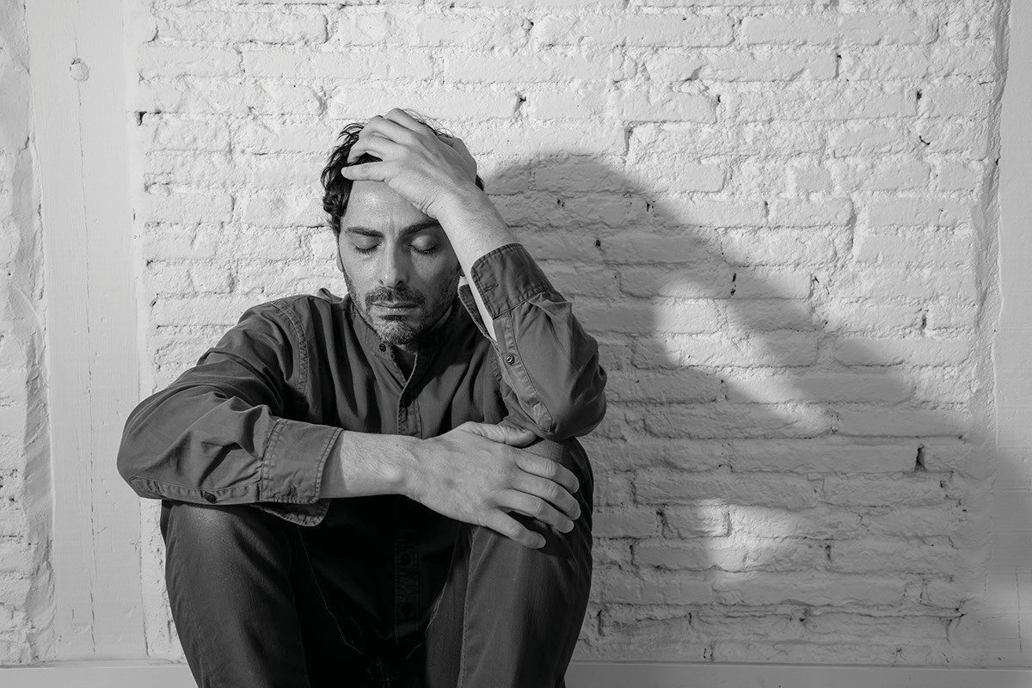

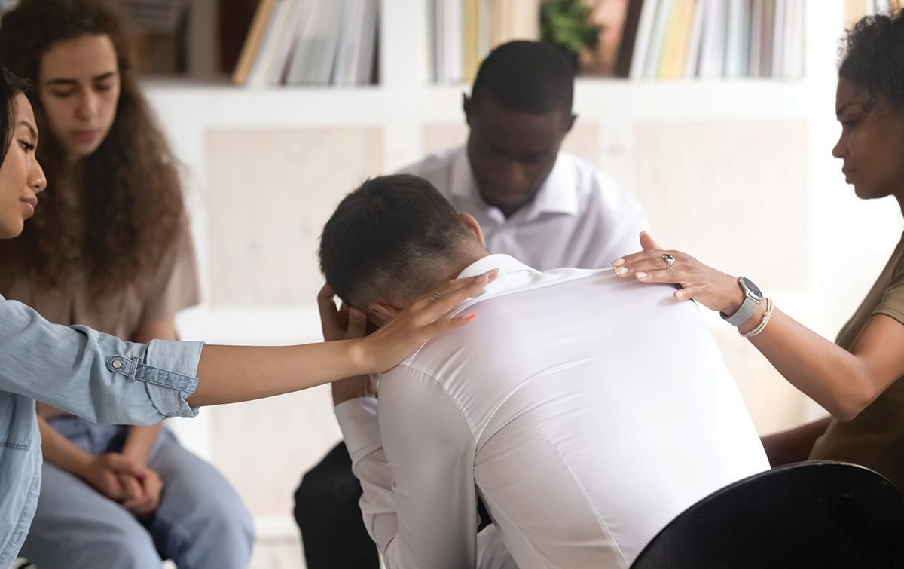

If you need our support, we’re here to help!

At the Renewal Center, our mission is to provide a safe, supportive and non-judgmental environment that empowers those who are struggling with the principles

of wellness and recovery.

Our Services Include:

* Professional Nursing Access
* Medical and Non-Medical Services Linkage
* Alternative Community Support Access
* Peer Support
* Tools for Support and Wellness Maintenance

The Renewal Center Hours:

3pm - 11pm Every Day

The Renewal Center is peer-operated and peer-staffed

to help individuals in a crisis

as they define it.

Contact Us at: 716.245.4200 327 Elm Street

Buffalo, NY 14203

Walk-ins welcome!

We serve individuals who are at least 18 years of age and have a primary mental health

or substance abuse condition.

renewal- center.org

**THE**

**RENEWAL**

**CENTER**

Our service is free.

SUPPORT for PEOPLE in CRISIS





**THE**

**We Turn On The Light!**

**When You’re In A Dark Place...**

**RENEWAL**

**CENTER**

SUPPORT for PEOPLE in CRISIS

Our Service is Free for those18 and Older

327 Elm Street

Buffalo, NY 14203 (Walk-Ins Welcome)

716.245.4200

renewal- center.org

Paid for by The Erie County Department of Mental Heath