Maura Kelley
MHPC Director, CPRP, NYPCPS

It Takes One to Know One

That is what I figured out, in dealing, living, suffering, and laughing with mental illness. I discovered at age 19, which was the first time I was hospitalized for my mental illness, that it does take someone’s experience to know someone else. Sometime between my 7 to 12 hospitalizations, I realized that they were all like me. Patients and staff: submissive, guarded, scared. The hospitals had so much over me. They owned my freedom, my medication, my comfort, and even my shoelaces. When the last hospital threatened me, with my literal life, I screamed, and screamed, and screamed. It worked. They let me out. Shoelaces and all. Ahhh...to have a voice. I learned that over and over here at MHPC. Over the years we picked up the slogan, “Slow Learner.” It takes a while to figure out that you know as much as the other person. We figure that out a lot at MHPC. We work together. We share. We struggle together, fight our failures and celebrate our successes. I don’t know of any other agency in this area that does that as well as we do. Because it takes one to know one.

At MHPC we encourage everyone to have a voice. No matter how meek, mild, or shrilling and loud; we express ourselves. What we say matters and how we say it does too. We learn that and teach that at MHPC. Lives change for the better, through teaching people advocacy and independent living skills. I know you know that because it takes one to know one. It takes our experience, our voice, and our things that matter to make us one another. At MHPC, we are not just a building. We are virtual group meetings, one on one telehealth and peer to peer support. That is what it takes for us to know one another. Why, because we experience the loneliness, emptiness, and the days without speaking to another human. So, we know it takes one to know what I am talking about. But it not only takes one, it takes all of us to overcome obstacles that get in the way of thinking, expressing oneself, and struggling to do an activity that seemed so effortless two days ago, yet now is insurmountable. I know you know, because it takes one to know one. We, I, know at MHPC. Our whole agency wishes to invite you into our little secret society club (which anyone can be a member of) to share, to come out of the shadows, to proclaim our freedom and our right to our own bodies, to inspire, to laugh, and even sometimes to leave the club because for all of us; it takes one to know one.

If you want to be a member, just give Bob a call 716-836-0822.

Gretchen Vinson
Team Leader Addict to Addict Family to Family Program

I Took Myself with Me:
A journey to my recovery from addiction

In the summer of 1989, I left NYC and returned to WNY my home, broke and strung out on Heroin. Me, this small-time girl who naively believed that there were no “hard drugs” in my hometown of Dunkirk NY. I could run back home and be safe from the mean addiction I found myself in. Problem with that solution? I took myself with me.

When I left my hometown at 18, I left knowing there were the regular drugs, alcohol, marijuana, acid, and pills. Of course, I knew cocaine and heroin were out there in the world but when I left home, I thought I would never use such drugs. Those were the bad drugs the stuff I used to party with are harmless. But when I first left home unknown to me I was well on my way to becoming a full-blown addict. When I left home, guess what? I took myself with me.

Away at college I partied hard and was introduced to cocaine. I loved it. Crack had not hit the scene yet, so we just sniffed it and went about our business. I left college due to my academic grades being too low. So, I moved to the city; I always wanted to live in NYC. My addiction was just getting started with me, but I was so unaware and guess what? I took myself with me.

A lot happened in the ten years I lived in NYC. I could never keep a job long, could never keep an apartment long. Never kept gas, electric or a phone long. I lived in a constant state of chaos, problems and dysfunction. I didn’t know what was wrong with me or why I couldn’t get it together, no matter how many times I started over. I was always starting over but guess what? I was living with me.

When I first moved back to Dunkirk I suffered through withdrawal, telling my dad that I had the flu. After, a week I felt better. I had reconnected with my old high school friends who were still partying as we had in high school. Nothing had changed for them. I stopped using heroin, but I used everything else. After six months I returned to NYC “on vacation” to visit my NYC friends. Within one day I was back on heroin. I mean the very next day. I was already broke. I was back to having to hustle up cash everyday to get my fix. One day during my so-called vacation, I was riding the subway back to where I was staying, I was high, in a nod and I had my moment of clarity. I thought, “could it be the drugs?”

When I returned home from my vacation, I had to suffer though withdrawal again. It wasn’t as bad as the first time because I hadn’t been using that long. I kept asking myself, could it be the drugs? I just wanted to be someone who didn’t get high anymore on anything. I wanted to find out how people live and not use drugs. I sought out help. I started by taking myself to outpatient drug treatment. At the clinic I attended they gave me a meeting list for a 12-step program that focused on drug addiction recovery.

I took myself to those meetings and started a journey of recovery that has been beyond my wildest dreams. On July 7, 1990 I surrendered myself to the 12-step program I was attending, and I gave my all to my outpatient treatment. I took myself on a journey of self-love, soul searching and taking responsibility for my choices. I went from a young girl who entered recovery full of self-hate, low self esteem and believing I was worthless; to a woman who loves who she is. Who is confident and knows my self-worth is priceless. That was over 30 years ago now. I have not used a drug or taken a drink in 30 years. Which is commendable. But recovery is so much more than that. It was looking at myself and working on changing my behavior so I could make better choices in my life. It’s about learning how to take care of myself and being kind to me. It’s about loving myself so I can love others properly. Through recovery I have learned how to have a stable life, pay bills on time, purchase material things, etc. However, it is the peace of mind and soul that lives freely in my body that I gained. That is what I cherish most about my recovery. I guard that with my life. I can lose all those other things and be OK but to lose me again? No! I keep my personal recovery first for that reason. I am proud to take myself anywhere now.

Brenda Starks, Benefits Advisor

How Benefits Made a Difference in Wanda’s Life

Wanda came to Mental Health PEER Connection to get assistance with applying for Social Security Disability Insurance (SSDI) because at the time she had a lot going on in her life both mentally and physically and was told she could get help with the Social Security process. Wanda had no income, no SNAP benefits and was worried about becoming homeless because she was not able to pay her rent since losing her job. Wanda and I talked about the resource that could assist her with getting back on her feet while waiting to be approved or denied SSDI. We completed the online Social Security application and during that time Wanda diligently completed the paperwork from the Social Security Administration and went to her IMA appointment at 699 Hertel Ave to have a medical evaluation per the request of Social Security. Wanda was approved for her SSDI benefits a year later by Social Security and was awarded back payments from the date of filing. Therefore, upon receiving the back-payment benefits Wanda was able to pay her rent and purchase a car to get back and forth to doctor’s appointments and her place of worship. Wanda is currently doing well and is able to maintain her housing and do some of the things she likes due to receiving her SSDI benefits monthly.
Rafiq J. Salim,
Peer Support Specialist

TURNING POINT

I was sitting with a small group of liberal (white) progressives when presidential candidate Donald Trump become President Donald Trump. Several of my colleagues were shocked, devastated that Hillary lost. I was smiling. One woman asked if I were okay, and I replied, “Yes, I am fine.” She then asked why I was smiling. I replied:

Donald Trump has insulted everyone in America except white men. He openly aligned himself with Neo Nazis and white supremacists. He denigrated Mexicans, African Americans, Muslims and Asians and demonstrated a complete lack of respect for women and their bodies. He said he can grab you between your legs and you will like it. And all the while, America has supported a narrative comparing Donald Trump’s in your face white supremacy with Hillary Clinton’s dalliance with racist politics as a young woman. Donald Trump was consistent in his message: White people should rule America. In reply, America voted white. Period. Tomorrow, when you wake up, everyone will say that you need to get over it and move on. And for one minute, you will know what it is like to be me forever.

So, as President Trump implemented his political agenda, African Americans suffered through four years of liberal tears and “I can’t believe Trump did blah blah blah.” African Americans, descendants of slaves, veterans of the Civil Rights Era, were neither sympathetic nor surprised. My colleagues grew weary of reminders that we were getting exactly what we voted for and deserve. I was the gadfly; grateful some appreciated the unpopularity of my views.

Then, COVID struck. The CDC said, “wear a mask.” President Trump flaunted not wearing a mask, effectively politicizing the health crisis. We were in a global pandemic and doing everything wrong. The country shut down and businesses closed. We were hurting. Then, George Floyd happened, and police racial violence and systemic racism were hurled in our faces. Again.

May 25, 2020, A white police officer, with three other officers watching, pressed his knee on the neck of a 46-year-old African American man until he was dead. The entire incident was recorded on cell phone video, the police officer occasionally looking directly into the camera. Some passersby tried to intervene and were stopped by a police officer holding up a can of mace; others pleaded with the officer to remove his knee and were ignored; still others looked and kept walking. George Floyd pleaded for his life and cried for his mother. It took nine minutes to kill George Floyd. The knee stayed pressed on George Floyd’s neck for a minute after he was dead; the officer did not remove the knee until asked to do so by a medic.

The video went viral and the world watched in horror and condemnation. Protests against police brutality and racism erupted around the world and across America. Black Lives Matter, again, was center stage calling for police reform. President Trump called for police to “dominate” the protesters and reestablish “law and order.” The world looked on, aghast. Was this happening in America, the bastion of democracy and freedom?

City governments floated proposals to demilitarize police departments, reduce police budgets and invest in community-based programs and services. Police reform proposals were collectively labeled a Defund the Police Movement by ‘conservatives’, suggesting liberals had chosen Black Lives Matter, the “thugs,” over the police. American Descendants Of Slaves (ADOS) presented that presidential candidates should support Reparations. The liberal media labeled ADOS a divisive element of the “black” community and blamed ADOS for Hillary Clinton’s loss to Donald Trump. ADOS challenged both presidential hopefuls: do you support Reparations to address centuries of systemic inequalities created by American law and policy or are you just talking? Are African Americans less deserving of reparations than the Jews and Japanese? The Biden camp refused to discuss Reparations until after the election. The Republican camp met with Ice Cube, an ADOS supporter, and used the meeting for talking points. Ice Cube cared nothing for the politics of either party: he would talk to anyone that would listen. Period. Liberals, once again, talked racial reconciliation and a need to address systemic inequities – outdated, ineffective, repackaged rhetoric. And as we huddled in our homes preparing for a post COVID America, the modern Equity Movement was born.

For almost a year, from the safety of our computers, we have fed upon a diet of trainings designed to make us ‘aware’ of systemic ‘bias’ as a first step toward healing. Whites mostly just wanted to “get back to normal.” When compelled to think about giving up white privilege, whites stopped stop listening. Just when we thought we were getting back to ‘normal,’ the “Insurrection” happened.

After losing the national election in the Popular and Electoral College vote, President Trump claimed the election was stolen from him through massive voter fraud. The President’s claims were unceremoniously thrown out of federal courts by Republican appointed federal judges as baseless and without merit. Asked directly, President Trump would not commit to a peaceful transfer of power. Republican House members and Senators wanted to throw out the Electoral College results and give the election to Trump. The Democrats said the American people have spoken, and Biden will be the next president. Former Trump Cabinet members and Secretaries of Defense publicly presented that military should not get involved in electoral politics. The stage was set, and lines were drawn.

President Trump invited his supporters to come to a rally in the Capitol on January 6, 2021 to ‘Stop The Steal,’ the same day Congress meets in joint session to count the Electoral College ballots. At the rally, President Trump said he wished the military was with them and should be with them. President Trump then swore he would never concede power to Joe Biden, urged his followers to march to the Capitol and “fight like hell,” “be strong,” “don’t give up,” and that he would be with them. President Trump’s supporters, the Insurrectionists, armed with weapons and zip ties, then attacked the Capitol and attempted to capture and kill United States Senators and Representatives. The entire Legislative Branch of Government and Vice President of the United States, the complete constitutional line of succession to the sitting president, were under attack. In the White House, ignoring calls from the besieged Legislators, presidential aides, cabinet members and former cabinet members to tell his supporters to stop, President Trump did nothing to discourage the attackers while there remained any possibility that the attackers would succeed in capturing the House Representatives and Senators. Trump called off the attack only after the Legislators evaded capture. In telling his supporters to leave the Capitol, President Trump said that they were “good” people and that he “loved” them.

In the Impeachment fiasco that followed, all but a handful of Republicans did not consider Trumps conduct an impeachable offense. Today, the worst kept secret in America is that, but for the heroism of the Capitol Police and the public opposition of former Secretaries of Defense, we were a hairs breath from a successful coup and dictatorship. The “Insurrectionists,” if we insist upon euphemizing them as such, demonstrated an acceptance that political violence is still an acceptable path to maintaining white supremacy in America. And evidently, more than a few folks agree.

Today, Whites are again tired of discussing racial reconciliation and systemic inequities. Nonetheless, Democrats in Congress are discussing Reparations and the Biden Administration is poised to join The Conversation. To be clear, a ‘white’ commitment to raising awareness alone is pointless. The 1960’s Free Love Era and three generations of open “interracial” mixing should have, at the very least, illustrated the fallacy of awareness as a change agent.

But to be fair, every former European colony has a systemic racism ‘problem.’ Entrenched Whites in Brazil increased European immigration to whiten the country. Entrenched Whites in South Africa created shades of color/class identities to maintain systemic inequalities, failed to stabilize civil unrest and were forced to concede political power. Spain attempted the same strategy in Cuba, failed, and were driven out by Cubans. (America stepped in to maintain White dominance.) Mexico pursued amalgamation to erase color difference and promoted itself as a new race. Trumps wall across the Southern Border and immigration policies were attempts to achieve the same result in the United States. America is on the path to having a “non-white” majority population in 20-25 years, a demographic shift at the root of white panic and insecurity at losing their country, as if the ‘BIPOC’ are hyphenated guests. Awareness, amalgamation and immigration policy has not and will not extricate us from the existential nightmare of racialized identities we have trapped ourselves within.

Black and White are not Races, but markers on a color/class hierarchy of privilege. Unhyphenated poorly pigmented Americans are born into the class; the poorly pigmented from other countries are invited in; some BIPOC marry White hoping their children will be light-skinned enough to legitimately get in; ‘mixed race’ folks sometimes sneak in and, if caught, are kicked out; some Whites quit; some Whites are kicked out for associating too closely with ‘Blacks;’ some Whites discover they are actually Black and do not know what to do. It is complicated, especially for Latino parents with both poorly and richly pigmented children.

We got to this place by living and growing within a world where race has had meaning for generations. Chattel Slavery was a legal institution, ‘miscegenation’ was a crime and race still determine privilege. Americans are unable to even look at one another without silently resolving race. We are obsessed by skin color and all we believe what skin color implies. We have effectively trapped our being within a racial paradigm in which we experience divisive and delusional skin-deep identities. And now, Whites and Blacks stand fists clenched in silent impotent rage as their children produce offspring with any human they love. Race has driven Americans mad!

Are we content in our madness? Do we want to do anything about race/color class issues other than “get back to normal?” Some whites find periodic civil unrest a reasonable price to pay for white privilege. At the same time, many non-whites are perfectly content with the racialized identity status quo. Non-whites generally do not perceive “persons of color” as a crudely disguised ‘racist’ slur directed at non-whites i.e., Asians, Latinos and Native Americans. Many non-whites have successfully carved out a niche within their class, done remarkably well financially, vote their financial interests and nothing else. For Blacks, working twice as hard to get half as far has been accepted as a fair price to pay for financial success. Black Power and White Power groups, though not moral equivalents, both reinforce the race paradigm by adopting its labels.

President Biden is an excellent example of an honorable White trapped in racialized identity. President Biden singled out ‘Black’ and ‘Brown’ people as particularly in need of financial COVID relief. I shuddered, hoping the President would name the remaining ‘Yellow’ and ‘Red’ People Of Color. This well-intentioned statement both minimized the pain of other struggling small businesses owners and reinforced the color/race class in America. It was also red meat for white supremacists crying ‘reverse racism.’ Biden’s 2020 campaign gaff that African Americans that do not vote for him are not ‘Black’ elucidates the point. President Biden, clearly not a racist, is unable to imagine himself as other than white, so he struggles to not use racist language.

White commitment to deconstructing the race paradigm is critical to our survival as a democratic republic. Consider. Women have decried systemic inequality for generations, yet inequality persists. Why? Because women cannot resolve systemic inequality without the commitment of those that collectively benefit from the inequality – men. Similarly, “People of Color” cannot resolve white supremacy without the commitment from the collective beneficiaries of white supremacy – Whites. However, unlike the inequality of the sexes that militate coexistence as an existential imperative irrespective of women’s objections, non-whites acquiesce to white supremacy until they have the power to oppose it. Witness Haiti, Cuba and South Africa, the latest decolonization domino to fall.

Canada, recognizing but not affirming racialized identities, removed all racial categories from its national census. America might consider following suit and remove all categories linked to the race paradigm from demographic information collected by the government. This effort should begin with the Census. The National Census provides not only a description of population, but an image of ourselves that we reinforce each time we complete the demographic section of a document. We might also:

- Enact a Voting Rights Act:
  - automatically register for life every American Citizen to vote at the age of 18;
  - proscribe any state or local government actions or laws that in any way interfere with a citizen’s right to vote;
  - create a federal commission without elected or party officials to create federal voting district guidelines;
  - Require states to follow the federal voting district guidelines.
- Provide Reparations for African descendants of slaves. The United States government provided reparations to former slave owners for the loss of property (slaves) and to Japanese American citizens interred during WWII. European countries provided reparations to Jewish Survivors of Concentration Camps whose property was seized during WWII; France demanded Haiti pay in reparations for French property (Sugar plantations in Haiti and the Haitians themselves).
- Educate Americans about the race paradigm. The mythology of race should be replaced by science in every educational institution within our society. Humans are one species; our birthplace is Africa; humans migrated from Africa began approximately 60-80,000 years ago. All visible human variations result from advantageous genetic mutation in relation to differences in climate and geography. These variations account for less than 1% of human DNA and have no impact on intelligence or any human character trait.
- Educate all agencies or contractors that receive government funding about the race paradigm. These trainings should be provided by qualified trainers who do not live within racialized identities.
Feel free to contribute to the list: just contribute.

Delmar Jackson, ECMC Peer Advocate

Peers Making a Difference at ECMC

ECMC peers are an integration in the treatment system of the consumers who are currently in the hospital. Peers provide ongoing peer groups of various topics that focus on mental health recovery, stress management, selfcare, coping skills and finding healthy supports. The ultimate goal is to prevent re-hospitalization through peer supports, advocacy and community services (MHPC). At ECMC, peers also provide peer counseling, clothing assistance through the ECMC volunteers closet, information and referral and discharge planning and meetings upon request of consumers to have a smooth transition back into the community. As peers, we care about the wellbeing of all consumers, we engage in a humble and professional manner and try to develop relationships during their sometimes, short admission. The real fulfillment is to see the people we serve get discharged with a wealth of community information, obtain the needed services and supports (MHPC) and to eventually see their quality of life grow beyond their own expectations.

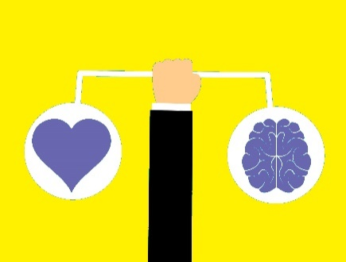
Lisa Maria Cruz, MHPC Outreach Coordinator

Transition

Cristina lost track of how much time she had spent at the Buffalo Psychiatric Center. The days merely blended into each other. One day was pretty much like any other. She was like an automaton mechanically walking from groups to meals, to bed. Her one bright spot was when she was allowed a short break and could go off grounds to smoke. Dragging on her cigarette was her one solace.

Actually, she did have something else that she turned to for comfort. She loved to read. With whatever free time she had, she used it to devour one book after another. Through the pages of her tomes she escaped into other worlds. Worlds where she could forget that she was living a substandard life. Where she could overlook the fact that almost all her liberties were stolen from her.

She mostly kept to herself. She tried to make herself as invisible as possible. She didn’t want anyone to notice her. Her hair was unkempt, and her clothes were three sizes too big. She needed a belt to hold up her pants or they would have easily fallen off. She learned that it was far better to be ignored. It was when you were noticed that the real trouble began.

When she lived in the outside world, she existed differently. She used to wear make-up, paint her nails, and wear flattering clothes. That changed when she was committed. When she first arrived, she received a lot of attention and she did not like it. The other patients were constantly hitting on her. And so quickly, very quickly her appearance transformed. She stopped caring about how she looked. She strove to appear as undesirable as possible. And eventually it worked, and she was left alone. Which is exactly how she preferred it.

Time moved differently inside these walls. The minutes, hours and days dragged by so slowly—more slowly that the slowest snail. Which was why she especially loved to read. As she read, she lost track of time. The hours flew by. At least for a time she was happy and could forget that she is being institutionalized against her will.

Eventually, that day arrived when she would be able to leave. She was going to be moving in with her mother. That would be a drag. She would much rather live alone, but that wasn’t an option and she definitely did not want to live in a group home or one of those hideous single room occupancies.

After she was released, the first thing she wanted to do was find a job. She would work two if she had to. She wanted to save enough money to get her own place and return to school. She knew that her mother was going to watch her like a hawk. The thought of it made her feel despair. To be 21 and living with her mom again would be difficult. But she knew that living with her mother, even under these circumstances was much preferable to living there at the BPC.

The day finally arrived. The day when she was being released. Her mom came to pick her up and for that she was exceedingly grateful. It was a bright, sunny spring day. With many more bright, sunny spring days to follow. As she was walking off the grounds, she felt her heart fill with immense hope, hope for a better tomorrow.

When she arrived home, the first thing on her agenda was to find a job. She wasn’t picky. She figured any job would do. She just needed to start earning her own money. Her mom wasn’t going to charge her rent. Another thing to be grateful about. And her mom wanted to support her in working and getting her own place. She wanted her daughter to be independent and self-sufficient. But she also wanted her daughter to be safe. She encouraged her to work only one job. Although, she was pushing for two. Her mother was aware that living on the outside could be stressful too and she didn’t want her to be overwhelmed.

So, Cristina found a part-time job working at a coffee shop. She worked with other young people and that was kind of cool. She smiled, said hi and was friendly. They chatted about things that didn’t really matter. She didn’t want to actually talk to them about anything serious. Serious things are not meant for the ears of these strangers. She confided in her mother about her hopes and dreams. She longed to return to school, earn her bachelor’s and then become a writer. She loved to write, and she had a lot to say. And she was willing to say it to whoever would listen. The mental health system must transform, and she would fight and act in order to make it happen. She vowed deeply in her hear that she will be a catalyst for change!!

Best-Ever Fried Chicken

https://www.tasteofhome.com/recipes/best-ever-fried-chicken/

Ingredients

- 1-3/4 cups all-purpose flour
- 1 tablespoon dried thyme
- 1 tablespoon paprika
- 2 teaspoons salt
- 2 teaspoons garlic powder
- 1 teaspoon pepper
- 1 large egg
- 1/3 cup whole milk
- 2 tablespoons lemon juice
- 1 broiler/fryer chicken (3 to 4 pounds), cut up
- Oil for deep-fat frying

Directions

- In a shallow bowl, mix the first 6 ingredients. In a separate shallow bowl, whisk egg, milk and lemon juice until blended. Dip chicken in flour mixture to coat all sides; shake off excess. Dip in egg mixture, then again in flour mixture.

- In an electric skillet or deep fryer, heat oil to 375°. Fry chicken, a few pieces at a time, 6-10 minutes on each side or until golden brown and chicken juices run clear. Drain on paper towels.

Nutrition Facts

1 serving: 811 calories, 57g fat (9g saturated fat), 176mg cholesterol, 725mg sodium, 26g carbohydrate (2g sugars, 2g fiber), 47g protein.

Leslie Saunders
Peer Support Specialist

The Beginning of Knowing
(What Daddy Is)

The black spandex briefs glistened with sweat as the men
Body-slammed one another on the padded floor.
Closer to home, the shadows boxed on the walls In a caricature of the infamous WWF antics.
In the middle of typical Saturday morning drama,
I was resting safely on the girth of my hero.
I nuzzle in the hairs of his chest, hypnotized by the scent of gin, juice and Old Spice.
It is very warm, intoxicating, and I drift in and out of sleep.
We move in syncopation.
As I breathe, he breathes. My heart beats his beat.
He tells my brother and sister that he is awake and watching the show,
But the rhythm of his breathing bears witness to the fie.
Arms that are flung toward the east and west,
Occasionally come together to hug his baby girl or softly pat my back.
There, I inhale security and exhale contentment. I know that I am loved.
Violence surrounds me; children play fighting, the battle on the television.
Yet I smile while sleeping in the midst of the chaos. I rest, laying on my belly, thumb in my mouth, and my butt in the air on top of my Daddy's stomach.
Confidently I smile in my sleep engulfed by a weightless cloud of flesh. I am secure that nothing can harm me.
My security had nothing to do with external circumstances but everything to do with an inner knowing.
I know who I am because my father taught me unconditional love, from the inside out.

* *Remember that song that said "...in order to move like this, you have to have confidence." That's my theme song. Can you hear the music when I walk?

Naomi Taylor, Peer Support Specialist
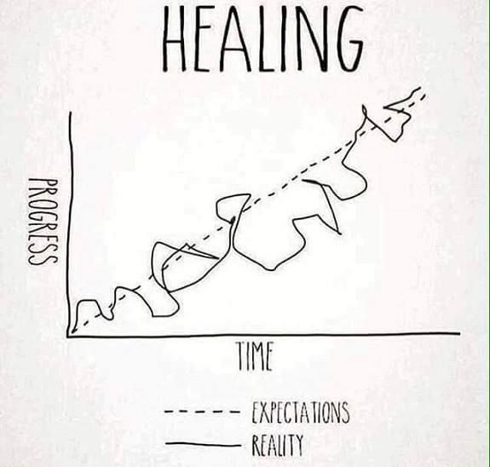
The many different paths to recovery-

Traveling the path to my own recovery from substance use, I have discovered that the path to recovery is not a straight line. It is more like an unpaved road through uncharted territory.

When I started on my journey 8 years ago, there were many barriers in my way. I had lost everything that I had worked towards in my life. My marriage ended, I lost custody of my kids, I was unemployed and homeless. My family didn’t want anything to do with me and I had nowhere to turn. The darkness that I felt was all encompassing.

I stayed with generous friends who allowed me to be in their home if I wasn’t using any substances. I threw myself into anything that promised to make me to feel better. I started yoga, went to several 12 step meetings a week, exercised and meditated. I started a raw vegan diet and grew my own food. On the outside it seemed that I was doing great but, on the inside, I was sinking further and further into despair. The darkness was growing and there was nothing I could do to stop it. I started having daily panic attacks and couldn’t sleep for days.

The pain got so great that I started thinking about ending everything. I couldn’t see a way out of the black that was my reality.

Somewhere along the way, I heard someone say, “The only person you have to be honest with is yourself.”

If I was really honest with myself, what I was doing wasn’t working. I was pretending to be fine when I was dying on the inside. I couldn’t stand yoga. Meditation made me dizzy. People in support groups drove me nuts. I wanted a steak, for crying out loud!

I started looking for the things that would help me, not what other people told me would help. I started telling people my honest feelings, rather than what they wanted to hear. I started to fight to get custody of my kids, even if their dad was not happy with me. I started lifting weights instead of doing yoga. I practiced moving mindfulness instead of trying to meditate. I learned that NO is a complete sentence. I went to different support groups, rather than the traditional 12 step meetings. Slowly, my self-worth and self-esteem started to grow. I found what truly suits me rather than what other people said.

The path to recovery is unique to everyone. There isn’t one-way set-in stone for a person to follow. The journey to find yourself can be a beautiful, incredible experience. Once I was sick and tired of lying to myself, I was able to find my own way. Today I can say that I love myself and my life!

DM
The sky waxed through shades of Increasingly intense hues.

I gazed out the window at This beauteous scene, longing for a return to my soul.

The connection was severed earlier that spring, with a swift decision that brought separation from self. This brought unending pain, and sparked a move to end the connection with the Earth. Rather than be transported to the Heavenly realms, I woke up somewhere else.

Seeing the glory of God in the sunset at my worst moments helped to see me through the next years of tough growth. I am on a soul journey, after all.

As I recovered, I did not foresee that later I would lead others down different paths of renewal.

DM

The Essence of Creation

Moving that block to create fulfillment is the moon shining into a darkened room. This soul that has hurt from the initial tear from the young self, this is the hurt one.

He entered into the world unprepared, youth tore from his very basis of living. His imagination was reflected in the dawn of a new day with the April sunlight. His belief was in a better tomorrow but not brought into existence for years to come.

He was Torn from the self, torn from the basis of his livelihood. Any kind of renewal had to be convinced from the depths of afar. Then, touching base with his reflection on the water, he came to and arose in a new form.

Lisa Maria Cruz

Winter Always Turns to Spring

It’s March 2021 and I’m already looking forward to Spring. Winters are so long in Buffalo, NY. But as we know, Winter Always Turns to Spring. I just wish that we didn’t have to endure snow showers from November until April, before we get to experience it. Winter is really 6 months long in Buffalo. But because of that when spring and the May flowers come it is that much sweeter. I love Spring and Summer in Buffalo. Those seasons are so wonderful in Western New York. I live off of Elmwood Avenue and it’s always amazing to see the transformation in the Elmwood Village. You see dozens of people walking along the sidewalks, and also see many others enjoying themselves at the outdoor patios. And of course, you see many people happily walking their dogs.

I received both of my COVID-19 vaccinations at the Delavan Grider Community Center. After my second shot my arm was a little sore, and I had a slight headache, but other than that I was totally fine. I am especially looking forward to when spring comes, because I will be fully vaccinated by then. My husband is definitely happy that I received my shots. He received his first and second shots before I did. He works for New York State at the Department of Environmental Conservation. The governor asked for state workers to volunteer to help with the vaccination campaign. My husband applied and was selected. Because he is screening people who are receiving their shots, he was able to get his as well.

My husband and I are looking forward to the warm spring weather, the flowers blooming and the longer days of sunlight. We love and appreciate those long summer nights when the sun sets after 8pm. It’s a welcome change after experiencing the long nights of winter. I’m looking forward to new beginnings that are certain to come with the change in weather. As more and more people are getting vaccinated, we can look forward to moving closer and closer towards some kind of normalcy. I’m hoping at some point to return to my Indian buffet days. Myself, my husband, and our friends have a long-standing tradition of going out for Indian food at India Star on lazy Sunday afternoons. We’ve been getting Indian buffet there for over twenty years. My husband and I actually met at Indian buffet. We’ve been married almost 19 years. Our anniversary is on May 25th. Yet, another reason to look forward to spring!!

With the warmer weather, my husband and I will be able to pick up sailing again. We took lessons last summer. He’s much better at sailing than I am. Although, he grew up with an uncle who had a sailboat and he’s constantly watching sailing videos online. He’s fascinated with sailing. Which is good for me, because he can help me to become a better sailor.

I’m also looking forward to Lake Effect Artisan Ice Cream opening on Hertel Avenue. They close for the fall and winter, but re-open every spring. They have delicious ice cream in a multitude of flavors. It’s walking distance from where I work, so I’m looking forward to getting an ice cream there on my lunch hour. There are many things to look forward to in Buffalo with the coming of spring and warmer weather. Because we have long, saturnine winters we get to experience profound joy when spring finally arrives.

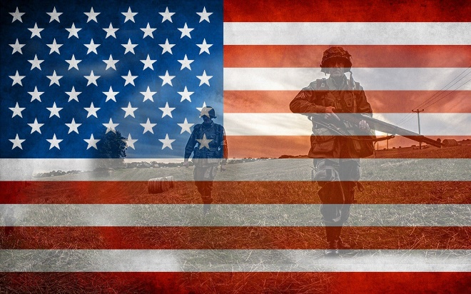
Terry McGuire, MS
Acting Public Affairs Officer
VA Western New York Healthcare System
3495 Bailey Ave., Room 1102
Buffalo, NY 14215

Community Profile on the Veteran’s Administration

We serve Veterans to help them re-establish their lives and put them back on track. We help them in their recovery from mental health issues, alcohol, drugs and homelessness through a process of change in which an individual can achieve abstinence and improved health, wellness and to live a better quality of life. Those involved are VA’s Certified Peer Support Specialist’s like Manny Welch, MHC for Acute Psych Inpatient/Outpatient and Substance Abuse. Manny helps assist and advocate for Veterans to find recovery and support. Led by Edwin Gadson, our PTSD Residential Program can also help veterans take back control of their lives by supporting and building a sense of wellness and making all participants aware of every available service. Additionally, Cole Johnson, VA Homeless Program, can assist with the HUD-VASH program, allowing stable housing options for Veterans and advising housing coalition groups how to best help Veterans in maintaining healthy lifestyles. Lastly, Terrence Sloan from the PRRC (Psycho-Social Rehabilitation and Recovery Center) can assist with suicide prevention efforts to motivate and help connect veterans to various community organizations and services.

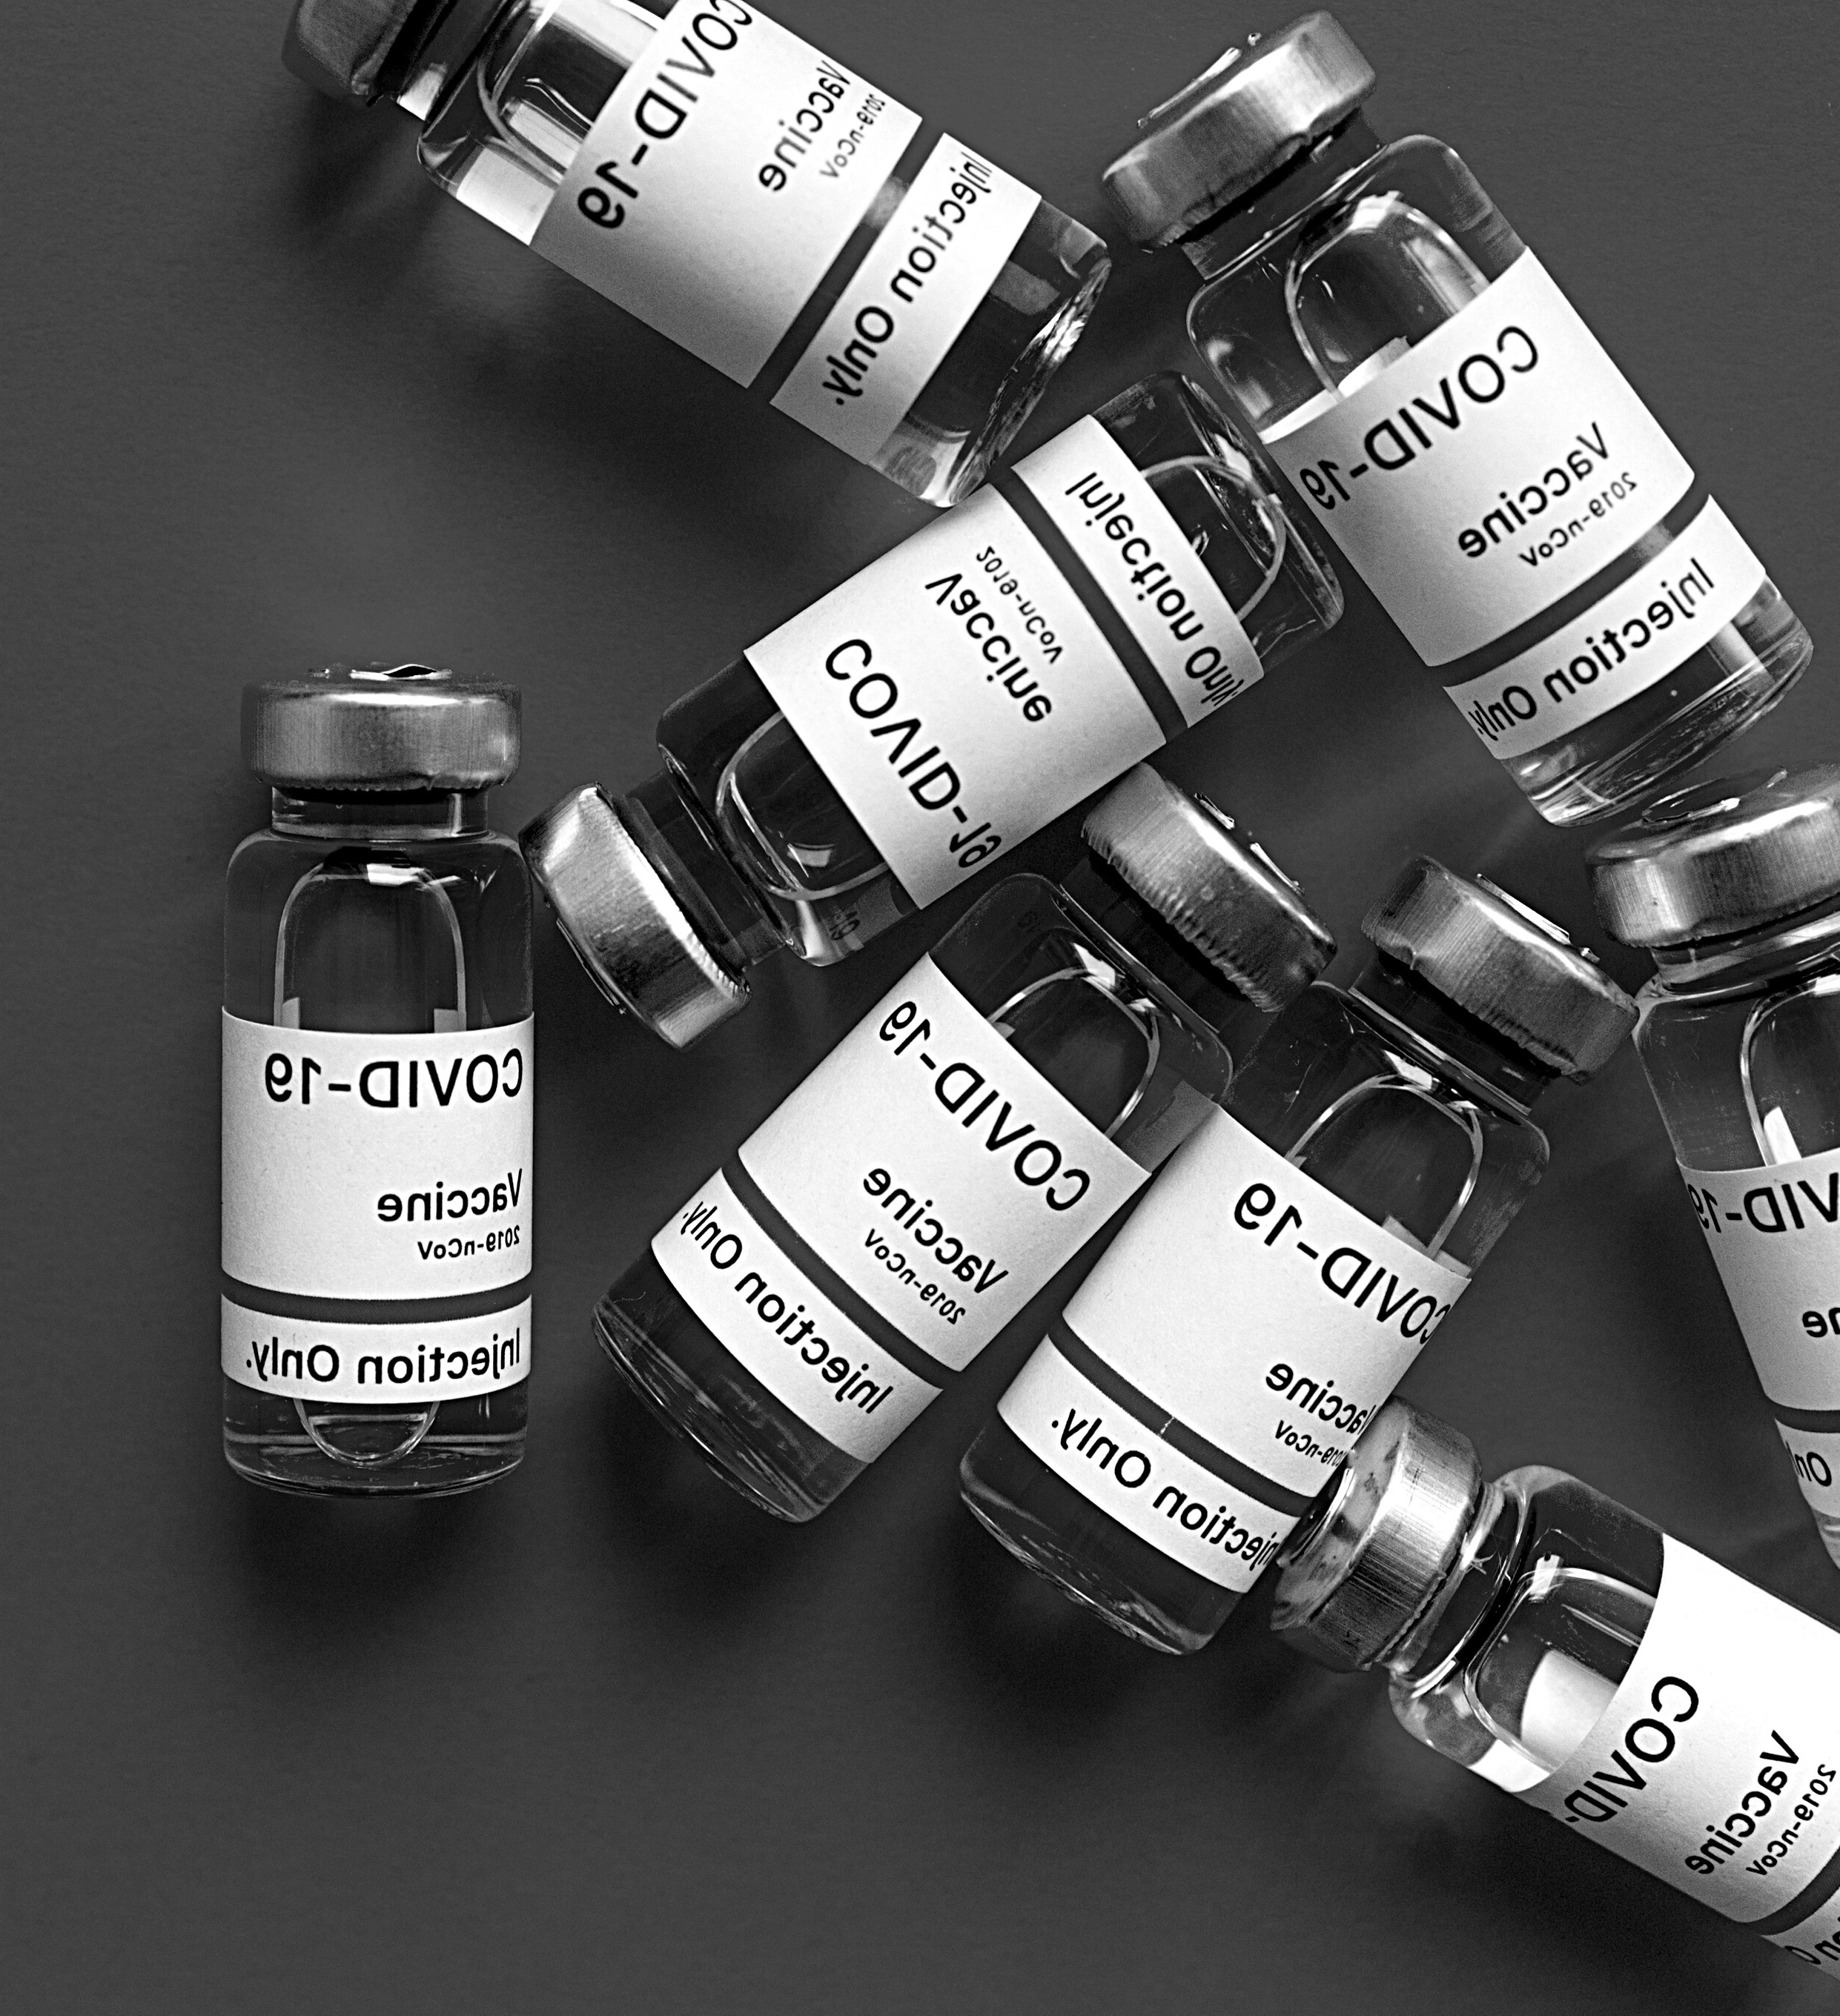
EASY READ
GUIDE
COVID-19
VACCINATION
IN NEW YORK STATE
Last Updated: April 2021

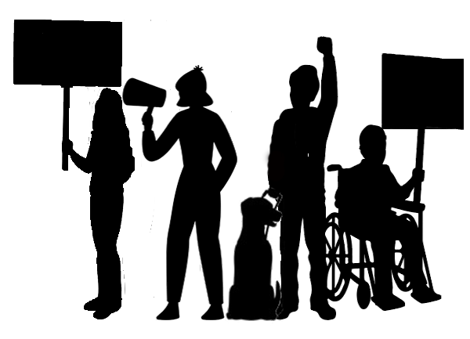
The document was developed by the Young Leaders and Advocates Network, a member agency of Western New
York Independent Living, Inc. Family of Agencies.
The duplication, distribution, and use of the product can be
without any notification of the authors or publisher of same.
PRIMARY AUTHORS
Melanie Hecker, YLAN Council Member Brianna Gower, YLAN Director

IN THIS GUIDE:
What is the COVID-19 vaccine?
How do I get the COVID vaccine?
Scheduling an Appointment
What To Expect Before, During and After

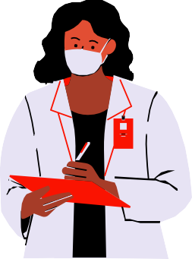
WHAT IS THE COVID-19 VACCINE?
The COVID-19 vaccine is a shot. It helps keep you from getting COVID. It teaches your immune system how to
recognize the virus and fight it.
If enough people get the vaccine, there is less chance for it to spread. This means that less people will get sick and the
pandemic will end.
The vaccine is free and safe to get. Doctors and scientists have done lots of work to make sure it is safe to use. The vaccine got tested on a lot of different people. Almost everyone who got the vaccine didn’t get sick. This means
that it works!
2
Young Leaders and Advocates Network | www.YLANetworkNY.org
You can sign up for the vaccine if you are:
·Age 16 and older ·Live in New York
·Work in New York ·Study in New York

HOW DO I GET A COVID VACCINE?
In order to get your vaccine, you will need to schedule an
appointment. You can schedule an appointment through:
The New York State Health Department
Your county health department Pharmacies and vaccine clinics
If you are 16-17 years old, you can only get the Pfizer vaccine. Studies are still being done to make sure the Moderna and Johnson & Johnson vaccines are safe for people under 18. The state-run website tells you which vaccine is offered at each site. Counties and pharmacies
should be able to tell you as well.
3
Young Leaders and Advocates Network | www.YLANetworkNY.org
Note: All places that offer vaccines will ask you for your insurance information. You will not have to pay for the vaccine. They just need your insurance information so they can get money back for giving you the vaccine. If you don't have insurance, you can still get the vaccine for free.

SCHEDULING AN APPOINTMENT:
STATE HEALTH DEPARTMENT
You can schedule an appointment with a state vaccination site by either calling the COVID vaccine
hotline or visiting their website:
1-833-697-4829
covid19vaccine.health.ny.gov
Be sure to have ready: Your birthdate
Your email address and phone number How you qualify for the shot
Your health insurance information
Where you live and work
4
Young Leaders and Advocates Network | www.YLANetworkNY.org

SCHEDULING OVER THE PHONE
When you call to make an appointment, the person on the phone will ask you a few questions. They will ask you if you have had any COVID symptoms in the last two weeks. If you have, you will need to call back when you are feeling better.
After, the person on the phone will ask you which of the
state-run clinics you want to get your shot at and what time.
If you need to get two shots, the state will make the second
appointment for you 3-4 weeks after your first appointment.
Once you have answered all the questions the person on the phone has, they will need to read you a lot of legal info
about the vaccine.
When they are finished, they will send a ticket for the
appointment to your email address. They will also send a few more questions that you will need to answer online.
5
Young Leaders and Advocates Network | www.YLANetworkNY.org

SCHEDULING ONLINE
When you get on the website, you will need to click on "Make appointment." This will bring you to a page with a list of places where the vaccine is being given. It will also say which places have appointments available.
Click on "get started" to start scheduling your appointment. You will need to fill out a form with your information. After you submit, it will bring you to a page with a list of vaccine sites with appointments available. The sites closest to you will be listed at the top. From there, you will pick a date and
time for your appointment.
Once you select a date and time, you will need to register for the appointment. There will be a 20-minute countdown in the upper corner. This is how long they will hold the appointment for you while you register. If you need more
time, you will be able to extend it.
The registration will take you through different screening questions. You will also have to fill out information about yourself. When you are done, you will get an email with your ticket. The email will also include instructions for your
appointment and what to do next.
6
Young Leaders and Advocates Network | www.YLANetworkNY.org

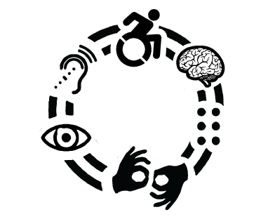
SCHEDULING AN APPOINTMENT:
COUNTY, PHARMACIES, AND CLINICS
Each county or local government has its own way you can sign up for an appointment. You can go to your county's website for information on getting a vaccine. They should
also have a phone number you can call.
Most counties have a form you can fill out to be notified when an appointment is available. This form does not sign you up for an appointment. This will add you to their list of people who want the vaccine. When appointments are
available, they will reach out and tell you how to sign up.
Vaccines are available at most pharmacies. You can go to vaccinefinder.org to find appointments available near you. You can also check your local pharmacy's website to see if
they have appointments available.
Some groups that serve people with disabilities are holding
vaccine clinics just for people with disabilities. Ask your service coordinator if any clinics are running near you.
7
Young Leaders and Advocates Network | www.YLANetworkNY.org

TIPS FOR SCHEDULING AN APPOINTMENT
8
Young Leaders and Advocates Network | www.YLANetworkNY.org
If you want to schedule your appointment around the same time as someone else, pick a date that has a lot of appointments available or is further away. This way, it'll be easier to find times that are close together.

Some places will let you get an appointment even if you don't live near it. Make sure you can get reliable transportation to the site if you do.

If there are no appointments available near you, try to get one anyways. Sometimes there are a few available even if it says there isn't.
You can also refresh the website to see if any new ones show up.

Book whatever appointment you can get.
You can always cancel it if you find one sooner.

Be patient but persistent.
Check scheduling websites often, and at different times of the day.

BEFORE YOUR APPOINTMENT
You will need to complete the NYS Vaccine Form. This can be found at forms.ny.gov/s3/vaccine. Print or take a photo of the confirmation. This way, you will not have to fill it
out again at the vaccine site.
All sites will need you to bring proof that you are eligible. This includes proof of identity, age, and residency. The state suggests using a driver's license or passport. You should also bring your insurance information. For more information, visit covid19vaccine.health.ny.gov. Make sure you have
everything you need for your appointment.
If you start to have COVID symptoms around the time of your appointment, call your healthcare provider before going to get the vaccine. You may need to get a COVID test before
you can go.
9
Young Leaders and Advocates Network | www.YLANetworkNY.org
If you are 16-17, a parent or guardian has to come with you to confirm your identity and consent to you getting the vaccine.

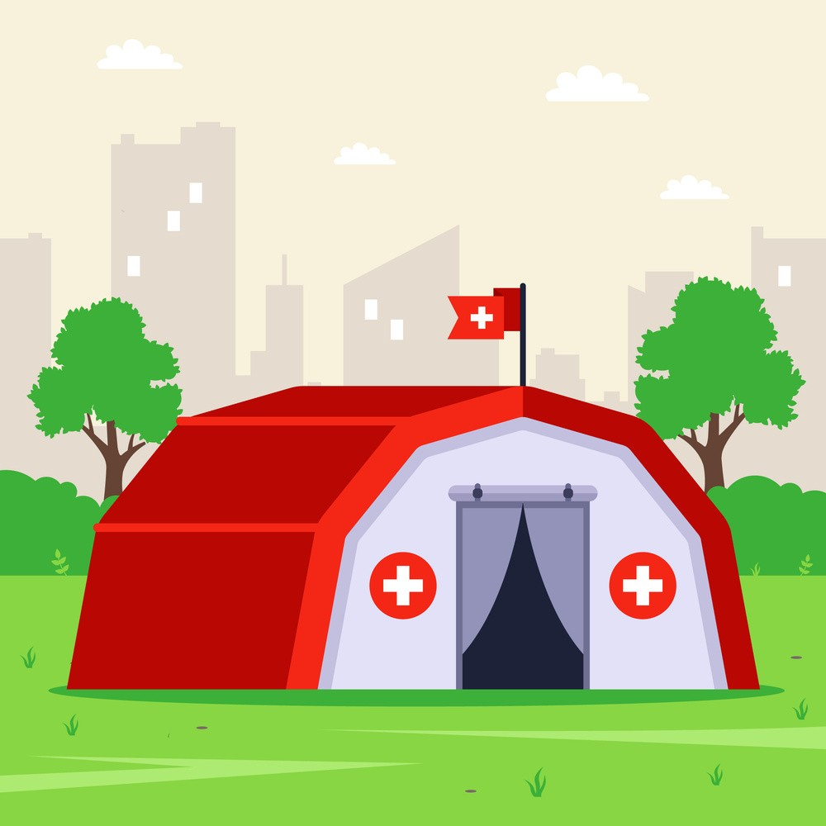
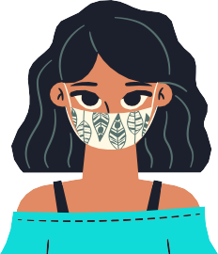
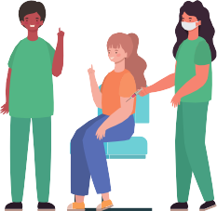
TIPS FOR YOUR APPOINTMENT
You can bring someone with you to the appointment if you need assistance or for the purpose of consent. However, only people with an appointment will get the vaccine.
You and the staff at the site will need to wear masks or face coverings. You will also need to stay 6 feet away from others
while inside and in lines.
Try to arrive 10 to 15 minutes early. The clinic may have specific instructions on how early you can arrive. This will be
in the email they sent you.
Expect the appointment to last at least 30 minutes. It may
take longer if there are a lot of people going that day.
The clinic may look like a regular building. It might also look like a big tent. No matter what the clinic looks like, people will
give you directions to it when you get close.
10
Young Leaders and Advocates Network | www.YLANetworkNY.org

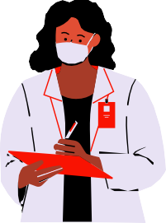
DURING YOUR APPOINTMENT
There will be a person at the front or at a table for you to check in. They will ask for your ID, ticket, insurance, and proof that you
did the survey. Have this information ready.
Afterwards, the person will tell you where to go for the vaccine. You may have to wait in line. You may also be told to walk straight to where vaccines are being given. This depends on
how they are set up.
When it's your turn, they will clean the area on your arm where they will be giving the shot. You'll feel a quick poke and then it will be over. After your shot, you will be given a vaccination
card. Make sure your information is correct.
Once you are done, you will need to be monitored for 15
minutes. This is to make sure you don't have an allergic reaction. After your time is up, you can leave the clinic.
11
Young Leaders and Advocates Network | www.YLANetworkNY.org
The process may look a little different depending on where you get your vaccine. There will be people there that help tell you where to go and what to do. For the most part, this is what an appointment would be like:

AFTER YOUR APPOINTMENT
After you get your shot, you might feel a little sick in some ways. These are called "side effects." It usually lasts a few hours or a few days. This doesn't mean that you have COVID. This means that your body is building protection.
Side effects might include:
Some people might have side effects that make them very sick.
You should call your doctor if:
The redness and tenderness where you got the shot gets worse after 24 hours
Your side effects are worrying you or don't go away after a few days
12
Young Leaders and Advocates Network | www.YLANetworkNY.org
The rest of your body:
Headache Tiredness Fever Chills Nausea
Where you got the shot:
Pain Redness Swelling

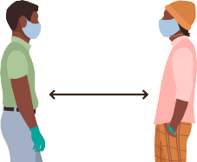
DO I STILL NEED TO WEAR A MASK?
It takes time for the vaccine to build up in your body. People are considered fully vaccinated 2 weeks after their
final shot.
Even though the vaccine helps protect you from COVID,
you might still be able to give it to others.
We are still learning how long COVID-19 vaccines can
protect people.
Until we know more, everyone should keep wearing
masks and following social distancing rules.
Doctors will tell us when it is safe to be in public without a
mask.
13
Young Leaders and Advocates Network | www.YLANetworkNY.org
Yes. Here's why:

YOU HAVE
THE POWER
#STOPTHESPREAD
Together we can protect our communities and stop the pandemic.
Get vaccinated
Wear a mask
Social distance
Wash your hands
www.YLANetworkNY.org

Your local center:

Contact your local center for resources and support navigating the pandemic and getting your vaccine.
GET SUPPORT FROM YOUR LOCAL INDEPENDENT LIVING CENTER
Your local Independent Living Centers are open and providing services during the COVID-19 pandemic.

