# From the Desk of Maura Kelley-, CPRP, Director Mental Health Peer Connection.

Mental Health Peer Connection is a member of the WNY Independent Living, Inc's family of agencies. Mental Health Peer Connection is a peer­ driven advocacy organization dedicated to facilitating self-directed growth, wellness and choice through genuine peer mentoring.

Last year, I don't think many thought much of our mission statement. But with the historic year we have had, all could probably use a little MHPC. MHPC isn't just a bunch of words put on documents to look all fancy and astute. MHPC is a living, thriving action that occurs daily at the center, in the community, and virtually. No one wants to be told what they must do, at MHPC people seek their own direction in growth, we are just the Peer guides. WE have become guides through our own hurtles into the community and barriers in life. Being a guide takes skill, finesse, active communication and attention to details. Our details.

This world has suffered like never before, and we, MHPC, have been there guiding our fellows in our small area of the world.

We have assisted several people out of the Psychiatric Center, the Behavioral Health units, group homes, or out of prison. We have found that there no longer is a separation between Jail and other institutions. Each lack freedom and self-determination. We assist people to learn how to live in the community who have been institutionalized, traumatized, and chastised. We assist with finding housing, learning everyday household skills, and navigating around one's own community. Our Peers offer support, thoughtfulness, and an ear to those with emotional issues. We also have Peers that are experts in maximizing individual's full potential while on disability or in need of essentials.

Then we do this. The ultimate choice of many individuals is to become a contributing member of society. WE assist people with gaining real employment. There are some authorities in the nation that says 80% of people with mental health issues are unemployed. At MHPC close to 40% of the people who self-directed their growth to employment obtained their goal.

These things just didn't happen because of our agency. It happened due to the dedicated Peer staff and all Staff at MHPC. All are dedicated to facilitating self-directed growth, wellness and choice themselves.

Currently it is said that Nationally that mental health issues and substance use disorders have increased 40%. MHPC makes that percentage decrease. At least it did this past year. Please come in, allow us into your community, or join virtually. Just call 716-836-0822 ext. 126.

It is with these words that I introduce the First Ever MHPC Newsletter, for the purpose of empowering peers together. Please feel free to contribute to this newsletter through your thoughts, experiences, and joys. You can do this by forwarding the article to Lisa Maria Cruz at: <lmcruz@wnyil.org>



Cathie Campbell  
*Peer Support Specialist*

# Unrealistic Expectations

Here we are, approaching the new year, all hoping 2021 will be a better year! But the closer 2021 gets the more I worry that we are embracing an unrealistic expectation which will leave us all feeling worse. When an expectation is not met, the result can be anxiety, inner turmoil, emotional instability, etc. Unrealistic expectations simply generate additional frustrations, to an already stressful life, which adds to the problem and does not help us get into the solution.

I find life to be so much better when I work on having realistic expectations and being happy despite the rollercoaster of life. When I was younger, I like so many others, hoped for better from life's situations and people. Hoped that if I got through this trial and tribulation somehow life would get better, easier, etc. Sadly, at the end of each trial and tribulation there was that unrealistic expectation adding to my problems because life will never get easier and people will always be who they are, not who I wish them to be.

One day I finally woke up and

realized I would be less frustrated if I stopped developing expectations that only resulted in me feeling worse. However, during 2020 I have had this expectation that surely next year will be better when in fact COVID-19 will still be here during 2021. I firmly believe the best expectation we could have is to accept this fact and be thankful that we know more about COVID-19 and have better procedures in place to manage this horrible situation. For me this means, focusing more on what I can do to help our world get into the solution and focus less on what I hope to happen.

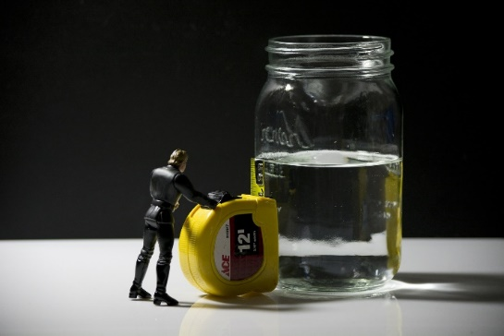

Brenda Starks

*Benefits Advisor*

# Work Incentives: Trial Work Period

Something important to know about working while receiving Social Security Disability Insurance (SSDI) benefits. The Social Security Administration (SSA) has a special rule called Work Incentives that allows an individual to work and still receive their Social Security Disability Insurance benefits.

So**,** let's start with Social Security Disability Insurance (SSDI) benefits and my most favorite Work Incentive which is the Trial Work Period (TWP) that allows an individual to test their ability to work for 9 months and still be considered disabled and "that the 9 months doesn**’**t have to be consecutive". But during the Trial work period an individual would still receive full benefits regardless of how much their earnings are. So**,** what triggers a Trial Work Period? If you earn $940 dollars in 2021 it would trigger a TWP. So, if you work in March and earn $941.00 dollars that triggers one-month Trial Work Period and if you earn $1200 dollars the next month**1** you'll have triggered another month TWP and would still receive your full Social Security Disability benefit. It's important to talk with a Benefits Advisor to get an understanding of how working would affect all your benefits.

# Cheesy Vegetable Bake

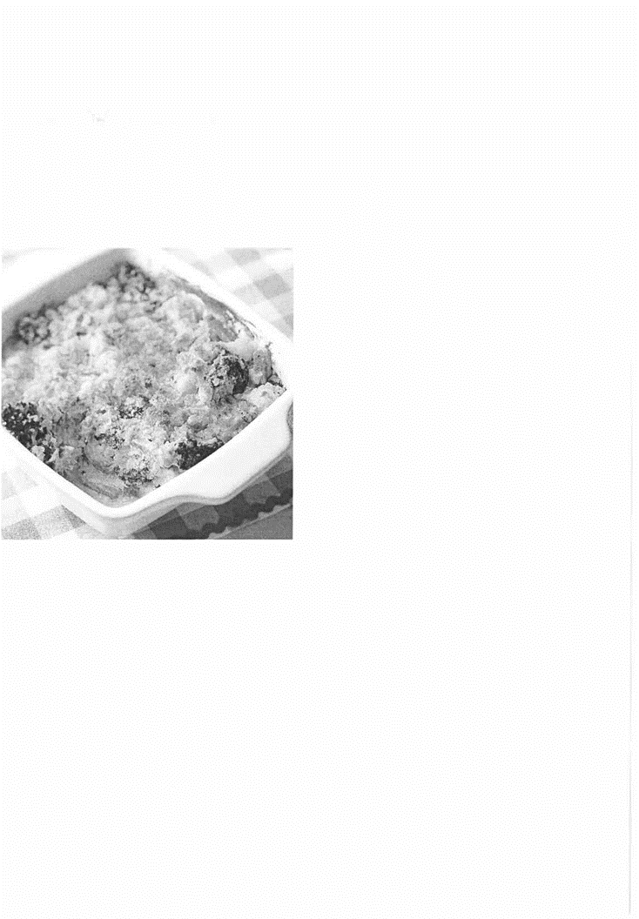This Cheesy Vegetable Bake casserole has 7 grams of protein and only 4 grams of fat per serving, making it an ideal side dish for any dinner. Using reduced-fat cheeses lowers the fat content of this recipe but does not compromise flavor.

**Recipe Summary  
Active: 30 mins  
Total: 1 hr. 20 mins  
Servings: 12**

**Ingredients**

1 Nonstick cooking spray

2 (16 ounce) packages frozen broccoli, cauliflower and carrots, thawed and rinsed

1 (12 ounce) can evaporated fat-free milk

¼ cup finely chopped onion

2 tablespoons all-purpose flour 2 cloves garlic, minced

¼ teaspoon black pepper

¾ cup shredded reduced-fat cheddar cheese (3 ounces)

½ (8 ounce) package reduced-fat cream cheese (Neufchatel), cut up and softened

2/3 cup soft whole-wheat breadcrumbs (1 slice)

2 tablespoons snipped fresh parsley and/or snipped fresh basil

**Directions**

Step 1.

Preheat oven to 350 degrees F. Coat a 2-quart square baking dish with cooking spray. Arrange thawed vegetables in the baking dish. Set aside.

Step 2.

In a medium saucepan, whisk together evaporated milk, onion, flour, garlic and pepper. Cook and stir over medium heat until thickened and bubbly. Remove from heat. Add cheddar cheese and cream cheese, whisking until melted and smooth.

Step 3.

Pour cheese mixture evenly over vegetables. Toss gently to coat vegetables with sauce. Sprinkle with breadcrumbs. Lightly coat crumbs with additional cooking spray.

Step 4.

Bake for 40 to 45 minutes or until mixture is bubbly and crumbs are lightly browned. Let stand for 5 minutes before serving. If desired, sprinkle with parsley and/or basil.

**Tip:** Thaw vegetables overnight in the refrigerator or place vegetables in a large colander. Run cool water over vegetables. Let stand for 15 minutes to drain.

**Nutrition Facts:**

**Serving Size:** 1/2 Cup

**Per Serving:**

104 calories; protein 7.1g 14% DV; carbohydrates 9.9g 3% DV; dietary fiber 2.1g 8% DV; sugars 5.6g; fat 3.8g 6% DV; saturated fat 2.3g 11% DV; cholesterol 13.2mg 4% DV; vitamin a iu 2111.3IU 42% DV; vitamin c 17.3mg 29% DV; folate 9.4mcg 2% DV; calcium 166.6mg 17%> DV; iron 0.2mg 1% DV; magnesium 13.2mg 5% DV; potassium 133.9mg 4% DV; sodium 162.7mg 7% DV.

**Exchanges:**

1 Vegetables, 1/2 Fat, 1/2 Medium-Fat Protein

# Coping with Consequences DM

I really don't know how I look in other people's eyes after all the damage I have done. From affecting family, to friends, to housing residence, it really can be hard to accept I have a real problem. There are many different rationalizations that can be made explaining my behavior, from schizoaffective to frontal lobe head injury. These in fact give a background to some of the inappropriate displays I have made. But it's really hard to accept that the person with an exaggerated temper or multiple hospitalizations is in fact me.

I could not just sit back and be satisfied by my explanation of mental illness giving me a good legitimization not to work. Most people in my shoes would take this for an answer and be happy to take what was handed to them, never to complain again. Yet something inside me saw there was more than what meets the eye in my diagnosis. I saw truths in various standpoints of my reading, from sociology, to psychology, to science. Adjusting to my new diagnosis of bipolar illness occurred in the midst of typical school years after all. Now 20 years later I still work extra hard to simply earn a vocation or a slip of paper. It seems a never-ending struggle, and I feel doomed to be forever unemployed.

At the heart of this all is the diversity of interests which never dies. This in turn affects my decision making, as well as my temperament. No solid decision has ever been made regarding my career or schooling. My life has been like the chaos of Pink Floyd's album "Saucerful of Secrets". In the end, I'm glad for my home, I'm glad for my talents, and I'm happy I have the schooling and vocational experience I do. Things could be a lot worse, and without understanding where I have come from, my life could return to where I was. With experience and with trial and error, all through the heartache, comes the understanding of how everything works out for the greater good, no matter how painful. I cannot be idle and accept my diagnosis as a defining life sentence. Rather grasping the struggle and accepting my experiences as part of me allows me to help others, and also to move on.



Lisa Maria Cruz

*MHPC Outreach Coordinator, interviewed Food Pantry Coordinator Michelle Cray, from the St. Philips Food Pantry on 15 Fernhill Ave., Buffalo, NY 14215.*

# A Community Resource for Over 30 Years: the St Philips Food Pantry

Q. *How long has the food pantry been in operation?*

A. Since May of 1990.

Q. *How many families do you serve?*

A. For the month of November 2020, we served 227 households, 3969 meals for 441 people. That has been a sharp increase since COVID-19.

Q. *What area do you serve?*  
A. 14215 zip code residents.

Q. *Have you been able to stay open since March 15th, 2020?*

A. Yes.

Q. *What were the biggest challenges you had to face to keep the doors to the food pantry open?*

A. There was no need to provide documentation and some people were being untruthful to take advantage. People could be a part of as many panties as they wanted to be. Another challenge is not having enough vegetables and cereal. Sometimes people were offended if they were told you need to step back and some of them didn't want to wear masks.

Q. *Does the food pantry have anything special planned for Christmas?*

A. We have purchased candies and put them cellophane bags and will put them in their bags. The candy must be prewrapped.

Q. *Do you have any plans for the Food Pantry in the New Year?*

A. Our intention is to stay open as long as we can. If a worker gets sick, we will definitely shut it down. Everyone would have to be quarantined.

Q. *Are you looking for any volunteers for the Food Pantry?*

A. We have enough volunteers.

Q. *Do you have any final words that you would like to add?*

A. Whenever you get a chance always donate to your food pantry. Thank you for doing what you're doing.

Kevin Smith  
*Mental Health Peer Connection Assistant Director*

# Reflections on the Status of Police Involvement with the Mentally Ill: Do we call on Satan and Expect Jesus?

As we witness nationwide protest over police interactions with American citizens, many of whom suffer with mental health issues, I can't help but think has this been a longstanding problem or has the ability for the average citizen to photograph or record these occurrences shed bright light on a crisis that's went on for far too long. I believe the latter.

Either way it is clear law enforcement's role in mental health crisis calls need to change if we expect to get people the help they desperately need and deserve.

Many agree that these encounters can result in injury or fatality for the very person in distress but go on to minimize how often it happens. What if the numbers we see and hear about are vastly higher than we know? In 2014 after an unarmed man was killed in Missouri a Washington Post investigation found that the FBI undercounted police involved fatalities by more than half. How could this be you ask? The reason being is these police encounters are reported on a voluntary basis. Many police departments across the country simply under report or do not report them at all.

I once heard a person with mental health struggles liken calling Police for help during a mental health crisis to calling on Satan and asking for someone named Jesus. Is this a fair analogy? I'm not sure but for the person who said it those feelings were real.

There was recent case involving police where they responded three times to the same home for someone in crisis. The third time resulted in a police shooting and killing the person suffering from mental health in front of his family.

How do we help people in this sort of distress? Trainings are good but in addition to training we need outcome measures. It should be mandatory that all police involved shootings be reported to the FBI for tracking. Departments must track the number of mental health calls Police attend. Create Satisfaction measurements involving community and mental health providers including peer support.

There is currently a nationwide model being used called (CIT) or Crisis Intervention Teams. The goal is to reduce arrests or police encounters with people suffering from mental illness at that same time increase the possibility of treatment if wanted. Part of the training police receive involves peers coming in and giving advice based on real life experiences in addition to peers being part of certain calls when mental health is in question ultimately giving police officers more tools and resources to do their jobs. There is no quick solution but if we continue to rely on just training to alter the attitude towards individuals suffering from mental health there is a long, long road ahead. In clear cases of negligence there must be consequences.

Naomi Taylor  
*Peer Support Specialist*

At the Renewal Center, you will be welcomed by peers. We understand what it is like to be in a tough spot and need someone to talk to. At our center, we focus on what YOU need to. We can help you find solutions to what is going on in your life- from changing professional providers, to needing to find a safe place to talk or working through the loss of a loved one.

We understand the need to be heard. So often people that are going through a crisis in their life have nowhere to go to talk things out. We find a lot of people that want to fix us but not very many that will help us to help ourselves.

Renewal CenterOne visitor writes - The Renewal Center helped me when I was in the middle of a transfer of psychiatric care. I didn't trust my new providers, so having peers to talk it through with helped me immensely. It helped me choose the right therapist and make the right decisions that worked best for me.

The Renewal Center is a very comfortable, relaxed environment. The space is set up much like a living room with couches, coffee, tea and soft music. Our goal is to support you and to help you find a way to work towards your goals.

Please come in for a visit! We encourage people to take a tour of our center, so you know what our center has to offer.

Geri Metcalfe  
*Peer Support Specialist*

# Success Story 12/2020

On January 17th, 2020, I was given a referral to contact GC. We set up an appointment for the following week and met for the first time. The consumer said he needed vocational assistance and peer support; he is a 64-year-old African American gentleman, single and living alone with an income provided through SSI. This consumer had a government phone and no basic computer skills in a world much different than he knew of in the past when he was working full time. This consumer had an aged paper resume and no knowledge on how to apply for jobs electronically. This consumer sat in the chair next to my desk and looked at me and said,

*"I need help, I have no idea how to apply for jobs. I really want to work and stay active and a little extra money will help me get things I need for myself. I live by myself in a small apartment and have no furniture and an old bed that needs replacing."*

I began working with GC weekly, we first rebuilt his resume and then set up and email and an account with Indeed Job Search Site and throughout the year we worked on a regular basis submitting resumes and filling out applications together for jobs. I always provided peer support to GC to combat the depression and delays associated with the waiting period. Finally, at the end of June GC was hired through Catalacian Center for a warehouse position. He was so happy; he began thinking about the bed that was infested with bed bugs he could finally replace, and he was anxious to begin working. I discovered GC was going to be riding a bike to work every day; I requested a 90 day bus pass through our transportation department to help him offset the cost of getting back and forth to work to help make it easier for him to travel there and back. GC was always grateful for any help he was able to receive.

I asked GC if he was open to me putting in a referral for him to get assistance in furnishing his apartment. He gave me permission and I submitted an application to "Upward Design for Life"; a free service that receives furniture donations for people in need to raise their quality of life. GC's name was put on a waiting list. On 12/12/2020 GC received a new bedroom and living room set for his apartment. He cried! Before and after pictures were taken of his apartment that I am including in this success story. GC's old bed went out to the trash and everything in his apartment is new. He is so happy and grateful for all the help he has received from Western NY Independent Living. He says working with the agency has totally changed his life.

Rafiq Salim  
*Peer Support Specialist*

# THE MENTAL HEALTH IMPACT OF THE RACE PARADIGM

**The Race Paradigm**

Europeans once believed Noah's Ark landed in the Caucasus Mountains, a mountain system at the intersection of Europe and Asia and stretching between the Black Sea and the Caspian Sea. Europeans also believed the Caucasus Mountains was the location in which the Greek god Prometheus fashioned man from clay. For Europeans, the Caucasus Mountains was, according to myth, legend and Biblical authority, the birthplace of humanity. The term Caucasian, as a racial category, was first used in Germany in the 1780s at the Gottingen School of History. Europeans believed that as the descendants of the Caucasian spread throughout the earth his skin, eyes, and hair darkened, his hair became kinky, his lips thickened, and his nose widened. Race theory divides people into classes according to observable physical characteristics. According to the theory, each race, possesses inherent qualities and degrees of intelligence suitable to their place on the hierarchy. The Caucasian, at the apex of the hierarchy, was intelligent, creative, vigorous, moral, and his light skin, blue eyes, blond hair, thin lips and narrow nose the standard of physical beauty. Africans, at the opposite end of the hierarchy, were of inferior intelligence, lacked creativity, lazy and ugly with their dark skin, wide noses and kinky hair. Asians, those closest to Europeans in skin color, were judged crafty, sneaky, sly and dishonest - intelligent but morally flawed. European science supported race theory and the measures colonists found necessary to maintain white European supremacy. The 'fact' of European superiority in intelligence and human development compelled Europeans to shoulder the "White Man's Burden" of forcefully civilizing savages through armed invasion and militia-backed government - colonialism. Anthropologists measured skull shapes, proportions and brain size as evidence of Caucasian superiority. Intelligence Quotient (I.Q.) scores were used to prove Caucasian superior intelligence. The last 'scientific' iteration of race theory was by Carleton Stevens Coon, a Professor of Anthropology at the University of Pennsylvania, lecturer and professor at Harvard University and president of the American Association of Physical Anthropologists. The belief that one's ethnic group is better than that of others, ethnocentrism, is a common phenomenon around the planet. However, the fusion of race theory with European ethnocentrism created a paradigm that shaped the way Europeans and their colonial subjects judged each other as human beings.

**A Changing World**

Hitler's brand of white supremacy shocked the European world. All of a sudden, the tenuous European 'equality' of racial superiority turned into Animal Farm: all Europeans are superior, but some Europeans are more superior than others. The death and destruction across Europe compelled European governments to rethink race. For example, Germany and France removed race from their national census. However, removing race from the census did nothing to remove the assumption of European racial superiority and racial discrimination within Europe. I remember a catechism from my youth,

If you're white, you're right.

If you're yellow, you're mellow.

If you're brown, stick around.

If you're black, get back.

And if you're red, you're dead.

To be called a color is inherently dehumanizing and insulting. 'Peoples of color' have moved beyond color to appropriate ethnic, nationalistic or geographic identifiers. Only black and white people persist.

**The Nail in the Coffin: The Human Genome Project**

The Human Genome Project (HGP) was one of the great feats of exploration in history. [T]he HGP was an inward voyage of discovery led by an international team of researchers looking to sequence and map all of the genes -- together known as the genome -- of members of our species, Homo sapiens. Beginning on October 1, 1990 and completed in April 2003, the HGP gave us the ability, for the first time, to read nature's complete genetic blueprint for building a human being. - National Human Genome Research Institute.

The findings and implications of the Human Genome Project sounded the death knell for the racial paradigm.

1. Human beings, Homo Sapiens, are one species.
2. All humans descend from Africa.
3. Humans share 99.9% of genes.
4. The percentage of genes that account for the physical variations among humans - eye color, skin color, hair color/texture as well as presence or absence of Neanderthal DNA - have no influence on intelligence or human potential.

Today, most governments have abandoned race as a meaningful way of classifying humans and no reputable scientist supports race theory. Race theory today is considered pseudo-science and oxymoronically as racist.

Race is a social construct, not a fact. Race is the way people have learned to think and talk about themselves, even when they say, "I don't believe in race." Consequently, people escaping racialized identities experience anxiety when inexorably dragged to THE QUESTION, "If not white or black, then who am I?"

**Mental Health and Race Theory**

Race theory promotes the idea that we are humanly different - not unique. Race theory demands we form unspoken judgements about intelligence, leadership, temperament and integrity based on what we now know to be irrelevant physical characteristics. We have been acculturated within the race paradigm, experience ourselves consistent with our social development, and cannot immediately think or believe our way out of it.

Personal identity is inextricably tied to mental health and living within racialized identities distorts self-perception. Black and white people do not escape the connotations of being black or being white. To be 'black' or 'white' is to consciously reject the denotations, connotations and racialized meanings of black and white, or to unconsciously absorb those meanings. What are the mental health consequences of fighting or not fighting to experience oneself as humanly equal when interacting with whites? To be black is to experience microaggressions from those that have drunk the poison of race. What are the mental health consequences of letting personal insults pass, "choosing one's battles," or not recognizing a microaggression? To be white is to arrogate to oneself an illusion of 'better,' a delusion that nurtures microaggressions against non-whites. To be white is to feel under attack by "others" who, through "reverse racism," want to take away "their" privileges. What are the mental health consequences of feeling a need to constantly prove one is not racist? Or the inverse, fear of calling out racist behavior from a relative position of powerlessness? We live in a dangerously racialized society unaware of the paradigm shift occurring around us.

**Advocacy for Tomorrow**

As an Independent Living Center, we are presented with a personal and systems advocacy moment. We can, individually, choose to step beyond racialized identities and brave the anxiety of self-reflection. We can choose to identify as citizens of a nation, land, continent and/or ethnic group. As an agency, we can advocate that the federal government remove all racial and color designations from demographics, an Executive Policy decision of the President of the United States of America. Today. This, in my humble opinion, could be the first step in a long arduous journey of national human recovery that will likely span generations.



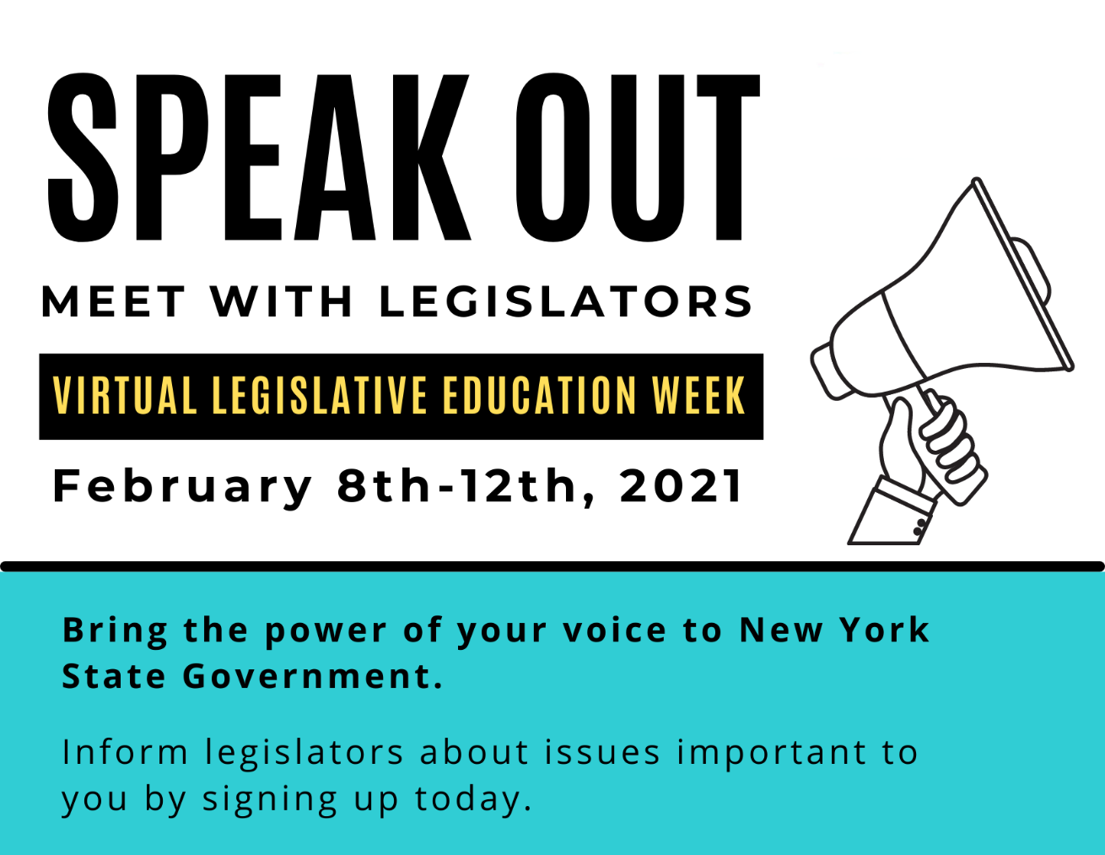

**NYAIL Virtual Legislative Education Week**

**February 8 – 12, 2021**

With the legislative session started, now is the best time to start reaching out to schedule meetings during the week of February 8.

**For more information or to sign up, contact Jillian Moss:**

**716-836-0822 ext. 146,** [**jmoss@wnyil.org**](jmoss@wnyil.org)