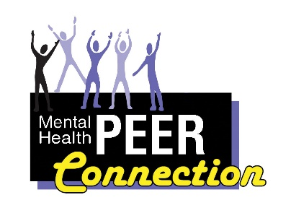Mental Health PEER Connection 8th Edition

Giving Ourselves the Gift of Gratitude
Annie O’Neil, Administrative Assistant

The definition of gratitude is the quality of being thankful; readiness to show appreciation for, and to return, kindness according to Oxford Languages (Oxford University Press). In life, when we are grateful to others, we say “thank you” or find other ways to show our gratitude. How often do we thank ourselves? Do we look in the mirror anytime of the day and say thank you? Many may think, “well, that’s absurd”. But is it?
Through recent years there has been an increase in the “Self-Love” movement. A part of that movement is showing oneself gratitude through self-love. Every day we complete should end with some form of gratitude. Every day is a battle for most people, even if it doesn’t seem like it. It can be hard to get out of bed. You could be fighting an addiction or just trying to better yourself. The fact that you make it through any obstacle in your life should be reason enough to pat yourself on the back and show yourself a little gratitude.
Showing yourself gratitude can be done in so many ways and those ways depend on the individual. You might be someone who likes flowers, so why not treat yourself to a beautiful bouquet? You might like the salon, so make yourself an appointment. It could be a spa day getting a facial, manicure or even a pedicure. You might be an avid reader, so get yourself a new book you’ve been wanting to read. If you are financially stable, then book a vacation. That is an awesome way of showing yourself gratitude after a year of working, school, being a parent or just living life, period.
No matter what, it’s imperative to show yourself some gratitude. We often expect it from others and sometimes it hurts us when we don’t get it. Remember that no one loves you more than you. Treat yourself the way you want to be treated. That is where you will start, and other people will follow suit. You just set a standard for yourself. Make self-gratitude a priority and I guarantee you will feel, and start to see, a change in who you are. It is never easy to do something for ourselves, especially in these hard times.
If you lack funds, think of some things that you like that are inexpensive. I like new clothes, so I use what I have at home as an artist and turn something old into something new. I can’t always go to the salon, so I will give myself a new hairstyle. Spa day? I will make a spa day at home with what I have. I have brought myself new journals from the dollar store and even some things to have a spa day at home. You are #1, and with that being said, remember you too deserve “Gratitude”.

Giving yourself the gift of gratitude
Denise Munir, Peer Support Specialist

When I think about gratitude, I am reminded of how important it is to recognize what it takes to truly give to others. In all your giving, it is important to give yourself the same gratitude you give to others, and even prepare to give to others on a larger scale. Giving is necessary, as well as caring for others. I can’t think of anyone that does not need care and appreciation.
There are some that may not want it or may even refuse it, but it does not mean they don’t need it. Extending kindness may not always be easy because others have been hurt, they may not even receive it at times. So, having that gift to truly care for others takes patience, diligence and even determination. That simply means that you will be able to reach others even when they don’t want it, but they still need it.
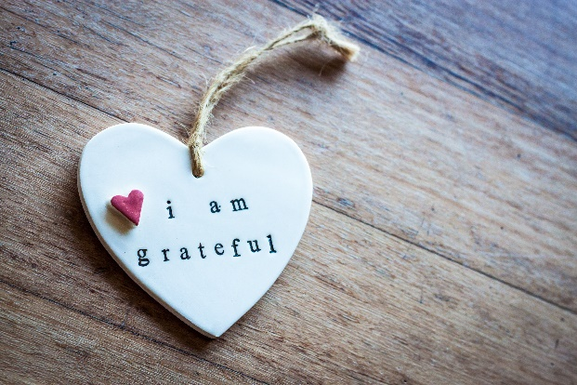
I had a friend once who was very distant and no matter how much I reached out she would not reach back to me. But I was determined to remind her from time to time that I loved her, and I am there for her. It was not overnight, and it took time for her to really understand that I was not going anywhere, because I knew she needed care and a true friend. The time I took was truly worth it. I became so consumed in giving her care that I didn’t realize how much I would truly need her. Today we are the best of friends, and we can tell each other anything and there is a true divine friendship where we lift each other up, as well as show each other appreciation. That’s what it truly means to give yourself the gift of gratitude.

I Choose to Give Myself the Gift of Gratitude
Lisa Maria Cruz, MHPC Outreach Coordinator

Giving ourselves the gift of gratitude can have a profound impact on our lives. Gratitude can definitely shift our perspective. Five years ago, I was diagnosed with breast cancer. When that happened to me, I made the determination to myself that I was not going to let the cancer take my happiness away. One day of life is more valuable than all the treasures in the universe.
I went for treatment at Roswell Park Cancer Institute. I underwent surgery and radiation there. After I successfully completed all that, I happily rung the bell in the Roswell Lobby. Patients who successfully undergo treatment ring this bell afterwards. I guess it’s just a little tradition. I was happy to participate. My husband was there to see me ring that bell. Honestly, I think that my illness was much harder on him than it was on me.
My parents came to Buffalo to support me during my surgery. My dad was especially surprised at how I was taking things. He said to my friend Cristina, “She’s so strong!” I did have a lot of support from family and friends. My aunt Wanda came to visit me from Rochester with our cousin Joli. We spent the day together and I was very appreciative of their support.
My Buddhist community gave me a lot of support as well. Many of my friends came to visit me in the hospital. I was very thankful. My parents were so happy to see that I had made so many friends in Buffalo. I have been practicing Nichiren Buddhism with the Soka Gakkai International-USA (SGI-USA) for twenty-two years. It’s my longest relationship. Even longer than I have been married. I was very grateful that I had my faith to rely on. Chanting Nam Myoho Renge Kyo has seen me through the vicissitudes of life.
I remember that after my surgery, I went to a support group. It turned out to be not so great. Listening to the other women share, I felt so out of place. Truth be told, I felt like an alien and like I didn’t belong. I could not relate to what they were saying. The other women were so unhappy and saw themselves as tragic victims of fate and I could not relate. Inside I felt very joyful. I was thankful to all the medical providers who were involved in my treatment. They literally saved my life. I did not see myself as a victim. I was thankful for all the compassionate care I received. I didn’t feel bitter. I felt jubilance. I left that support group and didn’t go back. I didn’t need to go to a support group that made me feel worse.
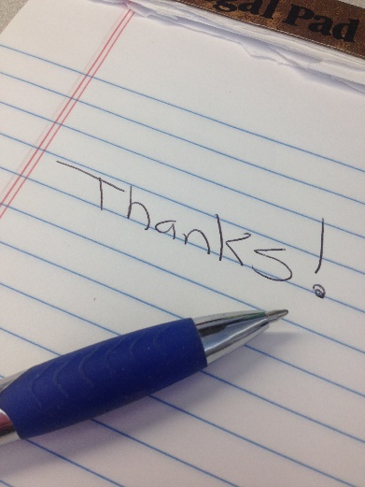
The funny thing is that, while I have gotten older while practicing Nichiren Buddhism, I have actually felt younger as I have aged. Today, at 53 years of age, I feel younger than I did at thirty. I remember that when I turned thirty, I actually felt down and like my youth had disappeared. I may be in my fifties, but I am not “old”, and I don’t see myself that way!! I have a very youthful spirit and I know that I am young at heart. I also feel that it’s never too late to go after your dreams. I will not let fear get in the way of my goals. I am so grateful that I have been able to practice with the SGI-USA for the past twenty-two years. It has given me a solid foundation to rely on as I navigate through life and for that I am eternally grateful!!

In the Moment
Brett Dunbar, Peer Specialist

I think I should start with why this groups is called “In the Moment”. It is a group focused on something known as “Mindfulness”. Mindfulness is a state of mental clarity in which a person achieves complete awareness of the present moment while accepting one’s own feelings, thoughts, and bodily feelings. Mindfulness can be a powerful tool for anyone, but I think it is especially important for those who are struggling with mental health. I think everyone from time to time has distracting thoughts and sometimes those distracting thoughts can be potent enough to take us out of our surroundings and put us inside our own heads.
I have a lot of experience with distracting thoughts because I, like many other people, deal with a mental illness. Another category of Mental Illness exists too that I also deal with, and we call it Substance Use Disorder or SUD. Mindfulness is one of the most powerful tools to help mitigate and manage symptoms from a SUD or a Mental Illness. I find myself thinking about drinking alcohol a lot and then I use a set of techniques in my daily life to focus on the present moment. This helps me not think about alcohol and I also find it is useful for when I am feeling sad.
“In the Moment” is a group focused on helping people understand how to use Mindfulness and promote the use of it as a useful Tool to help manage distracting thoughts. Another goal of “In the Moment” is to explore the link between Substance Use Disorder and mental health because, in my own experience, they are effectively the same thing and can cause similar symptoms.

Let’s Talk
Brooks Price, Peer Support Specialist

The group that I’m facilitating is called ‘Let’s Talk,’ a male focused mental health support group. The group is scheduled every Thursday at 1:30 PM to 2:30 PM at the Buffalo City Mission. A joint effort between Mental Health PEER Connection (Western New York Independent Living) and Buffalo City Mission -- The group is a part of the City Mission education curriculum and is currently only available to the residents of the City Mission.
For the past several years or so, there has been a rise in interest in men’s mental health. With this increased interest and awareness, there has been a recognition of the need for more resources concerning men’s mental health. In acknowledging this, many have begun to take action towards providing arenas for men to discuss, share, and support each other on their journey to recovery. ‘Let’s Talk’ is a response to this growing need. An all-encompassing support group designed to cultivate open dialogue related to specific issues concerning men, ‘Let’s Talk’ is an inclusive, supportive and non-judgmental space.
‘Let’s Talk’ has proven to be a source of relief and hope for many of the attendees. Many of the men who make their way to the group have just recently been released from incarceration. Without an outlet to discuss their pain, the men often spoke of the intense belief that they would return to ‘their old ways.’ ‘Let’s Talk’ has been very beneficial to these individuals as they have found support amongst others who also find themselves in similar circumstances. Their shared experience has led to support and a sense of purpose – Guiding them towards a path of renewal and personal success.

Loan Closet
Cathy DeMare, Administrative Assistant

Independent Living of the Genesee Region offers a Loan Closet filled with gently-used durable medical equipment. Residents of the Genesee, Orleans and Wyoming counties can borrow items such as commodes, canes, raised toilet seats, walkers, rollators, wheelchairs, shower chairs/benches, knee scooters, crutches and even some incontinent supplies. These items assist our consumers while they recover from illnesses, injuries and surgeries without the added expense of purchasing equipment that they will only need for a short time.
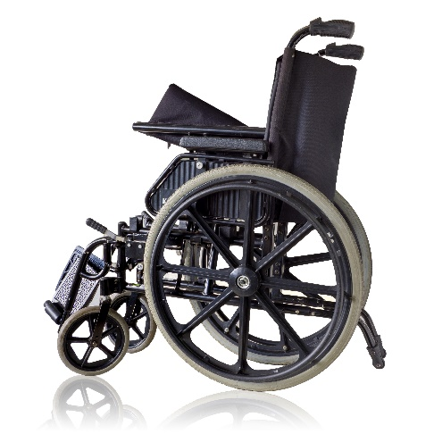
Our Loan Closet has also become a valuable resource for area occupational and physical therapists who are working with people, so they may remain in their homes and still get the therapies they need.
All our items have been donated by the community and can be borrowed for up to 3 months at no charge. Please call ahead for availability Monday – Friday 8:30 AM - 5 PM at (585) 815-8501, ext. 400.

A Listener’s Morning

Alarm’s ringing!!! Ok, ok…Waking up. Another restful night but boy, those were some scary dreams again, seemed so real! Another day out there…feels kind of warm…I hear a slight breeze…birds are sure awake! That faucet’s still dripping in the bathroom. Coffee sure smells good! Hope I can find that creamer.
Time to listen to the Newspaper! Sure doesn’t sound good in Europe right now but thank God for the Bills and Sabres! Gosh, I remember when I could see; when they had Kelly and Thurman, the French Connection, and all those guys. I can still picture them all. I wonder if their uniforms today still look as good as they did.
OK, coffee and news time! I don’t know what I’d do without this reading-radio. The folks at the Niagara Frontier Radio Reading Service are wonderful! I’ve never met them in person, but I sure know them! They’ve been my best friends for years. Can’t imagine life without them…hearing about the world; our hometown; all those wonderful books they read to us; even the weekend shopping ads and, unfortunately, but necessary, the obituaries. From the day my daughter surprised me with this wonderful new ‘friend,’ I’ve felt so much more alive!
I AM part of this world! I DO care about what’s going on ‘out there!’ OF COURSE I love a good book! Just because I’m blind doesn’t mean I don’t care about the same things you do!
Before I had radio reading, I was beyond lonely and, most probably, looking back on those days, depressed. My family and friends always seemed to have such great conversations about their lives and the world around them. I was uncomfortable. I didn’t know very much of which they spoke. They thought I was just a quiet person, but they didn’t know I was embarrassed not knowing very much about what they were talking about.
Now, I’m not only part of those talks, I can start them up! They’ve all remarked on how much happier and more awake I seem now. They even think I look better!
Can you believe listening to a simple radio can do so much for a life? I don’t even feel so blind anymore! It’s hard to explain but a huge part of my world that was missing – was dark – is back! I don’t even want to stay home alone as much as I did.
I always felt so different around others. Not just because they were sighted, but because they knew more than me…they must have been smarter than me… So sad then, so much better now!
My wish for everyone that has trouble reading, for any reason, is that the Niagara Frontier Radio Reading Service becomes their new best friend! They’ll even bring it right to your house! Just ask!
And, oh yeah, I found out recently you can now hear them on the internet…you don’t even need one of their special radios unless you want one. They’re all over!
I am worried about the future though. I heard they really need financial help to keep going. If more people only knew how much they mean to us Listeners… I’m telling as many people as I can about them! Anyway, time for my coffee and my news. Hey! There’s that creamer…right next to my radio!!!
You can help our friend above, and the other tens of thousands of Western and Central New York residents that can’t read, to rest assured of continued service from the Niagara Frontier Radio Reading Service. We don’t charge for what we do, and we keep our expenses as low as possible. It costs money, however, to operate a studio, maintain broadcasting equipment, provide special radios, manage our wonderful volunteers, and spread the word throughout Western and Central New York; all with just four staff members!
Please consider a tax-deductible contribution. It only costs $115 to provide service for one listener for a whole year! It could be you or a loved one someday. Why not sponsor one of them now? None of us knows what the future holds.
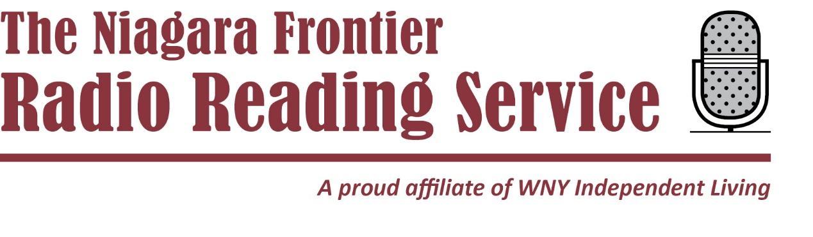

Reading and Writing for Empowerment
David Meyers, Contributing Writer

Storytellers have an innate capacity to weave unrelated events together into a compelling narrative. Stories help readers cope with life and put meaning to randomness. Since Unrelated events happen one after another for everyone, reading stories eases stress. Events in a plot line are relatable. In contrast, it is a challenge to find a coherent narrative in real life.
Society at Large is disorienting. The news or textbooks provide an empirical understanding to the world, but only the imagination can make sense of its complexity. Chaos in the world can seem less apparent through the liveliness in stories.
Likewise, journaling helps one discover their unique perspective, and helps to improve memory of events throughout the day. Events and thoughts are connected through the act of writing their correlation across time. Reading and writing help to process emotion. As a result, compassion for one’s self and empathy for others are nurtured.
Another benefit of reading stories is flexibility: “Stories that are personal and emotionally compelling engage more of the brain, and thus are better remembered, than simply stating a set of facts.”
https://greatergood.berkeley.edu/article/item/how_stories_change_brain#:~:text=Stories%20bring%20brains%20together,or%20safe%2C%20friend%20or%20foe.
Effectively, writing or reading stories build cognition. Also, character is grown from expressing one’s own unique voice. It builds resilience to pay attention to subtleties of personal development in stories. Narrative writing allows one to develop their personal story. The benefits gained from owning one’s story can be shared with others, providing them also with strength.
In sum, laying out events with story writing or journaling lead to familiarity with the self and a more independent mind set. It builds tools to lead a life with more ease and satisfaction.
Virtual Support Groups
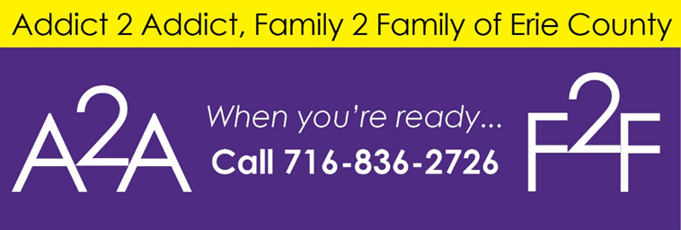

A Journey to Healing, Wednesdays, 1:00 – 2:00 p.m. Eddylees Guzman, 716-836-0822, ext. 164 or email at eguzman@wnyil.org - contact to register. We will bring awareness, education, and support surrounding addiction to families who are struggling with a loved one’s addiction. Participants will learn how to set healthy boundaries, learn the stages of grief & loss, model coping skills, and the importance of self-care.
Positive Perspective, Wednesdays, 1:00 – 2:00 p.m. Terrence Lockett, 716-836-0822, ext. 132 or email at tlockett@wnyil.org - contact to register. How do we change our thinking? Let’s find the positive in this very negative world!
Building Foundations of Recovery, Wednesdays, 3:00 – 4:00 p.m. Addict 2 Addict & Family 2 Family Peer Support Group Eddylees Guzman, 716-836-0822, ext. 164 or email at eguzman@wnyil.org - contact to register. This is an all-inclusive group supporting multiple pathways of recovery to educate individuals of the resources available to help them develop a strong foundation to their recovery.
Hand & Hand, Thursdays, 1:00 – 2:00 p.m. Ashanti Brown, 716-836-0822, ext. 160 or email at ashbrown@wnyil.org - contact to register. Reaching out to the community with a trauma and support group.
In the Moment, 1st and 3rd Thursdays, 3:00 – 4:00 p.m. Brett Dunbar, 716-836-0822, ext. 509 or email at bdunbar@wnyil.org - contact to register. My group is focused on using mindfulness techniques to acknowledge and redirect intrusive thinking. This can be used in everyday life and can be very helpful for people who are dealing with a mental illness or a substance use dependence.
Virtual Open Mic: Freedom of Expression, starting on Sept. 1, 2022, 1st and 3rd Thursdays, 4:30 – 5:30 p.m. Lisa Maria Cruz, 716-836-0822, ext. 520 or email at lmcruz@wnyil.org - contact to register. People can freely express themselves through spoken word, singing, playing musical instruments, theater, dance and comedy.
Walk with Me, Addict 2 Addict, Family 2 Family Peer Support Group, Fridays, 3:00 – 4:30 p.m. Eddylees Guzman, 716-836-0822, ext. 164 or email at eguzman@wnyil.org - contact to register. We will meet with individuals with Substance Use Disorder (SUD) and their family members to discuss effective communication, conflict resolution, trust building, co-dependency recovery and coping skills.

In-Person Support Groups
Hope Heals Family Support Group, Tuesdays, 12:00 – 1:30 p.m. Sparks of Hope, 107 Main St, Hamburg, NY 14075. Alan Tomaski, atomaski@wnyil.org or 716-931-0380 to register. Please wear a face covering for the duration of the group. As family members, our pain grows as we watch our loved ones suffering from substance abuse. The confusion on how to help can be overwhelming. Anger and fear become a part of our everyday lives.
In-Person SMART Recovery, Thursdays, 12:30 – 1:30 p.m. Revive Wesleyan of Hamburg, 4999 McKinley Parkway, Hamburg, NY 14075. Alan Tomaski, atomaski@wnyil.org or 716-931-0380 to register. Please wear a face covering for the duration of the group. (Room is open 30 minutes before and after group.) Our goal is to help individuals gain independence from addictive behavior and lead meaningful and satisfying lives.
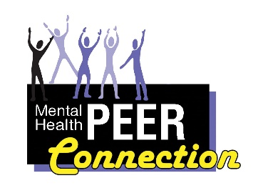
Healing Families, every other Friday starting on Oct. 22, 2021,
1:00 – 2:30 p.m. Rural Outreach Center, 730 Olean Road, East Aurora, 14052. Alan Tomaski, atomaski@wnyil.org or 716-931-0380 to register. Please wear a face covering for the duration of the group. Come join us for our peer family support group. We can help rebuild our lives after the devastation of substance use in our homes.
Wellness for All Group, every other Friday starting on Jul. 1, 2022, 3:00 to 5:00 p.m. Amity Club, 340 Military Road, Buffalo, NY 14207.
Randy Oaks, 836-0822 ext. 182 or roaks@wnyil.org to register. Peer support group for socializing. A pool table, dart board and television are available. Drinks and snacks can be purchased on site.
Support Group Sponsored by Depression and Bipolar Support Alliance (DBSA)
Depression, Anxiety, OCD and Bipolar Support Group, Mondays, 6:00 – 8:00 p.m. Western New York Independent Living, 3108 Main Street, Buffalo, NY 14214. Marie Therese Kersten, 716-435-0238 or jmtdkersten@yahoo.com. Open to anyone with any mental health challenge. Please call before attending for the first time.
An important note about the RSVP process and privacy: To maintain your privacy, we do not publicly share the phone numbers and links to our virtual meetings. We will respect people’s wishes to remain anonymous.

Un poco de español para principiantes
A little Spanish for beginners
Lisa Maria Cruz, MHPC Outreach Coordinator
Vamos a tener una lección pequeña en cada boletin informativo. Porque todo el mundo puede hablar el español!
We are going to have a small lesson in each Newsletter. Because everyone can speak Spanish.
Bienvenido! Welcome!
Me llamo Lisa Maria Cruz. My name is Lisa Maria Cruz.
¿Cómo se llama? What is your name?
¿Como está usted? How are you?
¿En que puedo servirle? How may I help you?
¿Qué hora es? What time is it?
¡Hasta luego! See you later!
*Note when meeting someone for the first time it is probably safest to use “usted”. But there is some variability with each individual. If you don’t know, just ask, ¿Puedo tutearle? May I use “tu” with you? If they say no, don’t be offended. It’s best to respect people’s boundaries.

Virtual Open Mic: Freedom of Expression Returns
Lisa Maria Cruz, MHPC Outreach Coordinator

Hello MHPC, WNYIL and community members; thank you for reading the MHPC Quarterly Newsletter. I just wanted to let everyone know that the Virtual Open Mic has returned. I needed to take a time out to do self-care. I work for the Mental Health PEER Connection and we need to be able to practice self-care so that we can better meet the needs of our consumers. You can’t support others if your own mental state is suffering.
Working is good for me. It provides me with structure and a purpose. I love working for the Mental Health PEER Connection. I have been here for over five years. I love my job and have no plans of being anywhere else. I needed to make an adjustment in our support group schedule. I hope that everyone is okay with that and that you can continue attending this group.
Thanks so much for everyone who has supported our group in the past. We met every Thursday night from 7:00 to 8:00 p.m. for a few years. I hope to see everyone here every 1st and 3rd Thursday from 4:30 to 5:30 p.m. You are always welcome to join us. We are a safe and friendly space, and anyone can feel free to attend.
Whether you have been an artist all your life or have recently started performing, this is your space. We welcome singing, playing musical instruments, and spoken word art; comedians, actors and dancers are also invited to join us. Whatever your craft is, you are welcome to perform. If you would like to observe for a while, that’s fine. I know that sometimes some artists may be a little shy to share their work and that’s okay too.
If you are interested in attending our virtual open mic, please feel free to reach out to me. My email is lmcruz@wnyil.org. If you would like to speak to me personally you can reach me at (716) 836-0822, extension 520. Thanks so much for your patience as I was getting myself back together. I appreciate all of you and hope to hear from you soon. Everyone is welcome at our Virtual Open Mic: Freedom of Expression!
Eggplant Lasagna
by LENA ABRAHAM
MAY 19, 2022
This Eggplant Lasagna Is Cheesy Bliss
by Delish US
This hearty dinner clocks in somewhere between lasagna and eggplant parm, and we think it may just be better than both? Okay, okay they are all great, but we love the incredible layers of tender eggplant in this recipe. It is comforting and is great for a crowd. It's also a perfect recipe to add to your Meatless Monday rotation.
Though you might be tempted to skip salting the eggplant as described in step 2, this actually helps leach out some excess moisture from the lasagna and keeps the final dish from getting too watery. Also, making sure to let the lasagna cool for at least 10 minutes, will help it to set. Leftovers will last up to 5 days and are best reheated in the oven at 400°.

YIELDS: 4
PREP TIME: 0 HOURS 25 MINS
TOTAL TIME: 1 HOUR 40 MINS

INGREDIENTS
2 medium eggplants, about 6" to 8" long
kosher salt
1 tbsp. extra-virgin olive oil
3 cloves garlic, minced
1 yellow onion
2 tsp. dried oregano
Freshly ground black pepper
1 25-oz. jar marinara
16 oz. whole milk ricotta
1/2 c. freshly grated Parmesan
1 large egg
1/4 c. chopped fresh parsley, plus more for garnish
4 c. shredded mozzarella

DIRECTIONS
- Preheat oven to 400°.
- Cut ends of eggplants and slice thinly, about 1/4” thick. Lay slices on a cooling rack and season with salt. Let sit for 20 minutes. Pat salted sides with paper towel. Flip, season again, and let sit for another 20 minutes. Pat dry with paper towel.
- In a large skillet over medium heat, heat oil. Sauté garlic for 1 minute, then add onions and oregano. Season with salt and pepper and cook until onions are translucent. Add marinara and cook until warmed through.
- In a medium bowl, combine ricotta, Parmesan, egg and parsley. Season with salt and pepper.
- In a 9"-x-13" casserole dish, spread a thin layer of marinara sauce, a single layer of eggplant “noodles", a layer of ricotta mixture, then a layer of mozzarella; repeat layers. Top last layer of eggplant with marinara sauce, mozzarella, and Parmesan.
- Cover with foil and bake for 35 minutes. If desired, remove foil and broil until golden on top, 1 to 2 minutes. Let cool 10 minutes, then garnish with parsley and serve.

