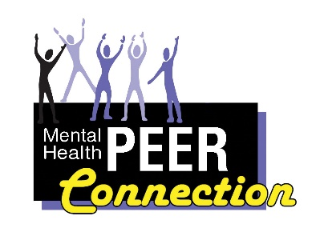Mental Health PEER Connection 4th Edition
“What Wellness Means to Me’”
Kevin Smith, MHPC Director
I remember some very stressful times in my life before being introduced to peer support and all its benefits. This was back when my perceived normal did not include the importance of developing good coping skills, wellness tools and a support system. There are so many people who are struggling to overcome personal challenges related to mental health, addiction or stigma which are all major factors diminishing or impeding our ability to live healthy productive lives.

Today not only do I work actively on maintaining my own wellness but welcome the opportunity to assist people in our community to do the same. Wellness is about developing and maintaining the skills that promote recovery and wellbeing. Wellness is about balancing a combination of spiritual, emotional, physical and mental health. Wellness for me wasn’t individual.

Important parts of wellness for me have been and continues to be working, boating, spending time with friends and family (not always blood related) and participating in the community around me and being okay with the things I had no control over.
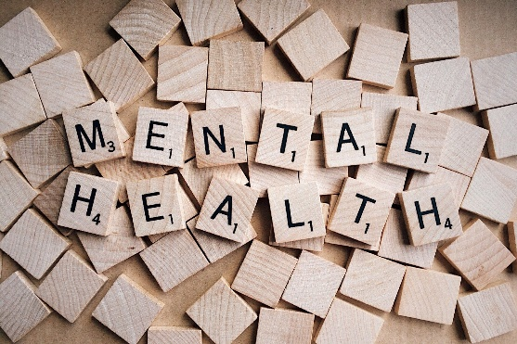
So, as I actively work towards staying well, I hope to continue being part of others’ wellness by helping them to rise above whatever challenges are standing in their way and like myself help then to become a priority in their own lives.

Saving Lives Through Telehealth
By David Meyers
Recalling that suicide prevention week was September 5-11, 2021, it is of utmost importance to specify the need for mental health support lines. The sole presence of a help line can make the difference between life and death. Additionally, the presence of support lines, crisis or otherwise, can save the government loads of money by preventing hospital stays and emergency room visits.
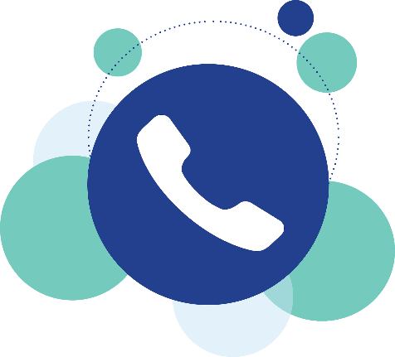
This is important to note in New York State, where funding for support lines has decreased in the face of fewer COVID restrictions. I believe however that the pandemic should have highlighted the need for substantial mental health services even as infection rates decrease.
Mental health is a big concern for everyone, as even the Olympics has highlighted recently. However, does this exposure mean that services will be more available to those who need it most?
In my own experience I had a hard time finding appropriate help for my condition of schizoaffective. Lack of services appropriate for my condition and experiences led to an avalanche of self-destructive thoughts and behavior. This culminated in two physically devastating suicide attempts, and over a year navigating between the county and state hospitals.
This situation could have been prevented by three circumstances 1) one on one therapy more specific to my mental health condition 2) a more pronounced presence of effective phone help lines 3) a more trauma centered approach in residential services for mental health.
At the top of this list however is the need for appropriate phone lines. Peer lines and warm lines were created to divert calls from crisis services and make the experience more person centered.
It is important for there to be both crisis lines and warm lines, since presentation of symptoms go across a wide spectrum. It can be hard asking for help at all, so this makes trained, sensitive counselors necessary in crisis calls. Availability of services depends on the state of residence, and the presence of Medicaid based supports. Greater awareness and education about mental illnesses has the potential to increase funding for Medicaid based mental health services. This is because people can have empathy for the debilitating nature of severe mental illnesses such as schizophrenia which require expensive and intense services.
Acts of violence against both self and others will be prevented with a more robust phone counseling system. National and state systems of both warm lines and crisis lines should be prevalent to help assist people with mental illnesses like schizophrenia and bipolar from suicide, acts of violence, and eviction.
Important data on suicides in the United States in 2019 can be found at https://www.nimh.nih.gov/health/statistics/suicide

Chanting Daily Keeps Me Happy!
Lisa Maria Cruz, MHPC Outreach Coordinator
I have been practicing Nichiren Buddhism with the Soka Gakkai International-USA for the past 20 years. The central part of our practice is chanting Nam Myoho Renge Kyo each morning and evening. This mantra means devotion to the mystic law of cause and effect through sound vibration. It’s how I start and end my days. I’m very grateful for my practice. It’s the longest relationship that I have ever had. It’s even longer than I’ve been married which is 19 years.
My friend Gordon introduced me to the practice when I was living in Rochester 20 years ago. We met at a local bar and he introduced me to Nichiren Buddhism as we played pool. He was very supportive of my practice. He would often call me to check in to see if I had chanted that day. At the time, I found his phone calls annoying, but years later I have come to appreciate his early support.
I feel great after I am able to chant abundantly in the morning. I find that me days go better and that I am more in rhythm with the universe when I get in a good chant. My family is very supportive of my practice. I chant for the happiness of my family members every single day. I also chant for the happiness of other people I care about.
I love going to Buddhist meetings. I’m very connected to our local Buddhist community. Right now, all our meetings are virtual through zoom. I’m looking forward to the day when we will be able to meet in person again. I miss chanting with my friends.
If you find that you are struggling or suffering, I would encourage you to give chanting a try. It has had a transformative affect on my life. I know that I am definitely in a much better place, than I would have been without my practice. Chanting Nam Myoho Renge Kyo keeps me happy and bright!

How to start getting in shape
By Michelle Wnek
Engagement & Outreach Coordinator for the Renewal Center.
Whether your clothes are a bit tighter, or you just want to feel healthier and better, you can get in shape. The hard part is following through. I had gained some “COVID weight” and decided to do something about it. Establishing new habits isn’t easy, but it is worth it.
I became committed to getting up early and working out for about an hour. It is great for stress, and I feel good. You can do it at any time, and at your own pace. Whether it is at a gym, or at home, it is the start of a healthy lifestyle.
The same thing goes for revamping eating habits. Set realistic goals. I saw a dietitian for a while, and she started me on a healthy diet. Don’t set a rule such as “no sweets.” We are not likely to succeed at something like that. Choose healthy foods, protein, vegetables, fruits, and we all need carbohydrates for energy. Fad diets can be pretty ineffective and can even slow down your metabolism. Eat enough, but not too little.
Becoming healthy can be slow, so be patient. Set small, attainable goals, for example, committing to 30 minutes of physical activity or walking three times a week. It really helps to find a workout that you love. There are many types of workout classes now, such as yoga, Pilates, spin, dance, using different equipment, or a sport. Then you will be excited to do it!

Health and Wellness Week
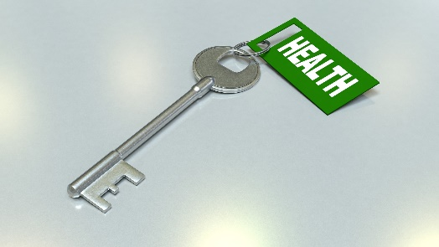
Reah Brown, Certified Benefits Advisor

Before the pandemic, I ate pretty healthy. I walked a lot. During the time I had to work from home, I didn’t really continue my healthy habits, and I think being isolated also helped that to occur. I didn’t make healthy choices which put my mental health in jeopardy. I made excuses for not doing anything. Today after returning to work in person, I embraced the actions to return to eating healthy again. Having co-workers around in person, helps me to stay focused on keeping well. What I mean by that is I don’t have as many mental health related issues as I did during the lock down. I try to exercise and go hiking with my daughter, too.

First Person
Glenn S. Goldman, First Person Founder & Owner
In life, people either take the high road or the low road, in determining one’s destiny and outcome. By taking the high road, one is happier and has a more optimistic view of themselves and the world around them. On the other hand, the low road usually means sadness and a more pessimistic view of themselves and the world around them.
I have been dealing with a mental illness all of my life and have traveled the high and low roads (mostly by myself). Being alone has been difficult at times. There was a period in my life, where the only people who listened to me and were on my side, were my therapist, my psychiatrist, and my doctors. Nobody in my family wanted to deal with me or my problems, either because they did not know how to, or they were not interested because they were dealing with their own problems.
In today’s world, most people I run into contact with are empathetic to me and my illness. I still run across people who do not understand or get it, that I am different. This used to bother me, however as the years went by, I discovered that is was not a “me” problem; rather, it was a “them” problem. You see, the people in your life that care about you and have a vested interest in you, they understand you. The others, they do not understand.
I wish I had a magic wand to resolve this issue. Unfortunately, there is no perfect solution. Problems such as this, have been going on in the world since the beginning of time. My advice do not turn into a person that you do not want to turn into. In other words, be the person that you want to be. If you allow other people to tell you how to live and what to eat as examples, then you are living your life through their eyes.
If you are unhappy with your life, take the initiative and make the necessary changes within reason to be happy. For the first 45 years of my life, I was not happy with my life, and I had no direction. Then one day, I decided to go for therapy to improve the quality of my life. After several sessions, I am happy to report that today, I am happy….I am a mental health advocate and enjoy sharing my life experience, to inspire and help improve the lives of others.
Therapy might not be for you. However, it is important to express your feelings and thoughts and not keep things bottled up inside. That is not good for your body because it could do harm to your body, which could possibly cause high levels of stress and anxiety.
First Person

Diversity, Equity, and Inclusion is Key in Improving Employees’ Health and Wellness in the Workplace
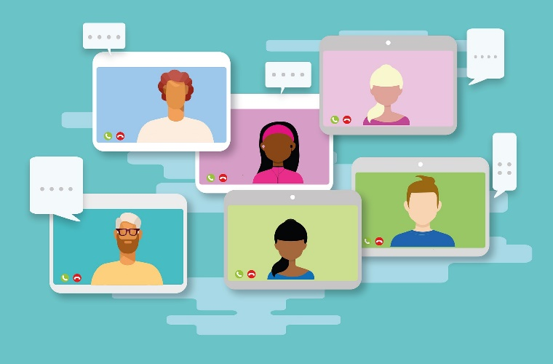
Renae Kimble, Chief Organizational Equity Officer for WNYIL

The Coronavirus pandemic has exposed the health care inequities of people of color, women, members of the disability and LGBTQ+ communities in such disproportion that now warrants greater focus on health than ever before. The pandemic further exposed the mental health and wellness crisis within diverse communities due to systemic racism, biases, and socio-economic concerns faced by these groups for decades.
Addressing these and many more societal concerns have become the new focal point in diversity, equity, and inclusion discussions now include the additional behavioral health and wellness component that must be addressed by employers when tackling health and wellness programs in their organizations.
Statistics have shown that where one lives, works, and how much privilege one is afforded is more often than not determined by the color of one’s skin, which has a direct correlation with a person’s risk of contracting COVID-19 and recovering from it. Studies show that African Americans and Latino Americans are three times likely to become infected with Covid-19 as white Americans, and twice as likely to die from the virus.
The Center for Economic and Policy Research states that four-in-ten frontline workers are African American, Latino American, Indigenous people and Asian-American/Pacific Islander.
These employees have additional stressors to confront at work, such as feeling isolated and not included due to microaggressions, unconscious bias, and discrimination based on intersectionality due to a lack of minority representation at their workplace.
It makes perfect sense that employers should act to address these mental health care disparities by incorporating into their Health and Wellness programs Equity, Diversity, and Inclusion strategies that support their employees’ mental health concerns.
According to surveys done by McKinsey & Company, “when someone’s race, identity, and sense of who they are, are repeatedly questioned and used against them, their mental health is affected. When those kinds of questions and attacks happen within the workplace, the individual and the company suffer”.
The following suggestions have been made by clinical psychologists that incorporates a mental health component into an Equity, Diversity, and Inclusion strategy that organizations should consider adopting. These strategies can empower employees and improve their mental health and well-being.
- Consider a wide range of topics that might apply to the different life stages and situations of your employees.
- Offer various channels of delivery of mental health services.
- Provide more than one scientific approach; not all techniques work for everyone.
- Communicate openly and celebrate each other’s differences.
- Promote a balanced work – life blend for employees.
One’s mental health and wellness is key to a more industrious workforce. Employees will begin to feel included and safe if shown that employers understand that one’s mental health is affected when their racial, disability, gender, LGBTQ+, religious, age, or ethnicity status is questioned.
Mental health and wellness programs which incorporate equity, diversity, and inclusion components as a priority will be successful in attracting and sustaining a more diverse, productive, and healthier workforce.
Keep it Moving
Lisa Maria Cruz, MHPC Outreach Coordinator
It’s very important to me to get exercise daily. I have a goal of getting in 10,000 steps every single day. That amounts to a little over four miles. For me, walking is definitely part of my wellness toolbox. It’s something I do to help me feel better by relieving stress and improving my mood. It also helps me to manage my weight.
I love walking and it’s something I look forward to doing. People often accompany me on my walks and that’s great. When I go for a walk on my lunch break, I will often call my mom and talk to her as I am walking. It’s nice to connect with her each day. That is one good thing that has happened because of the COVID pandemic. I have gotten closer to my mom. We connect with each other every day. We’re supporting one another as we both attempt to lose the COVID weight that we have gained.
Sometimes I will call one of my friends as I am walking too. I reach out to Nancy, Karen Ann, Phyllis, Cristina, and Karen. It’s a perfect opportunity to connect with people I care about as I’m getting in my 10,000 steps.
Walking during my lunch hour is an easy way to get in my exercise. I walk rain or shine. I’m not made out of sugar, so I won’t melt if I walk in the rain! I walk during the winter as well. All I have to do is bundle up in layers. I don’t let sleet or snow deter me from walking. Walking is an easy way to get exercise and all you really need is a comfortable pair of sneakers or shoes. I encourage you to give it a try. You’ll be glad you did.
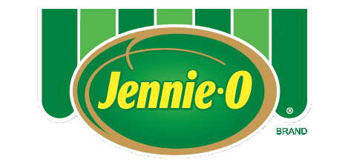
Buffalo Turkey Taquitos
Make taquitos filled with hot sauce and ground turkey
with a crispy mozzarella cheese shell for a spicy snack break.
Total Time: 30 Minutes
Serving Size: Makes 6 Servings
Ingredients
1 ½ cups cooked JENNIE-O® Ground Turkey
¼ cup hot sauce
12 slices mozzarella cheese
chopped cilantro
Directions
- Heat oven to 400°F. Line large baking sheet with parchment paper.
- In bowl, combine turkey and hot sauce. Arrange cheese slices on prepared sheet. Bake 5 to 7 minutes or until cheese is completely melted and edges are golden brown. Divide turkey mixture among cheese slices and roll up. Garnish with cilantro.
Recipe Nutrition Information
Calories 215
Protein 18.7g
Carbohydrates 2g
Fiber 0g
Sugars 0g
Fat 14.5g
Cholesterol 62.5mg
Sodium 702.8mg
Saturated Fat 5.8g

