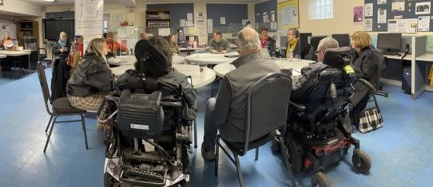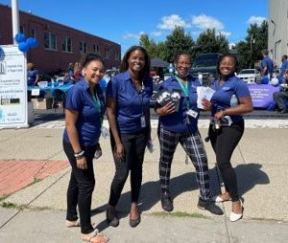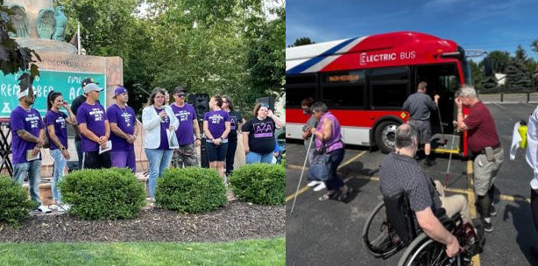

2021-2022 Annual Report

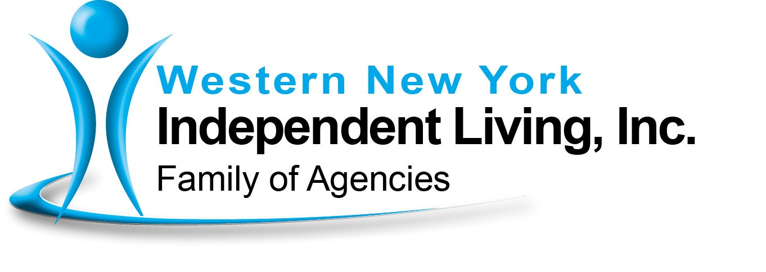

TABLE OF CONTENTS

Western New York Independent Living, Inc. (WNYIL) Vision, Mission, History.......................................... 1
Agencies ................................................................ 2

Board and Councils ............................................... 3

President’s Report ................................................. 5

Chief Executive Officer’s Report ............................ 7

WNYIL’s Work, Making Change............................. 9

WNYIL Statistical Report ..................................... 15

ILC Vignette ......................................................... 17

Statement of Financial Position ........................... 18

Statement of Activities ......................................... 19

Mental Health Peer Connection (MHPC)

Director’s Report .................................................. 20

Statistical Report...................................................21
Independent Living of Niagara County (ILNC)

Director’s Report .................................................. 23

Vignettes .............................................................. 25

Independent Living of the Genesee Region (ILGR) Director’s Report .................................................. 27
Vignettes .............................................................. 28

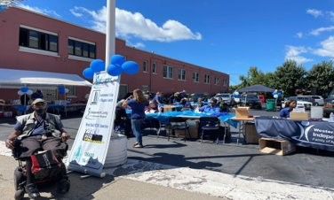Niagara Frontier Radio Reading Service (NFRRS) .. 30

Western New York Independent Living

Vision Statement
Western New York Independent Living, Inc. family of agencies is a catalyst for systems and individual change, enhancing the quality of life for persons with disabilities, while respecting diversity, and promoting choices for independent living in our societies.

Mission Statement
Western New York Independent Living, Inc.
(WNYIL, Inc.) Family of Agencies is an intercultural, civil rights organization that advances the quality of life for all people of any age and disability through
community change activities, empowerment programs, independent living services, community-based programs, fiscal intermediary services, and family supports. WNYIL, Inc. is directed, led, and staffed
by a majority of people with disabilities who run a professional and efficient organization, dedicated to cultivating a hospitable environment that actively seeks out community partnerships to eliminate barriers, facilitate transportation and promote employment.
The WNYIL Family of Agencies includes the
• Independent Living Center
• Mental Health Peer Connection
• Independent Living of Niagara County
• Independent Living of the Genesee Region
• Young Leaders and Advocates Network
• Niagara Frontier Radio Reading Service, Inc.
• Parent 2 Parent of NYS, Inc.

History
Born during the nationwide independent living and civil rights movement, college students with disabilities who were fed up with discrimination and the lack of access for people with disabilities, decided to make their own opportunities and assist their peers to do the same.
In 1979 “The Independents,” a group of students
with disabilities at the State University of New York at Buffalo, investigated the independent living movement and began operating what was then known as Western New York Independent Living Project (WNYILP).
The agency was awarded a Federal Title VII grant in
1980 and opened its own facility early in 1981. ■

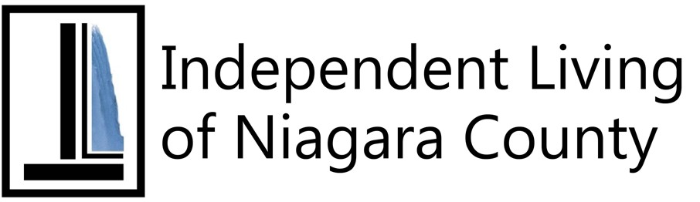

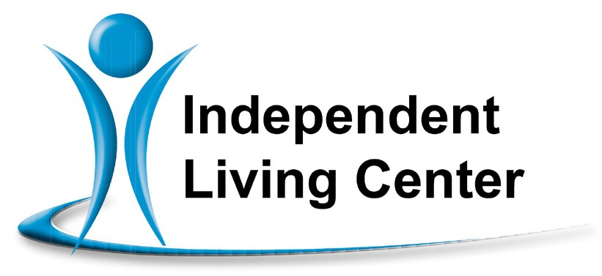Independent Living Center of
Erie County
Provides Independent Living’s 5 Core Services: Peer Services, Advocacy, Information and Referral, Independent Living Skills and Transition Services. ILC also provides Educational Navigation, Student Services, NY Connects Information and Referral, Housing Subsidies, and Benefits Application Assistance to individuals in Erie County.

Independent Living
of the Genesee Region

Independent Living of Genesee County A community pathway for an empowered life for people with disabilities by providing Independent Living Skills, Advocacy, Information and Referral, Peer Counseling, Transition Services and Financial Advisement in Genesee, Orleans and Wyoming Counties.
Independent Living of Niagara County An independent living center that provides the five core services of Peer Counseling, Independent Living Skills, Advocacy, Transition Services and Information
and Referral which empower people with disabilities on both the individual and community level.

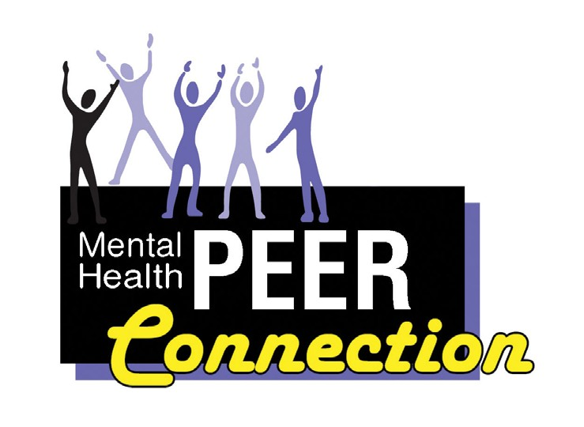
Mental Health PEER Connection A peer-driven advocacy organization dedicated to facilitating self-directed growth, wellness and choice through genuine peer mentoring. Provides institutional, community and vocational-based services assisting consumers in their recovery process.

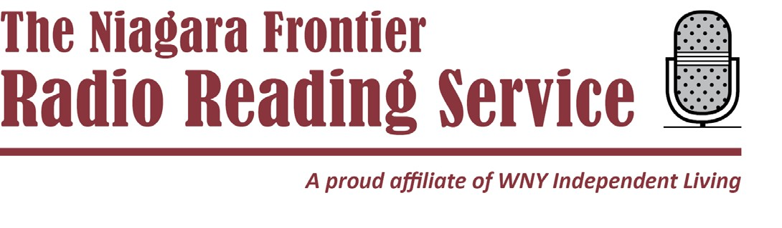

Niagara Frontier Radio Reading Service Your Niagara Frontier Radio Reading Service gives thousands of people throughout Western New York
and Southern Ontario who are blind or have a print
disability daily access to a variety of print publications. ■
The following volunteer representatives were in place
during all or part of the 2021-22 fiscal year.

Western New York Independent Living
Board of Directors
Paul Beakman, Sr. (President); Richard Dread (Vice President); Ann Scherff (Treasurer); Sue Ann Sehl (Secretary); Syreeta Dean; Barbara Gaetano; Melanie Hecker; Alexis Kennedy; Ellen Lawson; Donald LeBer; Linda Makson; Michael May; Bobbie Jo Meyer; Kaitlyn O’Dell; Juan Santiago; Miguel Santos; and John Schappacher.

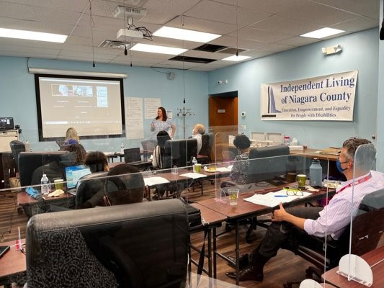Independent Living of the Genesee
Region Council
Ann Scherff (Chair); Kelly March (Vice Chair); Erycka Kosinski (Treasurer); Lorrie Gilbraith (Secretary); Jonathan Doherty; Linda Makson; Christi Waldron.

Mental Health PEER Connection
Council
Benjamin Woodrow (Chair); Bobbie Jo Meyer; Rita
Young; Mahogany Bell; Michael DiPirro.

The following volunteer representatives were in place
during all or part of the 2021-22 fiscal year. (continued)

Independent Living of Niagara County
Council
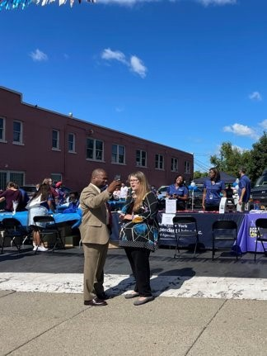Paul Beakman, Sr. (Chair); John W. Schappacher (Vice Chair); Barbara Gaetano (Secretary/Treasurer); Gracie Chambers; Brigid Dillman; Darren Sneed.

Niagara Frontier Radio Reading Service
Board of Directors
Paul Beakman, Sr. (President); Richard Dread (Vice President); Sue Ann Sehl (Secretary); Ann Scherff (Treasurer); Patricia LaMonte; Charles Nellis; Kenneth Sullivan. ■

From the Desk of: Paul Beakman, Sr.
President of the Board of Directors of Western New
York Independent Living, Inc.

Greetings:

Like any Family unit that has been around for over 40 years, and continues to grow, we have our moments of sorrow, unforeseen situations, and opportunities for joy. To me, Western New York Independent Living (WNYIL) is like a family, and this past year has shown that, not unlike human families, we have had to live through the emotional roller coaster as well.

This past year was met with the loss of long-time members of our staff, Board, and Councils. People whose efforts over the last over-four decades have helped us grow from a small community-based advocacy/service program to one of the top 20 not- for-profit organizations in Western New York. Due
to their years of dedicated, committed and just hard work, WNYIL experienced sad good-byes to Chief Financial Officer Mike Phillips, Driver Richie Nawrocki, Board member Donald LeBer, Mental Health PEER Connection Council member and former staff member Judy Capan, and ILGR Council member Jonathan Doherty.

Even with the loss of these great Independent Living supporters, WNYIL continues to move forward
in its efforts to insure that people with disabilities can live self-sufficiently in their homes, work in our neighborhoods, and continue to participate as equal members in our society.

Each member of our Family of Agencies has shown
a strong will to emerge from the COVID-19 pandemic isolation and roll up their sleeves to provide services, and expand their ability to improve the quality of life for people with disabilities.

Mental Health PEER Connection (MHPC) along with their partners: the Erie County Department of Mental Health, Recovery Options Made Easy (ROME), and Spectrum Behavioral health, have all worked together, jumping through bureaucratic hoops and leaping over community hurdles in a successful effort to bring to
the City of Buffalo and Erie County the Kirsten Vincent Respite and Recovery Center, where MHPC’s The Renewal Center will have a new home. This will bring hospital and emergency diversion programming for hundreds of our brothers and sisters with mental health and emotional disabilities a safe, warm, and welcoming place to regroup, recollect themselves, and forge their new path to recovery.

Niagara Frontier Radio Reading Service (NFRRS) has picked up where others dropped off. Our broadcast radio reading and internet/podcast service that reads

5 (continued on next page)

newspapers, magazines, bestselling books and other timely news and entertainment material to those who
are unable to read, has broadened their service area. The radio reading service for the “print-handicapped” in Rochester, “WXXI Reachout Radio”, had stopped
broadcasting. Fortunately, the NFRRS volunteers and staff picked it right back up! Using the Internet, the people with print disabilities are still able to “turn on the newspaper”
and read when they want and where they want.

Our van transportation service, Independence Express (IE), has leaped into the green environmental effort, by purchasing our first hybrid vehicle while continuing to expand services to our consumers, volunteers, and staff.

Independent Living of the Genesee Region (ILGR) continues to make us proud by being a top performer in the State, leading the way in the Emergency Solutions Grants Program (ESG). ILGR continues
to assist dozens of GOW (Genesee, Orleans, and Wyoming) Counties’ citizens find emergency, safe housing solutions options.

Independent Living of Niagara County (ILNC) has a new Director, Michelle Scheib, whose experience and expertise will lead us in spreading the IL philosophy throughout the County by bringing her vast knowledge of providing programs and services to people with disabilities to all parts of Niagara.
The Independent Living Center (ILC) located in Buffalo just continues to improve its efforts by forging linkages, networks, and relationships with local, State, and private organizations in getting the IL message to all who can benefit.

We have seen Taking Control (Consumer Directed Personal Assistant Service, CDPAS) continue to expand, our Care Coordination Program seek more opportunities to assist people with disabilities, the Young Leaders and Advocates Network (YLAN) reach out across the Empire State, and the New York Connects program continue to inform thousands
of New York residents of the various programs and
services that WNYIL offers to the entire region as well.

In closing, it is my pleasure to welcome the newest member of our family: Parent to Parent (P-2-P) has joined the peer programs of the WNYIL “Family of Agencies”. This 25-year-old Statewide program; that offers information, referral, and peer support to family members of people with disabilities, has united with
us. This mutual relationship will assist both WNYIL and P-2-P reach more people who live with people with disabilities and assist those people with disabilities to identify and connect to their life goals easier.

I thank all of you who have supported us this past year, and ask that you hold on tighter, because this 43-year- old agency isn’t done yet. ■
6

From the Desk of Chief Executive Officer
Douglas J. Usiak

“1983 to 2023”

How -- and when -- did I get here? Wasn’t it only a few years ago that I accepted the job as Executive Director of the then-”Western New York Independent Living Project”? Let me think… The “exciting” subway was being constructed under Main Street. Mmm…We had just convinced Erie County to have an Office for People with Disabilities and County Executive Edward Rutkowski signed the resolution into law. And I think that we were still pushing for full implementation of Section 504 (in the Rehabilitation Act of 1973, barring disability-based discrimination in federally funded institutions). That’s especially since the Supreme Court Grove City vs. Bell decision, (if college students are receiving federal funding, only the financial aid office has to be non-discriminatory), really took the bite out of everyone’s Civil Rights.

Our proud Center of seven (count them!) dedicated staff were willing and able to take it all on. Push for a totally accessible public transportation system (fixed route buses with wheelchair lifts AND Paratransit vans) to serve the Western New York area; Worked
on making what was then “Pilot Field” one of the most accessible stadiums in the country; trying to make the second floor bypass (over-the-street walkway) from
the Main Street Mall to the Rath building accessible; get curb cuts on every corner; install braille signage on elevators; have sign language interpreters for the deaf at public venues and at hospital emergency rooms; make our telephone system TTY (teletypewriter for the deaf) capable; widen doorways for wheelchairs; raise toilets; and the list goes on and on and on.

That is not to mention our providing the four core services of Independent Living for people with disabilities:
• Peer Counseling
• Independent Living Skills
• Advocacy
• And Information & Referral

And there’s more: assisting people out of institutional
care to Independent Living! Later was to come a fifth core service, Transition Services: guiding young people from school to work or from school to secondary education.

Quite a task for a hardy group of people with disabilities, most of us under 30.

Fast Forward to Today

I stop to consider what we are doing now. We continue to work with thousands of people with disabilities, empowering them to take charge of their lives. We

7 (continued on next page)

collaborate with housing developers to make sure

they are building homes/apartments that are at least “visitable” (wheelchair users can get inside) if not ideally accessible.

We continue to provide guidance to our elected leaders, cooperating on how to welcome people with disabilities into the mainstream by eliminating
architectural, communication, and attitudinal barriers.

We have expanded our original focus of removing
physical barriers to include finding ways to work
with our brothers and sisters with hidden disabilities. We are uniquely qualified as peers of people with behavioral health concerns, chemical sensitivities, intellectual and developmental disabilities and more.

We have become a valuable resource for the medical community by: providing in-hospital support and assistance; participating in the development
of evidence-based measurements of success for recovery; and the list goes on.

You can look back at our 43-year history and be proud of the impact we have had in our community, our
State, and even nationally. We can also point to the dozens of international visitors who came to WNYIL for technical assistance to learn how to run a Center for Independent Living; and advised all on how we practice implementing the principles of the Americans with Disabilities Act (ADA).
Although our history is impressive and solid, we still have challenges before us. We need to reach to the newly inducted Americans with disabilities to show them how America can foster the participation of its people with disabilities. We have an uphill battle before us to demonstrate to those who have succumbed
to substance abuse that there is recovery and the prospect of a full, healthy life before them.

And most of all, we continue to assist people out of premature institutionalization by making it possible for everyone to have the opportunity to live in their homes and in their neighborhood, work in our communities, and engage as full and equal partners in our proud society. ■

8 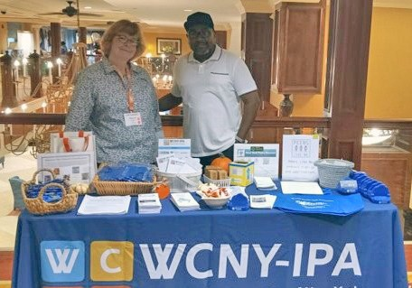

WNYIL’s Work is Good for Consumers
AND Good for New York State

$800,000,000
That is how much money in Medicaid payments the WNYIL Family of Agencies saved New York State taxpayers since 2008 by helping people stay in their homes instead of being admitted to nursing homes, group homes, and other institutionalized settings. ■

Nothing About Us Without Us
The Young Leaders and Advocates Network (YLAN) is a statewide network run for and by young people with disabilities with the support of Western New York Independent Living. YLAN is dedicated to uniting and empowering young people to get the support they need
with the respect and dignity they deserve. YLAN works to ensure that young people are authentically and meaningfully involved in all decisions that affect them.
Making Change

A critical part of Western New York Independent Living efforts is our vision and government mandate to bring change for people with disabilities in our communities.

As stated in our Vision Statement, Western New
York Independent Living is a catalyst for systems and individual change

We embrace the belief that without change, our community will never be able to insure that people with disabilities will have an equitable role in society.

The following is a sampling of the areas of where community change was realized, from specific concerns to State and National contributions:

A. Education
• WNYIL Staff collaborated with the University
at Buffalo Medical School to support the needs
of persons with disabilities, concentrating on degenerating conditions. Staff provided a video created by WNYIL at consumers’
requests that discussed the issue, and they recommended the continued use of the video on an ongoing basis for the class.

• Bullying had led to a student’s suicide and raised concerns in the community, WNY Independent Living staff were invited to participate in the “Finding Respect” Taskforce for the City of Batavia School District. This new taskforce was designed to bring bullying issues to light for all students, including students with disabilities within the district.
To assist the school and parents of prior and potential targets of bullying, our staff provided information and resources on Independent Living Philosophy to all students and families that access the School Resource Center.
• Staff met with Deaf Access Services regarding the lack of American Sign Language (ASL) interpreters during press conferences and events relating to the racially motivated Buffalo East Side Tops Market Shooting of May 14,
2022. Interpreters were not provided, meaning that deaf members of the neighborhood might not have been aware of critical information, such as curfews and road closures. In June
2022, our staff held a meeting with Buffalo Common Council President Darius Pridgen on the issue, since the Mayor’s office had yet to respond to our concerns, (due to the lack of
an ADA coordinator after the last one left City
employment). A plan is in development with
the new Chief Diversity Officer.

B. Commerce
• WNY Independent Living staff received a complaint about inadequate accessibility at a medical plaza in Niagara County. Consumers reported a lack of curb cuts and power
doors at the location. Independent Living of Niagara County staff reached out to the building manager, to make the Americans with Disabilities Act Title III violation(s) known. She agreed to address the issue and to notify us when the work was complete. Not long after received notice and verified that the plaza was now compliant.
• As part of our planning for the Disability Pride Celebration of the Americans with Disabilities Act, we met with members of the Olmstead Parks Conservancy on the accessibility of Martin Luther King Jr. Park. Staff highlighted concerns over the ramp to the permanent structure for restrooms, signage and wayfinding, and availability of accessible picnic tables. To move the process forward, staff agreed to help identify funding for accessible

picnic tables for the Park.
• A Post Office in Genesee County began a construction project to repair access to the front of the building. During construction, they made it impossible for people with walkers or wheelchair users to access the building. The alternate access path they had created was over curbs and on grass. Independent Living of the Genesee Region staff contacted the Post Office Manager and the municipality’s assistant manager about the accessibility concerns during the construction and repair phase. Changes were made to the pathway and the temporary access became accessible to all persons with disabilities.
• Clients for a local non-profit asked WNY Independent Living to help the business become compliant with Title III of the Americans with Disabilities Act. Concerns had been raised about the size of the chairs in the waiting area and the need for some bariatric chairs to meet the needs of the clients. Staff discussed the requirements of Title III and provided information on where chairs could be found. Based on this information, the agency bought two bariatric chairs, and arranged them in an accessible way in the waiting area.
C. Health
• As part of a broader collaboration with
statewide and local consumer groups promoting the increase of the hourly wage for Personal Assistants and Consumer Directed Personal Assistants, staff have been working on “Fair
Pay for Home Care”, an initiative promoting an indexed minimum hourly wage of 150% of regional minimum wage. Staff have participated in community events to educate the public on the issue, as well as supported discussions relating to the New York State budget. Eventually, the state budget was passed with
a provision to provide a $2 per hour raise, effective October 2022, with an additional $1 per hour raise, effective October 2023.
• Western New York Independent Living was approached by Erie County to participate in a broad coalition to reduce the high use of
Emergency Mental Health Interventions at Erie County’s Mental Health Emergency center. Staff promoted the use of non-traditional interventions, such as dealing with food
scarcity and the use of The Renewal Center, a peer-run respite and recovery center operated by the Mental Health PEER Connection. With

the increase in community integration, staff received notice in August 2022 that the coalition has achieved its goal, reducing high- need utilization by over fifty percent.
• Independent Living of the Genesee Region staff were invited to attend a Genesee Orleans Wyoming Community Health Assessment planning meeting facilitated by the Genesee County Health Department. Staff provided
input on the draft tri-county survey that would be used to assess changes needed in the public health system -- including recommending ways the reasonable accommodations could be made to help people complete the survey. Staff provided examples of appropriate language for announcing reasonable accommodations, as well as feedback concerning the draft flyer to be used to launch the public survey. An amended flyer was produced with the accommodation request clearly defined.

D. Citizenship
• As part of our regular work on Election Day, to ensure that polling places will be accessible to persons with disabilities, staff performed 23 polling site evaluations, finding
one inaccessible for entry. The information was forwarded to the Help America Vote Act Advocate at Disability Rights New York.
• For the past few years, staff has worked with community advocates and in-state collaborations to restore the New York State Office of the Advocate for Persons with Disabilities, including the seeking the support of consumers engaging in communication with policymakers on the need for input on
policy decisions affecting their lives. As a result of this work, Governor Hochul signed a bill creating the New York State Chief Disability Officer, carrying a staff of three and fulfilling the function of the ADA coordinator for New York State. WNY Independent Living was invited to attend the signing and introduction of the new Chief Disability Officer, Kimberly Hill.
• Staff contacted Orleans County to speak with the Americans with Disabilities Act (ADA) Coordinator to review community concerns. We learned that, as Orleans County has less than 50 employees, it is not legally mandated to have an ADA Coordinator. However, the Village of Albion does have more than the minimum complement of employees. Our

staff attended the Village Board Meeting
to present the importance of appointing an ADA Coordinator to the Mayor and Board Members. After the meeting, the Mayor appointed a Village of Albion Board Member as their ADA Coordinator.
• Independent Living of the Genesse Region spoke with the Batavia City Council about
a proposed new law banning agricultural animals in the City of Batavia. There was concern that people with disabilities who use an “agricultural animal” for service/or companionship will be forced to apply for an exemption to keep their animals. Staff delivered a written statement to the City
Council requesting that they allow exceptions for service/therapy animals in their statute, without the requirement of one seeking an individual exemption. Staff attended the public forum seeking community input and provided details on the mandates of the Americans with Disabilities Act. Despite our comments, the proposal has been sent to the Planning Board for review and passage.

E. Social
• As an initial step to provide culturally sensitive,
person-centered services, staff met with Erie County officials to measure the impact of Assistive Outpatient Treatment (AOT) in the County. Staff discovered that no ongoing
demographic data exists for AOT participants.
Staff advocated with county officials to collect this data, highlighting statewide media coverage about the racial and ethnic disparities in the application of the program,
and the County agreed to collect the data from state data pools.
• Staff visited Genesee Center for Nursing & Rehabilitation and conducted a presentation on inclusion of Independent Living Philosophy with those transitioning out of the nursing facility, and we also discussed programs that can be utilized with consumers while still in
the nursing home. Staff provided brochures and answered questions one-to-one after the presentation. Discharge planning staff agreed to share Independent Living philosophy information with patients planning a transition.
• As part of our collaboration with Housing Opportunities Made Equal (HOME), four home modifications were completed for consumers
in Erie County. Based on the success of the

program in this cycle, additional resources are being made available by HOME for two additional consumers this year.
• Staff completed seven Supportive Service Agreements or Referral Agreements for proposed housing projects to the New York State Office of Homes and Community Renewal. In each, applicants either went beyond the Federal Fair Housing Minimums for accessible units or permitted independent living technical assistance to be provided to residents in the proposals.
• Staff received a fully executed Referral Agreement from a local construction company for the multifamily housing project in Batavia, which will have six housing units fully adapted for persons who are mobility impaired, and three units adapted for persons who are hearing or vision impaired.

F. Transportation
• WNY Independent Living has been working
in collaboration with other community groups to promote the expansion of paratransit wheelchair-lift van service areas beyond the
0.75-mile limit currently established by Title V
of the Americans with Disabilities Act (ADA).
14
Local consumer advocacy efforts have been supported to the point where a proposal to expand the service area to 1.5 miles has been proposed as part of negotiations in the New York State budget. Staff explained the problem and the recommendation of state-based expansion to policymakers and received feedback on their concern of there being no estimate of cost. To deal with this question, the New York State Legislature provided $750,000 to the Niagara Frontier Transportation
Authority to perform a study on the costs for expansion of paratransit, to be completed in
2023-2024.
• As part of our participation in the Niagara Frontier Transportation Authority Accessibility Advisory Committee, the authority announced
a program to encourage the use of county/state parks by promoting special bus trips to them during the summer. Staff discussed the need
to provide a paratransit option for the activity, even though the special nature of the trips makes them exempt from the requirement. We were successful, as the Authority added the option in advertising in June 2022. ■

Annual Report 2021-2022
Number of Consumers by Race and Ethnicity
 | ILGR | ILNC | WNYIL
American Indian or  Alaska Native | 12 | 16 | 18
Asian | 3 | 1 | 37
Black or African  American | 144 | 163 | 798
White | 1069 | 495 | 1230
Hawaiian Pacific  Islander | 29 | 0 | 3
Hispanic or  Latino | 0 | 14 | 158
Race/Ethnicity  Unavailable | 104 | 156 | 412

WNYIL Statistics

Total Number of Consumers Served
ILGR | ILNC | WNYIL
1361 | 845 | 2656

Number of Consumers by Age
 | ILGR | ILNC | WNYIL
Under 5 years old | 5 | 1 | 2
Ages 5 - 19 | 24 | 10 | 76
Ages 20 - 24 | 43 | 14 | 111
Ages 25 - 59 | 594 | 375 | 1280
Age 60 and older | 695 | 446 | 1187
Age unavailable | 0 | 0 | 0

*Some consumers may have indicated more than one
Number of Consumers by Disability*
 | ILGR | ILNC | WNYIL
Cognitive | 364 | 344 | 1155
Mental/Emotional | 1013 | 737 | 2818
Physical | 1668 | 1242 | 3638
Sensory (hearing, vision, etc.) | 196 | 256 | 860
Multiple  Disabilities | 576 | 477 | 1654

Number of Consumers by Gender
 | ILGR | ILNC | WNYIL
Female | 850 | 479 | 1582
Male | 506 | 353 | 1064
Gender unavailable | 5 | 13 | 10

15 disability category.

County
 | ILGR | ILNC | WNYIL
Allegany | 0 | 1 | 0
Erie | 47 | 73 | 3446
Niagara | 12 | 933 | 155
Genesee | 1152 | 6 | 84
Wyoming | 294 | 5 | 15
Orleans | 308 | 1 | 25
Chautauqua | 2 | 0 | 23
Cattaraugus | 1 | 0 | 13
Genesee Valley  & Finger Lakes  Region | 81 | 1 | 4
Other counties in NYS | 3 | 0 | 16
Outside NYS | 1 | 4 | 7

16
Type of service received
 | ILGR | ILNC | WNYIL
Advocacy/legal services | 58 | 25 | 163
Architectural barrier | 0 | 0 | 1
Assistive devices/  equipment | 5 | 2 | 108
Communication services | 63 | 2 | 68
Family | 3 | 3 | 4
Childrens services | 0 | 0 | 0
Counseling services | 2 | 1 | 105
Housing and shelter services | 589 | 86 | 461
Information and referral | 972 | 260 | 1645
Independent living skills development and life skills services | 262 | 16 | 157
Mobility | 2 | 0 | 8
Peer counseling | 32 | 129 | 1010

Veteran status
 | ILGR | ILNC | WNYIL
Veteran | 67 | 47 | 91
Non-veteran | 1279 | 721 | 2412
Status unknown | 15 | 77 | 153

WNYIL Vignette - NY Connects
Type of service received (continued)
Personal assistance services | 277 | 316 | 769
Recreational services | 2 | 0 | 15
Transportation services | 13 | 34 | 215
Youth services | 0 | 1 | 0
Vocational services | 21 | 9 | 187
Plan for the achievement of self support | 0 | 0 | 1
Business/Industry/ Agency services | 4 | 30 | 8
Benefits  advisement | 302 | 67 | 366
Voter registration | 0 | 1 | 4
Other | 5 | 0 | 1

Our NY Connects Outreach Specialist (NYCOS) assisted a 60-year old African American woman whose son was refusing treatment for his schizophrenia and she wanted us to advocate
for him in gaining mental health services; she suspected that he may have substance abuse issues. The NYCOS made a number of calls and had a face-to-face meeting to craft the following Action Plan: 1) Contact the Buffalo Federation of Neighborhood Centers (BFNC) to discuss housing and available services; 2) Contact the Erie County Department of Mental Health’s Adult Single Point of Access (A-SPOA) program to request the Care Coordination and Assertive Community Treatment (ACT) Team to assist with his mental health
treatment and medication management; 3) Contact WNYIL’s Mental Health PEER Connection (MHPC) department and its Addict 2 Addict Program (A2A) for counseling. Our NYCOS continues to work
together with the mother as the process proceeds. ■

Businesses served
ILGR | ILNC | WNYIL
16 | 37 | 65

WNYIL, Inc. and Affiliate Consolidated Statements of Financial Position September 30, 2022 and 2021
Liabilities and Net Assets
Current liabilities:
Account payable | 617,099 | 608,525
Deferred revenue | 5,041,218 | 4,531,876
Accrued salaries | 1,823,644 | 1,694,915
Accrued expenses | 386,515 | 366,963
Total current liabilities | 7,868,476 | 7,202,279
Net assets:
Net assets without donor restrictions | 23,091,618 | 21,837,818
Net assets with donor restrictions | 733,285 | 18,624
Total net assets | 23,824,903 | 21,856,442
Commitments and contingencies
Total liabilities and net assets | $ 31,693,379 | $ 29,058,721

Assets | 2022 | 2021
Current assets:
Cash and equivalents | $16,254,821 | $14,003,755
Investments | 4,280,905 | 5,078,533
Contracts and fees receivable, net | 9,676,037 | 8,758,755
Prepaid insurance and expenses | 173,411 | 139,152
Total current assets | 30,385,174 | 27,980,195
Note receivable | 159 | 67,902
Property and equipment, at cost:
Leasehold improvements | 2,718,156 | 2,594,288
Office equipment | 439,344 | 439,344
Vans and related equipment | 394,008 | 394,008
Computers and related equipment | 306,527 | 306,527
Construction in progress | 438,218 | 91,927
 | 4,296,253 | 3,826,094
Less accumulated depreciation | (2,999,437) | (2,827,765)
Net property and equipment | 1,296,816 | 998,329
Other assets | 11,230 | 12,295
 | $ 31,693,379 | $ 29,058,721

WNYIL, Inc. and Affiliate Consolidated Statements of Activities Years ended September 30, 2022 and 2021
Expenses:
Program services | 42,751,610 | 42,329,915
Management and general | 3,131,635 | 2,832,586
Total expenses | 45,883,245 | 45,162,501
Change in net assets without donor restrictions | 1,253,800 | 2,855,309
Change in net assets with donor restrictions:
Revenue - contracts and grants | 733,267 | 26,858
Net assets released from donor restrictions | (18,606) | (1,039,422)
Change in net assets with donor restrictions: | 714,661 | (1,012,564)
Change in net assets | 1,968,461 | 1,842,745
Net assets at beginning of year | 21,856,442 | 20,013,697
Net assets at end of year | $ 23,824,903 | 21,856,442

 | 2022 | 2021
Revenue:
Contracts and grants | $ 7,030,254 | $ 6,382,704
Consumer directed personal assistant services | 40,267,576 | 39,792,680
Fees for services | 525,338 | 648,518
Membership | - | 6,660
Fundraising | 7,256 | 18,091
Grant income - paycheck protection program | - | 23,700
Investment income (loss), net of investment fees of $13,472 in 2022 and $13,142 in 2021 | (735,313) | 91,356
Other revenue | 23,328 | 14,679
Total revenue | 47,118,439 | 46,978,388
Net assets released from donor restrictions | 18,606 | 1,039,422
Total revenue and other support | 47,137,045 | 48,017,810

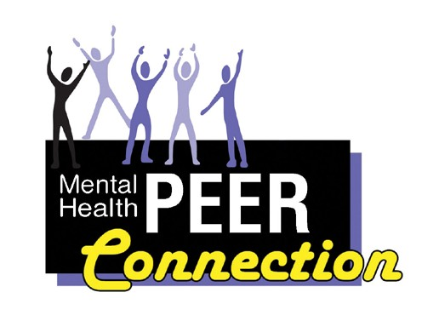

Mental Health PEER Connection
Kevin Smith, Director

Mental Health Peer Connection managed to prevail
in another difficult year. Staff were dedicated to the people we serve and did not allow the many challenges faced by our community to stop them from helping our brothers and sisters in their time of need.

Just as they answered the calls for help from so many during and after the COVID-19 pandemic, they also worked diligently to provide support and services to Buffalo Eastside residents after the tragic 5/14/22 Tops Market attack, on an already hurting community. Our staff participated in everything from healing circles
for those directly affected by this tragedy to providing ongoing support through tabling events at the Tops supermarket in question to educating the community on how to get help.

We were able to take over all staffing roles at the Renewal Center, and have the center highlighted on local news as part of the solution for crisis diversion in our area. The Renewal Center successfully became
a part of the Kirsten Vincent Respite and Recovery
Center, a collaboration between our agency and two

other community partners whose goal is to provide a multitude of needed services all under one roof.

The assistance to persons needing mental health supports also came in the form of a new initiative called the Peer Bridger program where our peer will help make the transition from Erie County Medical Center back into the community easier by explaining the intake process specific to participants’ discharge plans and help to break down any barriers that may stand in the way of a person’s seeking to maintain wellness.

And while our staff continues to work hard to show the value of peers in relation to all behavioral health needs, Director Kevin Smith is working to build alliances to further highlight their dedication. He has worked on committees and subgroups that include The
Buffalo United Resiliency committee, the Mental Health sub-committee in response the 5/14 tragedy, the Erie County Medical Center/Comprehensive Psychiatric Emergency Program (ECMC/CPEP) Steering group, ECMC Operations group, Crisis Diversion sub- committee, and the Family & Peer sub-committee, allowing the peer voice to be heard to improve how people experiencing a crisis are treated and at the same time strengthening our collaborations with other community stake holders.

In this new year we look forward to building upon our successes and improving the areas in which we may have fallen short! ■

Annual Report 2021-2022 MHPC Statistics

Addict to Addict Peer
and Family Support Program*
1394 | Total number of interactions with individuals presenting with substance use issues
251 | Total number of individual follow up’s completed
572 | Total number of interactions with families and caregivers of individuals who have substance use issues
64 | Total number of continued supports for families and caregivers
90 | Total number of family and A2A support groups
71 | Total number of community presentations regarding family members in relationships with people who have substance use issues

*Reflects data gathered between
ECDMH Benefits Advisement, Life Coaching,
and Work Support Programs
185 | Total number of individuals who received  benefits advisement services
65 | Total numbers of individuals served whose  qualifying benefits were identified
40 | Total number of individuals who were  certified or re-certified for benefits
539 | Total number of individuals who received life coaching services
37 | Total number of individuals who had an improved quality of life
138 | Total number of individuals whose basic needs (housing, financial, mental, physical, wellness) were met
40 | Total number of individuals who completed a Wellness Recovery Action Plan (WRAP)
206 | Total number of individuals who received work support services

January and December 2021

*Reflects data gathered between
January and December 2021

Renewal Center
193 | Total number of individual crisis diversions
45 | Total number of individuals linked to community-based treatment

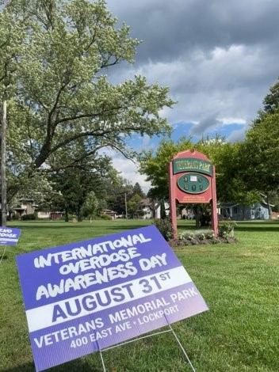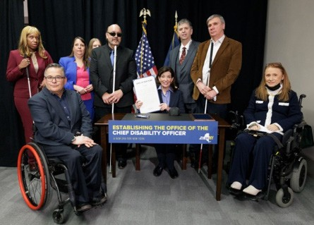Signing of legislation creating the office for the
Chief Disability Officer.

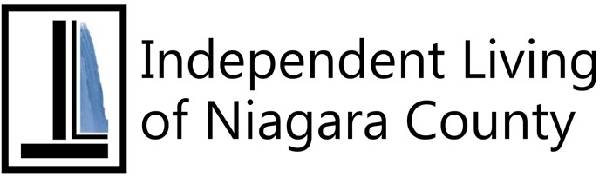Independent Living of the Niagara County
Michelle Scheib, Director

Due to precautions about in-person meetings due to the Coronavirus Pandemic, separate Meet the Candidates Days were held for each of the Western New York Independent Living (WNYIL) Family of Agencies. On October 27, 2021, Independent Living of Niagara County (ILNC) held its virtual gathering on the Zoom Meeting platform which was also live streamed to Facebook and YouTube. Candidates for Niagara Falls City Council and Niagara County Legislature participated.

As many people were not able get to the store, to find or acquire routine necessities due to the pandemic in the fall of 2021, ILNC staff in the State-funded NY Connects program were giving away bags of household items and toiletries to people whose household income was below the federal poverty guidelines. The bags included things such as paper towels, tissue, hand sanitizer, bar soap, dishwashing liquid just to name a few things. They appeared in public places, such as libraries, to put out the word and sign up those who qualified.

Beginning in February 2020, along with other members of the WNYIL Family of Agencies, ILNC distributed complimentary COVID Home Test Kits to people who participate in its programs, receive services, and/or
are qualified Listeners to the Niagara Frontier Radio Reading Service. The Kits were received through WNYIL’s membership in the New York Association on Independent Living.

On February 8, in concert with other recovery warriors from various Recovery Community Organizations (RCOs) throughout the Empire State, our staff made presentations in “Stand Up for Recovery Day”. Held virtually due to the COVID-19 pandemic by Friends of Recovery – New York (FOR-NY), it is a day in which participants celebrate recovery from addictions, but more so, to educate decision-makers and the general public about the recovery movement.

On March 10, staff discussed ILNC’s services on the cable access program “Many Faces of Mental Health” hosted by the Mental Health Association of Niagara County on Lockport Community Television.

In April, ILNC and Addict 2 Addict Niagara (A2A-N) hired Erin Zych to be their Recovery Peer Services Coordinator to coordinate, mentor and oversee the activities of the A2A Team, in addition to reporting, supervising and providing mentorship and engagement of the State Opioid Response (SOR) A2A and Family
2 Family (F2F) Teams in Erie and Niagara County, focusing on harm reduction principles.

23 (continued on next page)

Erin immediately got to work, overseeing four different support groups: Real Talk Peer Talk that is a recovery driven support group with each meeting having a different topic to discuss; a Work Support Group to reinforce all vocational services for peers; the Smart Recovery groups on Tuesdays and Fridays; and Bridging the Gap, which is for our rural areas.

Also, in that month, ILNC welcomed Georgia Brodie as its Assistant Director to aid the Director in the administration of the Agency, ensuring that all funding sources’ documentation and reports are compiled
and submitted in the required time and perform other
general office duties.

On June 30, the Niagara Frontier Transportation Authority welcomed staff and friends to the ILNC parking lot in downtown Niagara Falls for a demonstration of its ecologically friendly Electric Fleet Bus. As it is preferable to reduce emissions and global warning, these will gradually replace existing buses as the current vehicles age and are retired.

ILNC celebrated the 32nd anniversary of the signing of the Americans with Disabilities Act (ADA) at an Open House in our office and parking lot at 746 Portage
Road in Niagara Falls on July 26th. Food was available for purchase, plus additional fun, music, games with prizes, mugs and Quilt Raffle Tickets for sale. Other features included NY Connects bags that were given
away, Narcan opioid overdose antidote training, and other program outreach and educational sessions that were given by our staff.

As their offices are divided among what had been separate store fronts in Niagara Falls’ Haeberle Plaza, even long-term staff rarely connected with everyone else, and new colleagues joined them in mid-2022. Realizing that all would be well-served by getting
to know each other better, acting ILNC Director Stephanie Orlando involved them in a team building exercise at Beaver Island State Park on Grand Island, held August 25. Using Park photos taken by Office Manager R.J. Brehmer in key locations, she planned an Independent-Living-themed scavenger hunt.
The three intentionally diverse teams were rated on teamwork, creativity, and other factors. Afterwards, the day included a picnic and social time.

Independent Living of Niagara County and Addict 2
Addict Niagara welcomed the community to join its Sixth Annual Lockport Overdose Awareness Day Rally on Wednesday, August 31, at Veterans Memorial Park in Lockport to spotlight the increasing rate of deaths from addictive drugs. Highlights included free training in the use of Narcan, the emergency opioid overdose treatment spray, and fan favorite Joshua Vacanti of Lockport, a finalist on NBC’s The Voice in 2021, sang
Amazing Grace before a flameless candlelight vigil and

24 (continued on next page)

bell-ringing ceremony for every life lost to overdose in Niagara and surrounding counties in 2021. There was also a memorial table for loved ones to display photographs. Speakers from different backgrounds
who have been affected by overdose included Lockport City Court Judge William Watson, Niagara County Sheriff Michael Filicetti, Recovery Coach University Founder Lori Drescher, and Rochester ROCovery Fitness Executive Director Jonathan Westfall.

When the pandemic restrictions were easing, the New York Association on Independent Living held in- person Regional Meetings across the Empire State. On September 21, ILNC’s Open Doors Transition Specialist Team Leader Gerilyn Capps welcomed
statewide leaders, including the Association’s Assistant Executive Director and Open Doors Project Director Suzanne DeBeaumont and the Director of Olmstead Housing Subsidies and Rapid Transition Housing Projects Valerie Brennan to the Cataract City.

On September 29, ILNC hosted the monthly meeting of the Niagara Frontier Transportation Authority Accessibility Advisory Committee in its Conference Room. Holly Nidell of the NFTA administrative staff made a presentation.

While there were participant additions and departures in the Taking Control Consumer-Directed Personal Assistance Services each month, at the conclusion
of the Fiscal Year, the program had 301 active cases,
nearly a twelve-month high. ■ 25

ILNC Vignette 1 - NY Connects helps woman with multiple disabilities

Our NY Connects Outreach Specialists (OSs) actively work in the community, helping people in need and referring them to life-saving programs and services to improve their quality of life. “Tina”, a 56-year old Caucasian woman from Niagara Falls, who made a very strong impression, had fibromyalgia, bipolar disorder, and was recovering
from a concussion at the time we came to her house to meet her. Due to the concussion, her vision and mental capabilities were declining, and she was having mobility issues within the house. Our OSs were very concerned for her wellbeing, as she would touch or grasp objects in the home in order to guide her path. Throughout this complicated situation,
they witnessed medical providers being rude and inconsiderate with her on the phone. They were not mindful of her mental decline and so were getting frustrated with her and only providing dead end referrals. She began to cry as she thought nobody would care enough to help her.

Our OSs were going to do whatever was required to give this consumer some relief, as she had gone through so much already. They immediately recognized that her current community Medicaid
plan did not go far enough and helped her apply for Managed Long-Term Care (MLTC), which was in her best interest. They also referred her to Stern Physical

(continued on next page)

Therapy, who, within two days, was able to offer her a specific walker that fit her needs. They also had
a doctor conduct a home visit in which he modified the lighting, installed some railings, and marked the home with bright taped lines that she could follow
to help with mobility. Upon their next visit, she was like a brand-new person! She no longer slurred her words, was upbeat and confident, and hopeful about her future. This was a big difference from the scared and untrusting consumer they had first experienced. They had a pleasant time with her, and she thanked them over and over again, so they couldn’t be more overjoyed to be there for her during this time.

This consumer is a smart, beautiful, and capable individual who did not let her disability define her. She is continuing to remain independent and celebrates each day as a gift. Seeing our consumers enjoying their life despite obstacles is one of the best parts of this job. We are so glad the NY Connects program is available for consumers and they know we exist as a resource and tool for a better quality of life.

ILNC Vignette 2 - Open Doors helps young man in accident to regain mobility

Working with participants with the Open Doors
program can have varying degrees of success and not everyone has similar requirements, but the intention is the same with transition services. The goal is to assist and support a person to achieve a safe discharge out of a facility to live in a community of their choice and
ensure that community-based services are in place at their needs level.

A young man who was in a car accident and was residing in a nursing facility was referred to our Open Doors Transition Specialist. His injuries required he use a wheelchair which was new to him. The intake revealed that his main goal was to return to his apartment that he had been unable to live in for about eight months. With some effort, home care aides were identified during the time when their absence was a barrier. When the facility discharged him to home,
it was scary, because he was unable to do things independently the way he used to. He would tell us that physical therapy was difficult, believing the technician was being too hard on him. He refused services on several scheduled visits and ultimately discontinued physical therapy for that reason. After months of living
in the community, he was finally referred back to
outpatient physical therapy (PT).

He often shared his anxiety about driving again,
but staff would be supportive and encourage him to continue to make improvements. He became very comfortable with his outpatient PT, was making significant improvements, and, over time, he was able to take steps toward his goal.

The Open Doors program’s post-discharge follow-ups reveal that this consumer walks independently with
no assistive devices on most days and is once again
driving his own car. ■
26

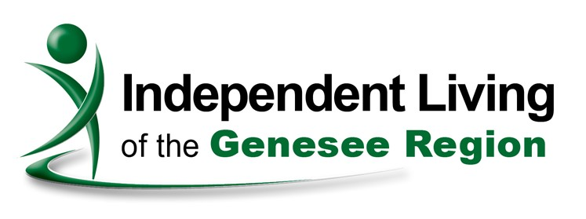Independent Living of the Genesee Region
Rae Frank, Director

Independent Living of the Genesee Region (ILGR)
experienced significant growth and changes in
this post-pandemic year. Donna Becker, long-time
Assistant to the Director, retired after nine years of dedicated service. Her departure gave way to restructuring our administration team and we created the position of “Assistant Director”. Fortunately, we were able to promote Ida Caldwell to the role. Ida
had joined the team as a Housing Specialist after years of serving on the ILGR Governing Council. Our restructuring also included the new role of Administrative Assistant, which was filled by Cathy DeMare, our Receptionist.

The ILGR growth also refers to improvement in our facility. In November 2021, the ILGR Council received the keys to an expansion/renovation project at the Batavia location which included 2,200 additional
square feet of space. This translated into seven offices, more Loan Closet space and a conference room dedicated to Michael Phillips, WNYIL’s Chief Financial Officer for 35 years. Due to the pandemic and reduced foot traffic into our Warsaw office, we downsized in Wyoming County and began to see consumers in the
local library or their homes. Our demographics showed an increase in the number of consumers being served in Orleans County and we opened an office in the Arnold Gregory Community Center in Albion.

ILGR was able to conduct our annual “Meet the Candidates” in 2021, although it was not in person. We met with three Genesee County contenders vying for Council Member seats via Zoom. In the spring
of 2022, we launched our Free Library Cart: “Grab and Go, Ala Cart” providing free (donated, gently used) reading material to anyone visiting our lobby. Our annual Americans with Disabilities Act (ADA)
Community Picnic was once again hosted on July 26th at Kiwanis Park. Rounding out the year, in September
2022, ILGR co-sponsored the “Moving Beyond ‘White Fragility’” event along with The YWCA. Community rights advocate Nanette D. Massey led a review and discussion about the book “White Fragility, why it’s so hard for white people to talk about racism” by Robin DiAngelo. Attendees had an opportunity to examine race from an unfiltered, real-world experience at Genesee Community College.

In keeping with our community systems advocacy role, ILGR was able to ensure that the Batavia Post Office remained accessible to people with disabilities during a remodeling project; confirmed that the Public Health Department made their community needs
27 (continued on next page)

survey accessible, and made sure that Orleans County appointed an ADA Coordinator in the Village of Albion.

While maintaining our regular programs, we added additional housing services with Emergency Solutions funds from New York State, helping to prevent eviction and homelessness by placing individuals in local motels. We also added the Healthy Ideas program in partnership with the Western New York Integrated Care Collaborative. This program provides a “healthy ideas coach” to people experiencing social isolation due to
the pandemic. Finally, another way we tried to fight COVID included the distribution of test kits throughout the year, including personal delivery and pick up at our office locations. ■

ILGR Vignette 1 – Stroke puts Father out of work, family needs housing, educational advocacy

Our Independent Living Specialist (ILS) is assisting a Father and his three sons, who recently went through divorce and bankruptcy due to the divorce. The Father experienced a stroke shortly afterwards, putting him out of work. Being the sole provider
for his children, he was unable to pay his bills. He came to the Agency after the eviction process had already begun. Our ILS has since assisted his family by helping them obtain temporary housing
(outside the prior school district) and assisting two 28

sons with enrolling in adult education programs through BOCES. The ILS advocated for the Father and youngest son through the McKinney Vento Homeless Assistance Act program at their local school district, which allowed the son to remain in his school since they are temporarily living outside of their school district. This advocacy led to the school providing the student with transportation. This is allowing his son to continue getting his Individualized Education Plan (IEP) services without any changes, in hopes he is able to pass his current grade. The youngest is struggling due
to so many changes that the family has been through this school year. Our ILS is continuing to assist with trying to locate stable housing.

ILGR Vignette 2 - Homeless consumer needs stable housing

This consumer was living outside in the woods during the winter, but he would visit ILGR to access the free phone in the lobby. After many attempts to discuss housing, our staff persuaded
the consumer to set the goal to find stable housing
and achieve income. The Center was able to pay for his shelter through the Rapid Rehousing program. Our ILS assisted with the Housing Choice Voucher Program Section 8 application

(continued on next page)

and finding a suitable apartment. The ILS also assisted with the Social Security application which was expedited. The consumer now has income and
is living in an apartment in the community on his own without assistance from our housing program.

ILGR Vignette 3 – Consumer with dementia needs home care

A consumer’s wife was overwhelmed with all of the care required by her husband who is experiencing dementia. He would wander outside and couldn’t be found for hours. Our Medicaid Application Assistance Program (MAAP) Facilitated Enroller
was able to assist with the application for Medicaid. This service allowed for a quicker response time than usual, and he was approved for his medical costs, as well as provided a means to receive homecare services. The consumer now receives
the much-needed help and has friends and family members who are paid for their time by Medicaid. The consumer’s wife was referred to the Alzheimer’s Association for additional support.

ILGR Vignette 4 – Teaching a consumer to augment her independence by using public transportation

This ILS assisted a consumer to increase her
29

independence by educating her in how to read the Regional Transit Service (RTS) bus schedule to better access the community. This education
lessened her need to rely on others to get her to the
store and bank. Her first comment when she looked
at the schedule was “Whoa! Way too overwhelming!”; but she learned to read the schedule. We tested her with scenarios of hypothetical trips, and she passed. The ILS accompanied her on the bus for a trip to the bank to lessen her anxiety level as she struggled with trying something new. She was nervous before the
trip but felt calm during the experience. Consumer is
now able to ride the bus alone. ■

Getting There with
Independence Express

Western New York Independent Living’s fleet of wheelchair accessible vans and vehicles operates under the Independence Express banners and make thousands of trips every year - from the grocery store to the doctor and to everywhere
in-between. The service is available people with disabilities who live in Erie, Niagara, Genesee, Orleans, and Wyoming counties. Costs range from free to $15/trip plus mileage. If you have questions or would like to schedule a trip, call 716-836-0822, ext. 126 or 585-815-8501, ext. 126.

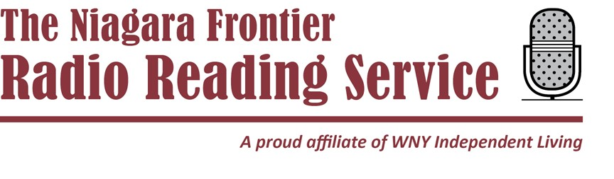

Niagara Frontier Radio Reading Service
Michael Benzin, Executive Director

Volunteers for the Niagara Frontier Radio Reading Service started reading newspapers, books, magazines, and other publications for people who were blind or had a print disability more than 35 years
ago – long before the Internet became widely used and before books-on-tape were common. The publications were recorded or broadcast live to Listeners
throughout Western New York who had special radio receivers.

Print is as important now as it was then. Print brings a level of depth and detail to stories that many modern sources can’t. By sharing these publications, we are helping people stay informed about what’s going on
in their community as well as with national and world news.

Since bringing our broadcast to the Internet two years ago we’ve been able to expand our reach and serve more people in our community. While we continue to broadcast over the air, we share our digital live stream over the Internet to Listeners through their laptops, tablets, smart speakers and smart phones.
The extra capacity that online services provides has also allowed us to add even more publications to our weekly reading lists – meeting the needs and interests of even more people. Not only are we doing a better job serving the residents of Western New York we
are expanding to included Listeners in Rochester, the Genesee Valley and the Finger Lakes with their own local publications. Last year more than 5,000 Listeners enjoyed news, books and magazines both online and on-air.

Your Niagara Frontier Radio Reading Service can
be reached by phone at 716-821-5555 or by email to read@nfradioreading.org ■

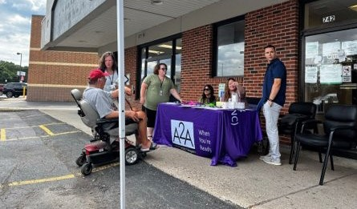

30

Western New York Independent Living, Inc.

Independent Living Center

Mental Health PEER Connection

3108 Main Street, Buffalo, N.Y. 14214

716-836-0822

800-348-8399 (Toll Free)

716-835-3967 (Fax)

Independent Living of Niagara County

746 Portage Road, Niagara Falls, N.Y. 14301

716-284-4131

716-284-3230 (Fax)

855-366-1042 (Toll Free)

Independent Living of the Genesee Region

319 West Main Street, Batavia, N.Y. 14020

243 South Main Street, Albion, N.Y. 14411

585-815-8501

585-815-8502 (Fax)

Niagara Frontier Radio Reading Service

1199 Harlem Road, Buffalo, N.Y. 14227

716-821-5555

31

