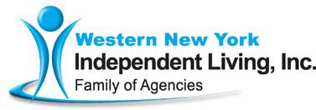



*ACCESSnews*

**Vol. 37, No. 4 - Autumn 2019**

**1**

Western New York Independent Living, Inc.

3108 Main St.

Buffalo, NY 14214

(716) 836-0822 (Voice/TDD)

(716) 835-3967 (Fax)

**Gala Sponsors page 9**

**Holiday Appeal page 7**

**Medical Equipment Loan Closet**

**page 6**

**Cold Truth page 5**

**From the Desk of the CEO: Looking Back at The Past Year**

*Douglas J. Usiak, Chief Executive Officer*

Since this will be probably the last newsletter for the 2019 year, I think that I will take the time to reflect on some of the occurrences around the Western New York Independent Living, Inc. Family of Agencies (WNYIL). The year started with a major shock: the passing of the long-time President of our Board of Directors, **Dennis M. Kessel**. A tri-lateral amputee since birth, he was active on the Board from 1982

until 2019 and served admirably as its President for 30 years. Under Dennis’ leadership, the agency grew from about a dozen staff providing services to consumers in Erie County, to the organization it is today. We have over 2,600 people picking up a paycheck, with offices in four counties, and are contracting programs and services to six other Independent Living Centers serving 22 Counties in New York State. I call that a job well done, Dennis!

In late Winter or early Spring, a bill was passed by the New York State Legislature, that was intended to redesign the **Consumer Directed Personal Assistance Services Program (CDPAS)** in New York. The method of payment for the administration of the service was to change from a long-standing hourly rate to a managed care per-member- per-month reimbursement. This “little adjustment” would cause **a 65% reduction** in WNYIL’s resources that are needed to provide and administer the service.

*continued on page 2*

**Mental Well-being page 4**



***continued on page 3***

**2**

To our consumers’ credit, this bizarre knee-jerk reaction to a very beneficial, rapidly growing program was not taken lying down. Press conferences were held by individuals who were participants of the program, to bring to light their concerns of a projected catastrophic impact on services that would result if the reduction were to happen in our community. Then, the Board of Directors of WNYIL agreed to join other organizations, by signing on to an Article 78 legal action, claiming that the process by which the New York State Department of Health (NYS DOH) executed the new payment option was not done properly. This effort by our Board was a joint action with: the Consumer Directed Personal Assistance Association of New York State (CDPAANYS); the New York Association on Independent Living (NYAIL); the New York State Association of Health Care Providers (NYSAHCP); Southern Tier Independence Center (STIC); AIM Independent Living Services; Rockland Independent Living Center, dba BRIDGES; the Center for Disability Rights (CDR); Independent Living Center of the Hudson Valley (ILCHV); Finger Lakes Independence Center (FLIC); ARISE Child and Family Service, Inc.; Independent Home Care, Inc.; Long Island Center for Independent Living, Inc (LICIL); and Consumer Directed Choices, Inc.

Our consumers and their personal assistants not only participated in community demonstrations and press conferences, but wrote letters, made phone calls, and made trips to Albany to demonstrate to the NYS Department of Health and even the Governor’s office, their belief that this was an eminently bad decision. Even on the day of the actual hearing in front of the Supreme Court of New York in Albany County, consumers from all around the Empire State came to hear and participate in the protest of this landmark action that people with consumer-directed in-home care were facing.

And would you believe it, we won! Unfortunately, this probably means (in the words of Todd Vaarwerk, our Chief of Public Policy), “We have just beat back an offensive.” Meaning that NYS DOH, if we are to take them at their word, is still attempting to reduce costs. So, we will see another attempt at lowering this rate, hopefully not as deep or as disastrous as the last one would’ve been, if not for people with disabilities taking the bull by the horns.”

WNYIL was to deal with its second loss of the year. Its founder and former Executive Director, **Anthony (Tony) Serra** passed away. Over 40 years ago, Tony had the privilege to go to the original Center for Independent Living (CIL) in Berkley, California, where he was introduced to the philosophy and mission of Independent Living. At that time, Tony was doing an internship for his graduate work in Rehabilitation Counseling, at the University at Buffalo, and embraced the spirit of equal access, self-direction, and peer

support, of the people of the CIL. They were not only working with their brothers and sisters with disabilities but were pushing that City to become more accessible for all people with disabilities. Tony brought home this spirit to the City of Good Neighbors, and, along with the disabled student union at the University at Buffalo, “The Independents”, wrote and received a grant to begin our predecessor, the Western New York Independent Living Project. It provided the IL core services of Peer Counseling, Independent Living skills, Advocacy and



**3**

Information & Referral.

Tony’s contributions did not stop there. He was the first Executive Director of the Erie County Office for People with Disabilities, the founder of the first Niagara Falls CIL, the Niagara Frontier Center for Independent Living, and later went to Albany to work in the New York State Office of the Advocate for Persons with Disabilities, and finished up as one of the regional directors of VESID (Vocational and Educational Services for Individuals with Disabilities), now known as ACCES-VR (Adult Career and Continuing Education Services – Vocational Rehabilitation).

At 70 years old, Tony, a quadriplegic since the age of 16, has made a huge impact on the lives of people with disabilities. That is not only in direct services, but with his tireless efforts as a community change agent, and with his work in pushing for, and advocating on behalf of, legislation that improved the programs and services for people with disabilities here in Western New York, throughout the State, and nationally. Our thanks and gratitude go out to Tony, and our blessings to his family and friends, for he will be missed.

As the year moves on, we have been able to replace the roof at our youngest member of the Family of Agencies, the **Niagara Frontier Radio Reading Service**. Their volunteers

provide a voice for the printed word, 24 hours per day, for those of us who are unable to read it for ourselves. And, as I understand it, they will soon be able to stream their service via the Internet, once all the software and hardware upgrades are in place. I look forward to the time when anyone in Western New York and Southern Ontario who needs to, or wants to, access the printed word is empowered by doing so, especially when it comes to local news and publications.

In closing, I dedicate my last few years as WNYIL’s CEO to my niece **Shannan Tabak**, a young woman who came into this world as a person with multiple disabilities. With very severe intellectual challenges, blindness, and lacking individual ambulation, she spent her entire life dependent on others to assist her in being part of our family. Thanks to her parents’ devotion to her, Shannan was able to participate in family gatherings, outside activities, school, and trips. Her ability to live at home, with the family who loved her, gave Shannan the daily feeling of belonging and being loved, as she struggled with 30 years of disabling conditions that would eventually take her from us all. I credit the work of Centers for Independent Living throughout this Country for creating the in-home supports and services that Shannan and her family utilized to keep her out of institutional care. Whereas, I know that institutional care would never have been an option for Shannan as long as her family was around, their strength and commitment to community participation for all will inspire me every day from this day forward. I now know that, as Shannan rests in peace, that the work that I and those at WNYIL have been doing for forty years will continue to make opportunities and choices available for many of our brothers and sisters, which they never would have had, just a few decades ago.



**4**

**What does it look like for you to take care of your mental well-being?**

*Naomi Taylor, Outreach and Community Engagement Peer*

Recovery from mental illness takes a multifaceted approach. Wrapped up in the brain, there are many different layers. They need to be worked through, peeled away and allowed to grow into what is the TRUE you. The you that can allow yourself to be an empowered person in recovery. It takes hard work and dedication. The process is one of unlearning

behaviors and tools that do not suit your well-being and learning ones that can lift you into a life that is beyond your wildest dreams!

* **Social**

Developing a sense of connection, belonging and a well-developed support system.

* **Intellectual**

Recognizing creative abilities and finding ways to expand knowledge and skills.

* **Spiritual**

Expanding our sense of purpose and meaning in life.

* **Physical**

Recognizing the need for physical activity, diet, sleep and nutrition.

* **Occupational**

Personal satisfaction from one’s work.

* **Environmental**

Good health by occupying pleasant, stimulating environments that support well-being.

* **Financial**

Satisfaction with current and future financial situations.

All mental health can be affected when the different aspects and needs are not met. As we continue to grow and explore ourselves, these needs and aspects shift and change. The biggest gift we can give ourselves is meeting ourselves where we are at. That means if the best thing for our spiritual wellness is to go for a walk in nature, then make time during the week to do that. If the spiritual need changes into a religious one, then we allow ourselves to make that change. The ebb and flow of growth is a beautiful dance between learning what we need to do in the moment and falling back on old tools. Be gentle with yourself!



**5**

**The Cold Truth of Disability in The Winter**

*Julia Lange, NY Connects Program Assistant*

Colder months are among us. While that’s a relief for many after a hot summer, cold can affect people with disabilities.

Ice and snow can make it difficult for people with mobility impairments to trek outside. The extreme cold can pose risks to people with respiratory illnesses such as asthma or COPD.

Many people with disabilities may also have trouble affording adequate shelter that keeps them warm. Many cannot afford heat nor can the afford well-insulated housing.

Not everyone is aware of weatherization programs, HEAP, or tenant rights. Not everyone is aware that electric companies and gas companies sometimes offer additional protections for people with disabilities or chronic illnesses. Not everyone is aware that Paratransit has provisional passes for those who cannot walk in the snow or ice.

Thankfully there is a service in your area to help you. NY Connects at Western New York Independent Living can help point people in need of these services in the right direction where to find these services (and many more).

Funded by New York State Office for the Aging (NYSOFA), NY Connects is a statewide initiative to offer information and referral services to seniors and their caregivers. Offices for the Aging (OFA) linked older and their caregivers to community resources, helping consumers make informed choices, and apply for public benefits.

NY Connects has since expanded into a partnership between independent living centers (ILC) and local offices for the aging (OFA) to give these services to people across the lifespan.

Region 1 Coordinator, Amanda Pinter, oversees 17 counties and one territory in Region 1 of NY Connects. Amanda works with seven ILCs, including the three in the Western New York Independent Living family of agencies. People in need of services in Erie, Niagara, Genesee, Orleans, Wyoming, or the Seneca Nation of Indians may contact NY Connects at 1-888-564- 5171 between 8:30 a.m. and 5:00 p.m., Monday through Friday.

Let NY Connects be your guide to helping find appropriate winter services!

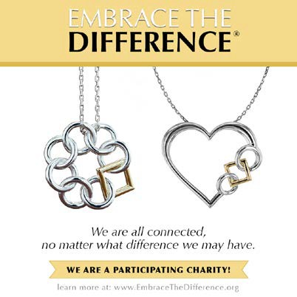

**6**

**Medical Equipment Loan Closet**

*Dan Colpoys, Chief Community Engagement Officer*

If you, or a family member, are in need of durable medical equipment to assist with personal needs or mobility, WNYIL has a supply of canes, walkers, commodes, wheelchairs, and shower benches to provide the required assistance needed. You do not have to be a consumer of the agency – we are happy to help anyone in need of such equipment. We have three medical equipment loan closet locations:

3108 Main St., Buffalo, NY 14214

Phone number: 716-836-0822 ext. 115

746 Portage Rd, Niagara Falls, NY 14301 Phone number: 716-284-4131 ext. 214

319 W. Main St., Batavia, NY 14020 Phone number: 585-815-8501 ext. 400

Simply, call one of our locations to arrange pick up (sorry, we do not deliver). We are also happy to take durable medical equipment items as donations to help those in need. Donations can be dropped off at any of the above-listed locations between the hours of 9:00 a.m. and 4:30 p.m.

When you shop at AmazonSmile, Amazon donates 0.5% of the purchase price to Western New York Independent Living, Inc. Bookmark the link <http://smile.amazon.com/ch/22-2316065> and support us every time you shop.

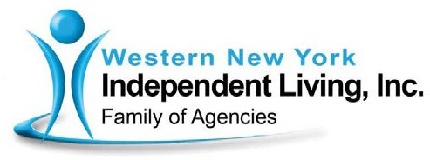

(over)

December 2019

Dear Friends of Western New York Independent Living,

For 39 years, Western New York Independent Living has helped individuals with disabilities to **Live** in our neighborhoods, **Work** in our communities, and **Engage** in our society.

You have supported us along the way as we annually taught thousands of Western New Yorkers independent living skills so they can remain in their home as opposed to institutionalized care. Our support programs provide the services & resources for people with disabilities that they need, when they need it.

Last year the WNYIL Family of Agencies added a new family member, the Niagara Frontier Radio Reading Service. NFRRS is a 24/7 radio station that provides audio information services for people who are blind, have low vision, or other cognitive or physical impairments that make reading difficult or impossible. A team of dedicated volunteers read newspapers, magazines, books and other materials daily over a private radio frequency to people who have special receivers.

NFRRS ensures that their listeners have the same access to news, information and entertainment as anyone else. Located on Harlem Road in Cheektowaga, *NFRRS has been bringing print to life for more than 30 years.*

Studies have shown that people who read are not only more open-minded and creative, but also have lower stress levels, are less likely to develop Alzheimer’s, and are more likely to be engaged in their community. With WNYIL’s help, the Radio Reading Service is currently:

* upgrading its system to introduce live streaming and podcasts over the Internet to complement its broadcast services - which will expand its listener base ten-fold and provide a larger program catalog for listeners to choose from. *Listeners will be able to listen to what they want, when they want it, on whatever device they choose*
* and renovating vacant offices on its second floor to make them fully accessible so the space can be leased out and the proceeds put toward funding their operations.

*(continued on next page)*

**Western New York Independent Living Center**

3108 Main Street, Buffalo, New York 14214 ◻ (716) 836-0822

***Visit us on the web at wnyil.org!***

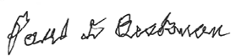

Paul Beakman Sr.

Chair, Board of Directors WNY Independent Living

This Holiday Season, I would like to invite you to help make these

much-needed upgrades to the Radio Reading Service. Your gift of:

o

$1,000 will digitally transmit our signal from our studio to our radio tower in the

Southtowns for one month or bring it to the Internet for two months,

$300 will underwrite one listener for one year,

$100 will buy a new radio for a listener, or

$25 will deliver one hour of programming to our listeners

You can make a secure gift by credit card online by visiting [www.wnyil.org](http://www.wnyil.org/) and

o o

o

clicking the Donate button. Or you can mail a check payable to Western New York

Independent Living, Inc. to 3108 Main St., Buffalo, NY 14214.

Please help us meet our vision of ensuring that people with disabilities have what they need to empower themselves and become (or remain) contributing and equal members of our community. Thank you for your thoughtful consideration and generosity!

Sincerely,

Paul Beakman Sr.

President of the Board of Directors WNY Independent Living



**9**

***Thank you to our 2019 A Night for Independence Gala Sponsors!***

Assemblyman Angelo Morinello BlueCross BlueShield

Clauss & Company Insurance Agency EBC Inc.

EFPR Group Frank’s Mobil On the Run Friedlander Group, Inc.

Geico HealthWorks WNY

Integrity Health Group Kideney Architects

Long Associates Architects M&T Bank

Main Mobility Inc. Miranda Real Estate

Niagara Frontier Radio Reading Service PCA Technology Group, Inc.

Philadelphia Insurance Companies Pro Carpet

Queen City Imaging Senator Chris Jacobs Senator Timothy Kennedy Seneca Resorts & Casinos ShelterPoint

The Arc of Genesee Orleans United Healthcare Wegmans

*We hope to see you next year at our 7th Annual A Night for Independence Gala!*





A Night for

Independence

Gala

7th

Annual

*To benefit Independence Express Transportation*

**Spring 2020**

□ High end live & basket items   Music & entertainment 

□ Sit-down dinner & a night of fun 

*Thank you to our 2019 Diamond and Gold sponsors:*

•

•

•

•

•

•

•

•

EBC Inc.

Miranda Real Estate Main Mobility Inc.

Clauss & Company Insurance Agency M&T Bank

Friedlander Group, Inc. Seneca Resorts & Casinos

Geico

•

•

•

•

•

•

United Healthcare HealthWorks WNY Frank’s Mobil on the Run

PCA Technology Group, Inc. Pro Carpet, Inc.

BlueCross BlueShield of Western New York

10

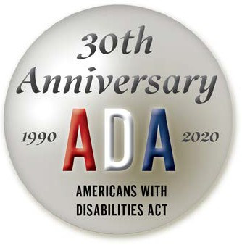

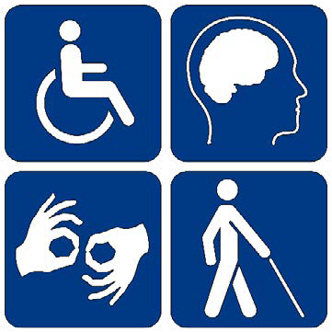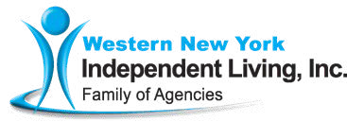

**Inclusion, Awareness, Visibility**

**Disability Pride**

**Parade & Festival**

**July 2020**

Western New York Organizations invite you to join us to celebrate the Americans with Disabilities Act and Disability Pride with **FREE** food, fun, and games.

We look forward to having you celebrate with us!

*Thank you to our 2019 sponsors:*

•

•

•

•

•

•

•

•

•

•

National Grid YourCare Health Plan T Mobile

The Arc Erie County New York United Healthcare

Buffalo Bisons

People Inc.

Person Centered Services Cradle Beach Camp

Learning Disabilities Association of WNY

•

•

Cellino Plumbing

Western New York Federal Credit Union

Lawley Insurance People First Mobility

Westfield Memorial Hospital

Community Services for Every1

National Federation for Just Communities of Western New York, Inc.

WNY Adaptive Water Sports

William Mattar Law Offices

•

•

•

•

•

•

•

11