

❖ **SibTeen**—for sibs who are teenagershttps://[www.facebook.com/groups/SibTeen/](http://www.facebook.com/groups/SibTeen/)

❖ **Sib20**—for siblings in their 20s https://[www.facebook.com/groups/Sib20/](http://www.facebook.com/groups/Sib20/)

❖ **SibNet on Facebook**—for adult siblings https://[www.facebook.com/groups/SibNet/](http://www.facebook.com/groups/SibNet/)

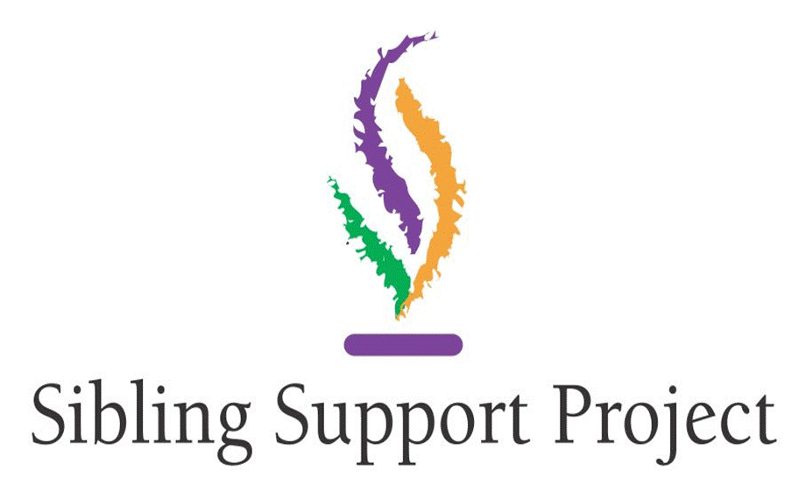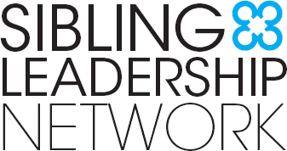

Resources for Siblings of

People with Disabilities in New York

Siblings of people with disabilities experience various support needs throughout the lifespan. Better outcomes for siblings can lead to better outcomes for their brothers and sisters with disabilities, and all family members. It is important to start early and provide supports to young siblings. As they age, siblings may take on greater support roles and need more information. There are resources, networks and supports for siblings and their families in New York throughout the lifespan!

**Resources for Siblings of Individuals with Disabilities**

**Sibling Resources:** [www.siblingresources.org](http://www.siblingresources.org/)

Sibling Resources is an emerging website dedicated to issues concerning siblings of individuals with disabilities. This website recognizes that Siblings are **stronger together**. By joining SiblingResources.org, you will become part of the sibling community in NY and receive information, resources and learning opportunities.

**SibsNY:** [www.sibsny.org](http://www.sibsny.org/)

SibsNY is a volunteer organization dedicated to providing the siblings of individuals with intellectual, developmental and learning disabilities with information and support.

Comprised of siblings and providers of sibling services throughout New York, sibsNY is committed to connecting siblings to each other and to the resources they need to help them and their siblings with disabilities live the most fulfilling lives possible.

**Sibling Leadership Network:** [www.siblingleadership.org](http://www.siblingleadership.org/)

The Sibling Leadership Network (SLN) provides siblings of individuals with disabilities the information, support, and tools to advocate with their brothers and sisters and to promote the issues important to them and their entire families.

**Sibling Support Project:** [www.siblingsupport.org](http://www.siblingsupport.org/)

The Sibling Support Project is a national effort dedicated to the life-long concerns of brothers and sisters of people who have special health, developmental, or mental health concerns.

**Connect with Siblings Online:** There are a number of online, interactive closed communities for siblings at different ages to connect with each other for information and peer support. Hosted by The Sibling Support Project, these groups serve as a front-line resource for sibs, by sibs! Siblings can look on Facebook to request to be added to a group.

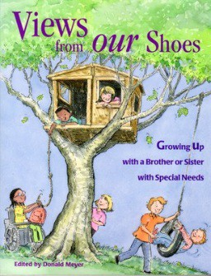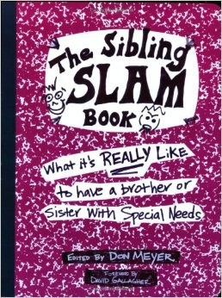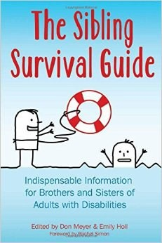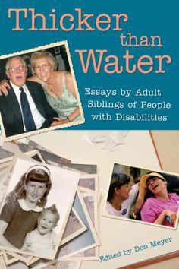

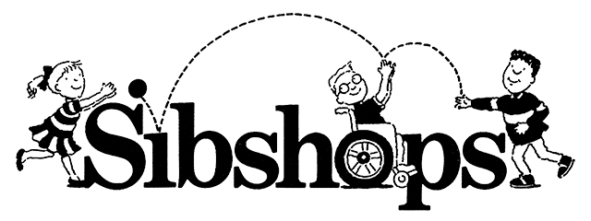

**Sibshops** are pedal-to-the-metal events where school-age brothers and sisters meet other sibs (usually for the first time), have fun, laugh, talk about the good and not-so-good parts of having a sib with special needs, play some great games, learn something about the services their brothers and sister receive, and have some more fun.

To find a Sibshop near you, visit: [www.siblingsupport.org/about-sibshops/find-a-sibshop-near-you](http://www.siblingsupport.org/about-sibshops/find-a-sibshop-near-you)

**Books for siblings of all ages:**

There are lots of great books for siblings of all ages—check out the Sibling Support Project’s Amazon Astore: [http://astore.amazon.com/thesibsuppro-20.](http://astore.amazon.com/thesibsuppro-20) Here are a few good books for siblings:

**Disability Resources in New York:**

**NYSARC:** [www.nysarc.org](http://www.nysarc.org/)

NYSARC’s mission is to advocate for people with developmental and other disabilities in every manner possible. In its advocacy role, NYSARC is committed to a full quality of life for every person, as it recognizes the challenges of the present and has a clear vision for the future.

**The New York State Developmental Disabilities Planning Council:** [www.ddpc.ny.gov](http://www.ddpc.ny.gov/)

NYDDPC in collaboration with individuals with developmental disabilities, their families, caregivers and policymakers provides capacity building by promoting policies, plans and best practices that: Affirm the dignity, value, respect, contribution and worth of all New Yorkers with developmental disabilities; support full participation of people with disabilities in society; uphold equality and self-determination for all; promote access to research and information needed for informed decision making; convene individuals with disabilities, family members, service providers and others to learn from each other to promote promising system changes.

**The NY State Office for People with Developmental Disabilities:** [www.opwdd.ny.gov](http://www.opwdd.ny.gov/) OPWDD is responsible for coordinating services for more than 128,000 New Yorkers with

developmental disabilities, including intellectual disabilities, cerebral palsy, Down syndrome, autism spectrum disorders, and other neurological impairments.

This resource was developed by The Sibling Leadership Network supported by a grant from the New York State Developmental Disabilities Planning Council. The project partners include Yang- Tan Institute at Cornell University and SibsNY.