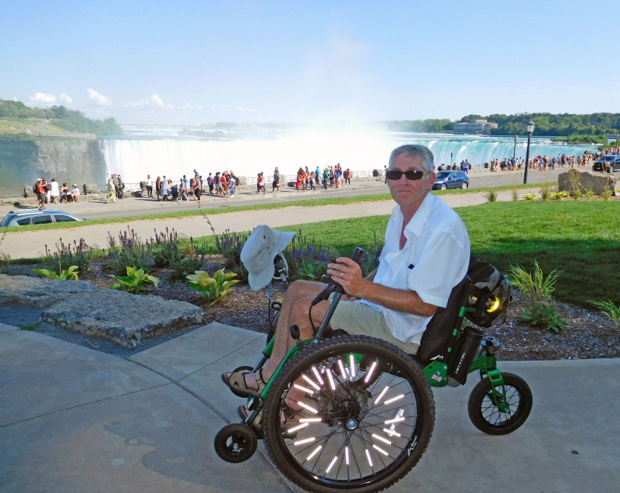

Additional Programs

**To enhance your life**

**ILNC is a member of the Western New York Independent Living Family of Agencies**

**Our Vision:**

Independent Living of Niagara County (ILNC) is a member of the Western New York Independent Living Family of Agencies. ILNC serves to en- courage individual and systems change, enhanc- ing the quality of life for anyone with disabilities, while respecting diversity, and promoting choice and alternatives for independent living within the community.

746 Portage Rd., Niagara Falls, NY 14301

(716) 284-4131 • 8:30 a.m. - 5:00 p.m.

140 Genesee St., Lockport, NY 14094

* **Systems Advocacy:** working to remove barriers to equal participation communitywide.
* **Medicaid Application Assistance Program:** guiding you in signing up for Medicare or Medicaid health insurance.
* **Health Care Coordination:** an integrated approach to meeting your medical needs, in which a customized care management plan assists your health providers to communicate with one another, ensuring you can access all appropriate services and reduce emergency room visits and long-term stays in the hospital.
* **Addict 2 Addict:** where your Peers can assist you if you are ready to embrace recovery.
* **Services for the Deaf and Hard-of-Hearing** provided by an American Sign Language user and instructor.
* **Various monthly support groups:** you can access a current list at the WNYIL website at:<http://wnyil.org/Events/monthly-support-> groups

For more information on ILNC’s programs, go to [www.wnyil.org/Independent-Living-Niagara](http://www.wnyil.org/Independent-Living-Niagara)

**Our Mission:**

ILNC is a multi-cultural, grass roots, peer-direct- ed, civil rights organization that provides a full range of assistance, programs and services to enhance the quality of life for all individuals with disabilities.

ILNC is an agency that is directed, monitored, and staffed by people with disabilities to assist people with disabilities like you to achieve their life goals.

**The Independent Living philosophy of consumer choice; means that you,**

**the person with the disability, determine how you want to improve your quality of life, as you…**

**Follow Us on Social Media**

Independent Living Centers are 501(c)3,

non-profit organizations.

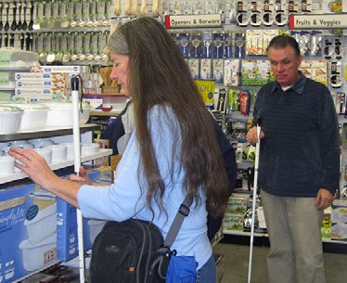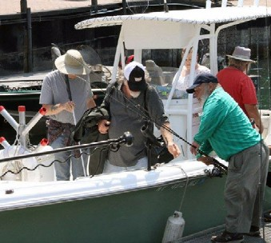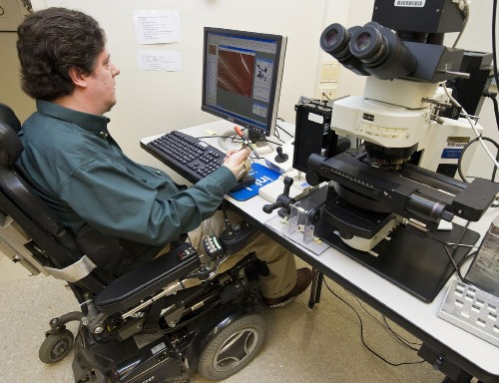

Live

Work

Engage

**in the neighborhood of your choice**

ILNC staff can support you in your efforts to achieve your life goals, providing information and instruction through a menu of programs and services:

* **Peer counseling**: sitting down with people with disabilities who can share their lived experiences.
* **Housing assistance**: finding a place in the community of your choice which offers appropriate access to meet your individual needs.
* **Independent living skills**: working with one of our peer counselors to gain the skills YOU want to know.
* **In-Home Personal Assistant Care:** if you have functional limitations, Personal Assistants can help with daily living activities
* **Individual Advocacy** to assist you in removing barriers that prevent your equal participation.
* **Transition Services**: helping you deal with the challenges of transitioning from school to higher education or vocational training, from school to work, or from institutional care to living in the community.
* **Long-Term Loan of Medical Equipment,** offering you a selection of simple assistive devices that can enable you to live independently in your home

**in your community**

**in your society**

The Independent Living Specialist (ILS) can assist you in finding the job you want and learning the best ways to sell yourself on paper and in person.

Once you have dealt with housing and employment, you can show the community your value by engaging and taking control of the choices available to you. We invite you to join us in our efforts to improve the accessibility of Niagara County for people with disabilities.

•

**Filling out Job Applications**, with either paper

or on-line employment bids.

**Preparing necessary paperwork**, creating a résumé that best showcases your education, work and volunteer experience, and a cover letter showing you would be a good fit for the open position.

**Practice job interviewing techniques**, discovering the best approaches to speak to your strengths and downplay your weaknesses.

**Job Search Assistance**, using local jobs publications and the Internet.

**Accessing public & private transportation**, to

get to and from work.

**Benefits Consultation**: learning how to maximize your benefits, while simultaneously empowering you to work.

•

* **Become involved in the electoral process**: call ILNC to secure a Niagara County Voter Registration card, send it in to the Board of Elections, and vote at every election.
* **Be better informed** by attending ILNC’s Meet the Candidates Day in October, and Brunch with the Policymaker in April to make your voice heard.

•

•

* **Celebrate disability rights** by joining us in ILNC’s annual Olmstead Picnic, confirming the Americans with Disabilities Act provision that people with disabilities should be able to live in the least restrictive environment.

•

•

* **Take advantage of accessible recreation**

at ILNC’s annual Small Mouth Bass Fishing Derby on the Niagara River and other programs available in the community.