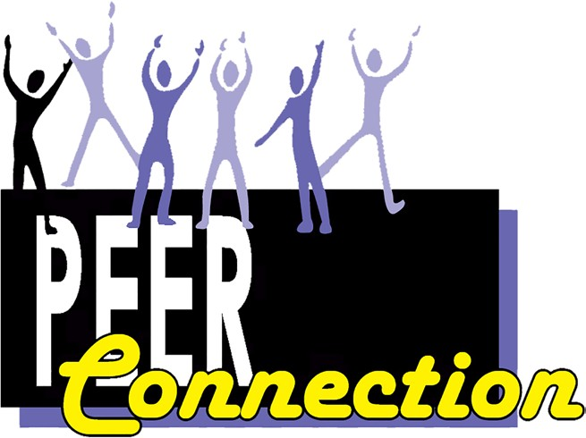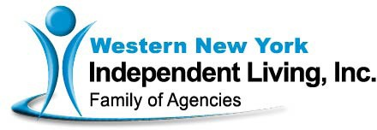

**Home and**

**Community Based Services (HCBS)**

**Family Support and Training** services facilitate engagement and active participation of the family of the individual receiving services to assist with the treatment process. These services are only provided at the request of the individual and may include assisting the family to provide a safe and supportive environment, education, family mediation and conflict resolution, and behavioral management strategies.

[www.facebook.com/WNYIL](http://www.facebook.com/WNYIL)

https://twitter.com/wnyil

**Contact:**

Skylar Amari, LMSW, NYCPS-P MHPC Community Coordinator [samari@wnyil.org](mailto:samari@wnyil.org)

716-836-0822 x511

716-835-3697 (fax)

Western New York Independent Living, Inc.

3108 Main Street

Buffalo, NY 14214

(716) 836-0822

[www.wnyil.org](http://www.wnyil.org/)

Mental Health Peer Connection (MHPC) is a peer driven advocacy organization, dedicated to facilitating self-directed growth, and wellness and choice through genuine peer mentoring. Our staff of peers are people who are in recovery from mental health issues and/or chemical addiction who can relate to the individuals they

are serving.

Mental Health PEER Connection is a member of WNY Independent Living, Inc.’s family of agencies.

*Education, Empowerment, and*

*Equality for People with Disabilities*

Independent Living Centers are

501(c)3 non-profit organizations.

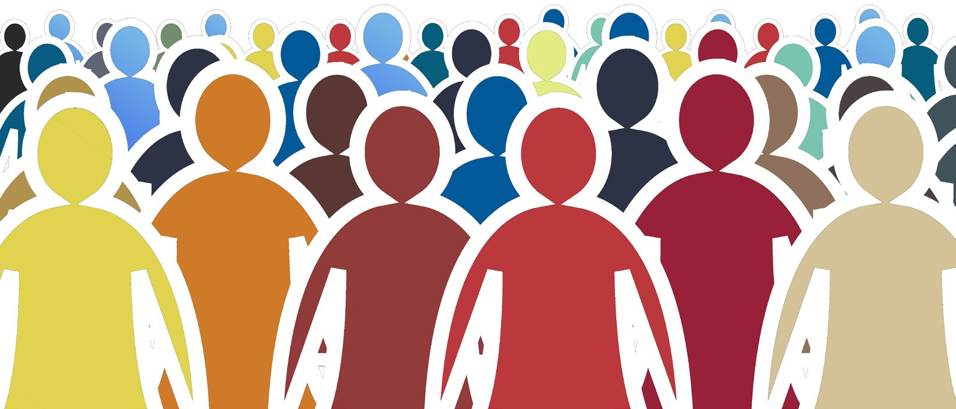

**Home and Community Based Services (HCBS)**

MHPC’s Home and Community Based Services is for hard-to-reach adults experiencing behavioral health issues.

Our peers are experienced in what it takes to be in recovery, and have personal experience navigating systems that impact quality of

life such as the Social Security Administration, Social Services, Housing systems, OPWDD, and gaining meaningful employment. Our peers help to bridge individuals from their homes into the community.

behavioral health symptoms while facilitating the utilization of natural resources and the enhancement of recovery oriented principles. This may include advocacy, assistance seeking and obtaining benefits, systems navigation, companionship, self-directed recovery tools such

as WRAP, and removing barriers to activities that help people bring meaning and purpose to their life.

and interpersonal skills necessary to create, increase or, maintain functioning in a social environment, such as home, work, school, and the community.

**Pre-Vocational** services are time- limited that prepare a participant for paid or unpaid employment.

This can include helping an individual through a job search, building a resume, identifying and removing barriers to paid or unpaid employment, and teaching work-related concepts such as

work compliance, attendance, task completion, and problem-solving.

**Habilitation and Psychosocial Rehabilitation:** Rehabilitation counseling, including recovery activities and interventions that build and restore social, personal,

**Counties Served:**

Erie, Niagara, Chautauqua, Genesee, Cattaraugus, Orleans, Wyoming.

**HCBS Services Provided:**

**Peer Support** services are peer-delivered services with a

rehabilitation and recovery focus. They are designed to promote skills for coping with and managing