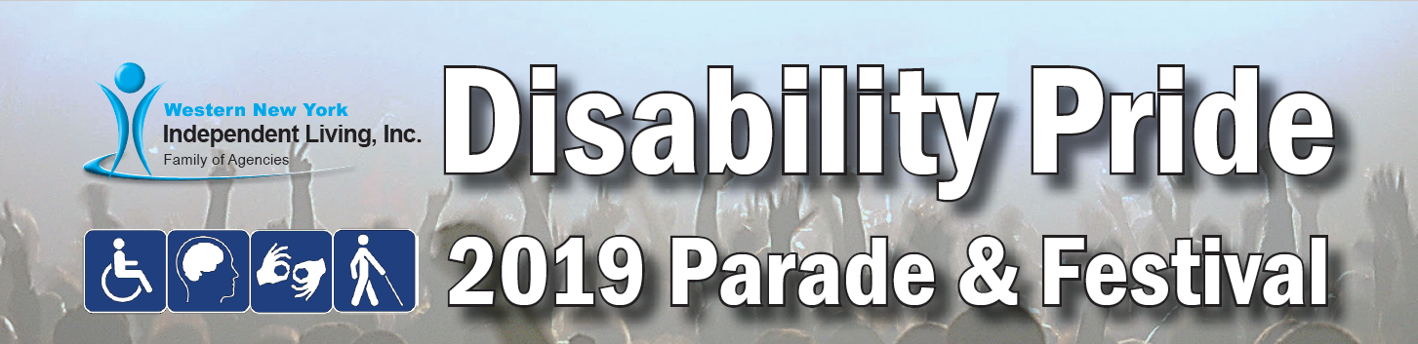
Join the Celebration
Saturday, July 27, 2019

Western New York Disability Pride Parade
Starting behind Buffalo City Hall at 10:30 a.m.

Disability Pride Festival
At Buffalo Canalside (Dart Lawn), 11:00 a.m. to 2:00 p.m.

Adaptive Water Sports
Free Boat Rides to Attendees with Disabilities
At Buffalo Canalside, 9:30 a.m. to 3:30 p.m.

Annually, community organizations from across Western New York come together in honor of the Anniversary of the signing of the Americans with Disabilities Act (ADA) and to celebrate the power of people with disabilities. Join over 1,400 people in demonstrating pride in human diversity. Admission is free and open to all persons with disabilities. Food, refreshments, and entertainment provided.
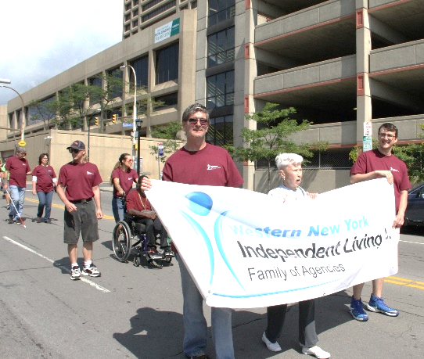
Get involved!
Individuals and community organizations can contribute to the planning and delivery of the Disability Pride festivities.
- Volunteer at the Event
- March in the Parade
- Become a Sponsor
- Exhibit at the Festival

For more information visit http://www.wnyil.org/Events/Disability-Pride

To become a sponsor, vendor, parade participant, or volunteer contact Marykate Waringa at 716-836-0822 ext. 146 or mwaringa@wnyil.org.

